CHE1031 HW set 2: Atoms, molecules & ions

Please solve these problems on green engineering graph paper.
Problems are assigned at each class meeting and are due at the next class.
Please number each problem, show all work for credit and box your answer.
Note that answers to quantitative problems are provided in blue. Not many in this set!

2.1: Early ideas in atomic theory
1. Which postulate of Dalton’s theory is consistent with the following observation concerning the weights of reactants and products? When 100 grams of solid calcium carbonate is heated, 44 grams of carbon dioxide and 56 grams of calcium oxide are produced.

2. Samples of compound X, Y, and Z are analyzed, with results shown here.
compound | description | carbon (g) | hydrogen (g)
X | clear, colorless liquid; strong odor | 1.776 | 0.148
Y | clear, colorless liquid; strong odor | 1.974 | 0.329
Z | clear, colorless liquid; strong odor | 7.812 | 0.651

(a) Do these data provide example(s) of the law of definite proportions, the law of multiple proportions, neither, or both?
(b)What do these data tell you about compounds X, Y, and Z?

2.2: Evolution of atomic theory
3. The existence of isotopes violates one of the original ideas of Dalton’s atomic theory. Which one?

4. How are protons and neutrons similar? How are they different?

5. Predict and test the behavior of α particles fired at a “plum pudding” model atom.
(a) Predict the paths taken by α particles that are fired at atoms with a Thomson’s plum pudding model structure. Explain why you expect the α particles to take these paths.
(b) If α particles of higher energy than those in (a) are fired at plum pudding atoms, predict how their paths will differ from the lower-energy α particle paths. Explain your reasoning.

6. Write the symbol for each of the following ions:
(a) the ion with a +1 charge, atomic number 55, and mass number 133
(b) the ion with 54 electrons, 53 protons, and 74 neutrons
(c) the ion with atomic number 15, mass number 31, and a -3 charge
(d) the ion with 24 electrons, 30 neutrons, and a +3 charge

7. Determine the number of protons, neutrons, and electrons in the following isotopes that are used in medical diagnoses:
(a) atomic number 9, mass number 18, charge of 1−
(b) atomic number 43, mass number 99, charge of 7+
(c) atomic number 53, atomic mass number 131, charge of 1−
(d) atomic number 81, atomic mass number 201, charge of 1+
(e) Name the elements in parts (a), (b), (c), and (d).

8. Give the number of protons, electrons, and neutrons in neutral atoms of each of the following isotopes:
(a) ¹⁰₅B
(b) ¹⁹⁹₈₀Hg
(c) ⁶³₂₉Cu
(d) ¹³₆C
(e) ⁷⁷₃₄Se

9. An element has the following natural abundances and isotopic masses: 90.92% abundance with 19.99 amu, 0.26% abundance with 20.99 amu, and 8.82% abundance with 21.99 amu. Calculate the average atomic mass of this element.
20.17 amu

10. Variations in average atomic mass may be observed for elements obtained from different sources. Lithium provides an example of this. The isotopic composition of lithium from naturally occurring minerals is 7.5% 6Li and 92.5% 7Li, which have masses of 6.01512 amu and 7.01600 amu, respectively. A commercial source of lithium, recycled from a military source, was 3.75% 6Li (and the rest 7Li). Calculate the average atomic mass values for each of these two sources.
6.94093 amu and 6.9625 amu

2.4: Chemical formulas
11. Explain why the symbol for an atom of the element oxygen and the formula for a molecule of oxygen differ.

12. Write the molecular and empirical formulas of the following compounds:
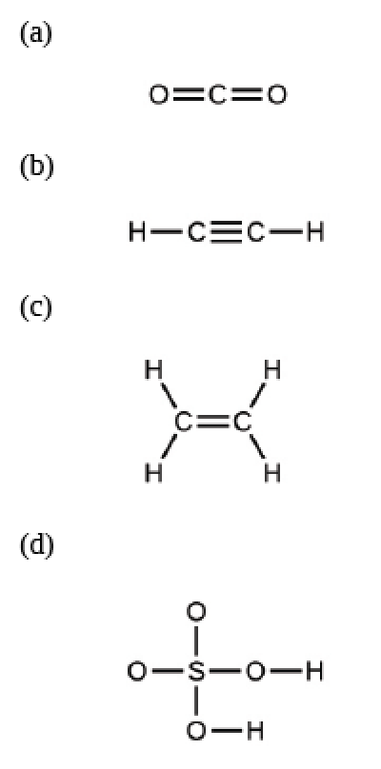

13. Determine the empirical formulas for the following compounds:
(a) caffeine, C8H10N4O2
(b) fructose, C12H22O11
(c) hydrogen peroxide, H2O2
(d) glucose, C6H12O6
(e) ascorbic acid (vitamin C), C6H8O6

14. Write the empirical formulas for the following compounds:
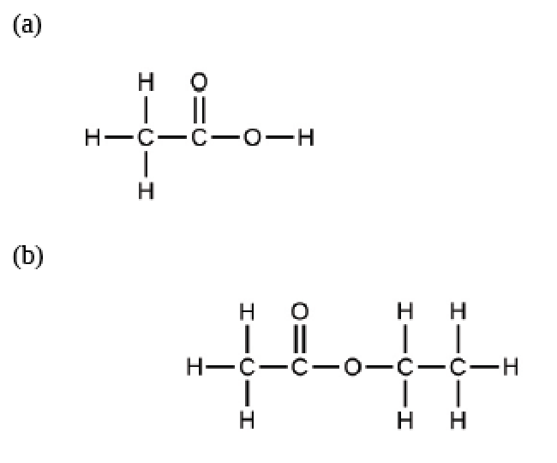

2.5: The periodic table
15. Using the periodic table, classify each of the following elements as a metal or a nonmetal, and then further classify each as a main-group (representative) element, transition metal, or inner transition metal:
(a) uranium
(b) bromine
(c) strontium
(d) neon
(e) gold
(f) americium
(g) rhodium
(h) sulfur
(i) carbon
(j) potassium

16. Using the periodic table, identify the lightest member of each of the following groups:
(a) noble gases
(b) alkaline earth metals
(c) alkali metals
(d) chalcogens

17. Use the periodic table to give the name and symbol for each of the following elements:
(a) the halogen in the same period as the alkali metal with 11 protons
(b) the alkaline earth metal in the same period with the neutral noble gas with 18 electrons
(c) the noble gas in the same row as an isotope with 30 neutrons and 25 protons
(d) the noble gas in the same period as gold

18. Write a symbol for each of the following neutral isotopes. Include the atomic number and mass number for each.
(a) the chalcogen with a mass number of 125
(b) the halogen whose longest-lived isotope is radioactive
(c) the noble gas, used in lighting, with 10 electrons and 10 neutrons
(d) the lightest alkali metal with three neutrons

2.6: Molecular and ionic compounds
19. Using the periodic table, predict whether the following chlorides are ionic or covalent: KCl, NCl3, ICl, MgCl2, PCl5, and CCl4.

20. For each of the following compounds, state whether it is ionic or covalent. If it is ionic, write the symbols for the ions involved:
(a) NF3
(b) BaO,
(c) (NH4)2(CO3)
(d) Sr(H2PO4)2
(e) IBr
(f) Na2O

21. For each of the following pairs of ions, write the formula of the compound they will form:
(a) Ca⁺², S⁻²
(b) NH4⁺¹ , SO4⁻²
(c) Al⁺³, Br⁻¹
(d) Na⁺¹, HPO4⁻²
(e) Mg⁺², PO4⁻³

2.7: Chemical nomenclature (naming)
22. Name the following compounds:
(a) CsCl
(b) BaO
(c) K2S
(d) BeCl2
(e) HBr
(f) AlF3

23. Write the formulas of the following compounds:
(a) rubidium bromide
(b) magnesium selenide
(c) sodium oxide
(d) calcium chloride
(e) hydrogen fluoride
(f) gallium phosphide
(g) aluminum bromide
(h) ammonium sulfate

24. Write the formulas of the following compounds:
(a) chlorine dioxide
(b) dinitrogen tetraoxide
(c) potassium phosphide
(d) silver (I) sulfide
(e) aluminum nitride
(f) silicon dioxide

25. Each of the following compounds contains a metal that can exhibit more than one ionic charge. Name these compounds:
(a) Cr2O3
(b) FeCl2
(c) CrO3
(d) TiCl4
(e) CoO
(f) MoS2

26. The following ionic compounds are found in common household products. Write the formulas for each compound:
(a) potassium phosphate
(b) copper(II) sulfate
(c) calcium chloride
(d) titanium (IV) dioxide
(e) ammonium nitrate
(f) sodium bisulfate (the common name for sodium hydrogen sulfate)

