CHE1031 HW set 3: Composition of substances & solutions

Please solve these problems on green engineering graph paper.
Problems are assigned at each class meeting and are due at the next class.
Please number each problem, show all work for credit and box your answer.
Note that answers to quantitative problems are provided in blue.

3.1: Formula mass and the mole concept
1. What is the total mass (amu) of carbon in each of the following molecules?
(a) CH4
(b) CHCl3
(c) C12H10O6
(d) CH3CH2CH2CH2CH3
(a) 12.01 amu
(b) 12.01 amu
(c) 144.12 amu
(d) 60.05 amu

2. Determine the molecular mass (MW) of the following compounds:
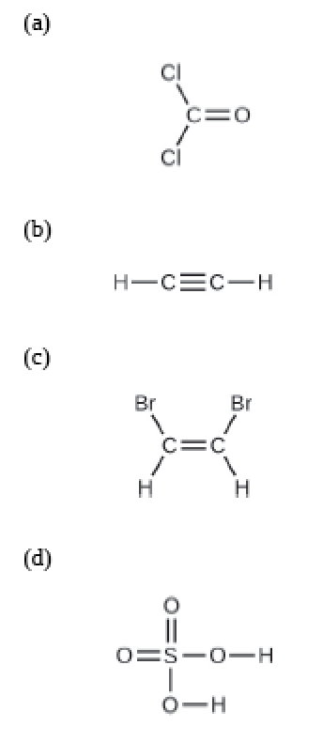
(a) 98.90 g/mol
(b) 26.04 g/mol
(c) 185.84 g/mol
(d) 98.04 g/mol

3. Which contains the greatest number of moles of oxygen atoms: 1 mol of ethanol (C2H5OH), 1 mol of formic acid (HCO2H), or 1 mol of water (H2O)? Explain why.

4. Calculate the molar mass of each of the following compounds:
(a) hydrogen fluoride, HF
(b) ammonia, NH3
(c) nitric acid, H(NO3)
(d) silver sulfate, Ag2(SO4)
(e) boric acid, B(OH)3
(a) 20.00 g/mol
(b) 17.04 g/mol
(c) 62.99 g/mol
(d) 311.76 g/mol
(e) 61.81 g/mol

5. Determine the number of moles of compound and the number of moles of each type of atom in each of the following:
(a) 25.0 g of propylene, C3H6
(b) 3.06 E-3 g of the amino acid glycine, C2H5NO2
(a) 0.594 mol C3H6; 1.78 mol C; 3.56 mol H
(b) 4.08 E-5 mol glycine; 8.15 E-5 mol C; 2.04 E-4 mol H; 4.08 E-5 mol N; 8.15 E-5 mol O

6. Determine the mass of each of the following:
(a) 0.0146 mol KOH
(b) 10.2 mol ethane, C2H6
(c) 1.6 E-3 mol Na2(SO4)
(a) 0.819 g
(b) 306 g
(c) 0.23 g

7. The approximate minimum daily dietary requirement of the amino acid leucine, C6H13NO2, is 1.1 g. What is this requirement in moles?
8.4 E-3 mol

8. A 55-kg woman has 7.5 × 10⁻³ mol of hemoglobin (molar mass = 64,456 g/mol) in her blood. How many hemoglobin molecules is this? What is this quantity in grams?
4.5 E 21 molecules and 483.4 g

9. The Cullinan diamond was the largest natural diamond ever found (January 25, 1905). It weighed 3104 carats (1 carat = 200 mg). How many carbon atoms were present in the stone?
3.112 E25 atoms C

10. A tube of toothpaste contains 0.76 g of sodium monofluorophosphate (Na2PO3F) in 100 mL.
(a) What mass of fluorine atoms in mg was present?
(b) How many fluorine atoms were present?
(a) 0.10 g F
(b) 3.2 E21 atoms F

3.2: Determining empirical and molecular formulas
11. Calculate the following to four significant figures:
(a) the percent composition of ammonia, NH3
(b) the percent composition of photographic fixer solution (“hypo”), Na2S2O3
(a) N = 82.2%; H = 17.8%
(b) Na = 29.1%; S = 40.6%[ O = 30.3%

12. Determine the percent water in CuSO4∙5H2O to three significant figures.
36.1%

13. Determine the empirical formulas for compounds with the following percent compositions:
(a) 43.6% phosphorus and 56.4% oxygen
(b) 28.7% K, 1.5% H, 22.8% P, and 47.0% O
(a) P2O5
(b) KH2PO4

14. A compound of carbon and hydrogen contains 92.3% C and has a molar mass of 78.1 g/mol. What is its molecular formula?
C6H6

3.3: Molarity
15. Explain what changes and what stays the same when 1.00 L of a solution of NaCl is diluted to 1.80 L.

16. Determine the molarity for each of the following solutions:
(a) 0.444 mol of CoCl2 in 0.654 L of solution
(b) 98.0 g of phosphoric acid, H3(PO4), in 1.00 L of solution
(c) 0.2074 g of calcium hydroxide, Ca(OH)2, in 40.00 mL of solution
(a) 0.679 M
(b) 1.00 M
(c) 0.06999 M

17. Consider this question: What is the mass of the solute in 0.500 L of 0.30 M glucose, C6H12O6, used for intravenous injection?
(a) Outline the steps necessary to answer the question.
(b) Answer the question.
(b) 27 g

18. Calculate the number of moles and the mass of the solute in each of these following solutions:
(a) 2.00 L of 18.5 M H2(SO4), concentrated sulfuric acid
(b) 100.0 mL of 3.8 × 10⁻⁵ M Na(CN), the minimum lethal concentration of sodium cyanide in blood serum
(a) 37.0 mol; 3.63 E3 g
(b) 3.8 E-6 mol; 1.862 E-4 g

19. Consider this question: What is the molarity of HCl if 35.23 mL of a solution of HCl contain 0.3366 g of HCl?
(a) Outline the steps necessary to answer the question.
(b) Answer the question.
(b) 0.2621 M

20. Calculate the molarity of each of the following solutions:
(a) 0.195 g of cholesterol, C27H46O, in 0.100 L of serum, the average concentration of cholesterol in human serum
(b) 4.25 g of NH3 in 0.500 L of solution, the concentration of NH3 in household ammonia
(a) 5.04 E-3 M
(b) 0.499 M

21. What volume of a 1.00-M Fe(NO3)3 solution can be diluted to prepare 1.00 L of a solution with a concentration of 0.250 M?
0.250 L

22. What is the concentration of the NaCl solution that results when 0.150 L of a 0.556-M solution is allowed to evaporate until the volume is reduced to 0.105 L?
0.794 M

23. What is the molarity of the diluted solution when each of the following solutions is diluted to the given final volume?
(a) 1.00 L of a 0.250-M solution of Fe(NO3)3 is diluted to a final volume of 2.00 L
(b) 0.5000 L of a 0.1222-M solution of C3H7OH is diluted to a final volume of 1.250 L
(a) 0.125 M
(b) 0.04888 M

3.4: Other units for solution concentrations
This section is optional. While there are no required problems, you’ll find optional problems in the Module 3 practice problem set.

