# The scientific method, experimental and computational methods

**Reminder about the scientific method**

The scientific method (Figure 1) is a set of steps scientists take to determine how the world works. The method begins with observation of an interesting **phenomenon** or happening. After looking for patters in these observations, scientists formulate a **hypothesis**, a tentative and educated guess about the how or why the phenomenon occurs. A good hypothesis must be testable by **experimentation**. If repeated and independent experiments, preferably performed using a variety of techniques, supply lots of data (information) that supports the hypothesis then the hypothesis becomes a theory. A **theory** is a hypothesis that is supported by a large quantity of data that many scientists agree upon. If the data does not support the hypothesis then the scientist must form another hypothesis and repeat the process. The scientific method is **iterative**: it is repeated until success is achieved. This is why science requires patience!



**Figure 1: Diagram of the scientific method**

It’s important to note that while it’s easy to disprove a hypothesis it’s not actually possible to prove a hypothesis to be absolutely true. For example, for centuries the European establishment believed that swans were white. Every swan that had ever been seen in and around Europe was white. However, when Europeans emigrated to Australia, they found that Australian swans were black. We can never access all data, so we say that theories are established, but not proven.

**The critical difference between data & results**

**Data** are observations you make by eye while in the lab. Data include visual observations and readings taken from instruments. All numbers that you record directly, without doing math, are data. In a data table, trials can be recorded in adjacent columns: trial 1, trial 2, etc.,. Each piece of data can be recorded in its own row. To create a complete data table, simple read through your protocol and create one row label for each piece of data, observations included, that you are told to record. Include the units in that row label: mass (g).

**Results**are numbers calculated from data; the result of any type of mathematical operation. To create a results table, read through the calculations section and create a row label corresponding to each value you need to calculate: volume dispensed (mL). Don’t forget to include means and standard deviations where they are required.

Data and results should be **recorded and reported separately** (Figure 2). The easiest way to do this is to create one (or more) table for data collection and one (or more) results table in your lab notebook. I like to place data and results tables on opposing pages of the notebook, data to the left and calculations on the right; look at the data, punch numbers into your calculator, and record the result on the opposing page. Simple and efficient! See page 11 of this manual for more on how to use your lab notebook to best effect.



**Figure 2: Data and results tables**

**Making measurements and recording data**

A scientist’s work and results are only as good as her data and the quality of data is determined by the quality of her instruments and how well she uses them. Most data have two essential components: **numbers, or values**; and the **unit of measurement**. The International System of Units (**SI units, aka metric system**) are used in laboratory sciences. **Table I** shows the SI units used in introductory chemistry labs. The metric system is based upon "factors of ten". Metric prefixes represent factors or multiples of ten. **Table II** lists some of the most commonly used metric prefixes.

**Table I: Common units of measurement in chemistry**

|  |  |  |  |
| --- | --- | --- | --- |
| Quantity | Metric Unit | Symbol | Instrument(s) |
| Energy | Joule | J | Calorimeter |
| Length | Meter | m | Meterstick |
| Mass | Gram | g | Balance (analytical) |
| Time | Second | s | Stopwatch/ clock |
| Temperature | Degree Celsius | C | Thermometer |
| Volume | Liter | L | Pipet, graduated cylinder |

**Table II: Examples of Common Metric Prefixes**

|  |  |  |  |  |
| --- | --- | --- | --- | --- |
| Prefix | Symbol | Decimal  multiplier | Exponent multiplier | Example |
| kilo- | k | 1000 | 103 | 2.2 kj = 2.2 x 103 J = 2200 J |
| centi- | c | 0.01 | 12-2 | 1.5 cm = 1.5 x 10-2 m = 0.015 m |
| milli- | m | 0.001 | 10-3 | 3.6 mg = 3.6 x 10-3 g = 0.0036 g |
| micro- | u | 0.0000001 | 10-6 | 2.7 ul = 2.7 x 10-6 L = 0.0000027 L |
| nano- | n | 0.000000001 | 10-9 | 8.3 ns = 8.3-9 s = 0.0000000083 s |

**Using Instruments and collecting data**

The markings (or “**graduations**”) of an instrument determine the quality of the data we can collect using that instrument. For example, have a look at the ruler shown in Figure 3. The ruler is divided in to major divisions (centimeters) and minor divisions (millimeters). Each of these markings is a graduation. The smallest graduation, called the **least count**, is 0.1 cm. What happens if a measurement falls in between these divisions? It is possible to estimate distances between the smaller millimeter divisions, but with **uncertainty**. Looking at the ruler, the arrow is pointing to a measurement between 6.8 and 6.9 centimeters. I would estimate the value at 6.84 cm. The first two digits (6.8) are more certain than the last (the 4) that is called the **digit of uncertainty** and is an estimate that may differ depending on who makes it. My estimate should be recorded and reported as 6.84 + 0.05 cm. This tells the reader that I estimated the last digit and that my estimate could be 0.05 cm low or 0.05 cm high. The **uncertainty**, the +, is recorded as half of the value of the instrument’s least count. In this case, the uncertainty as half of a tenth of a cm, 0.05 cm.

**Figure 3: Calibration or graduation of a ruler**

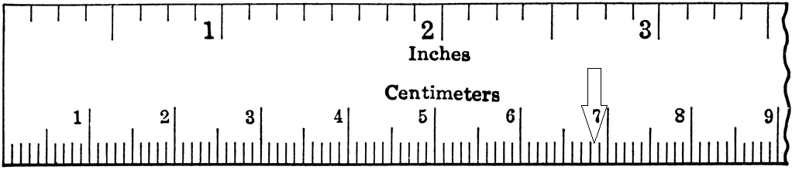

Each instrument in our lab has a specific number of graduations. **Table III** gives some examples and shows how data from these instruments should be reported.

**Table III: Examples of instruments**

|  |  |  |  |
| --- | --- | --- | --- |
| Instrument | units | least count | example |
| Analytical balance | mass in grams | 4 | 4.124 + 0.01 g |
| 100-mL graduated cylinder | volume in mL | 1 | 50.2 + 0.5 mL |
| 10-mL graduated cylinder | volume in mL | 0.1 | 5.67 + 0.05 mL |
| 50-mL burette | volume in mL | 0.1 | 21.56 + 0.05 mL |

Our balances are digital, so the uncertainty is shown as + the least count. Balances can be **tared** to subtract the mass of weigh paper or glassware used to contain samples. Hit the “zero” button to tare the balance with a container on the pan. Be sure that your balance is set to express mass in grams (g) rather than other units.

**Using the right glassware**A variety of glassware can be used to measure the volumes of liquids. **Beakers** and **Erlenmeyer flasks** *cannot* be used to measure volumes accurately. Their calibration marks are very crude and notoriously inaccurate. **Graduated cylinders** can be used to measure volumes with some accuracy and can be read one digit beyond their calibrations. **Pipettes** are generally more accurate than cylinders because volumes contained in pipettes are more easily controlled and calibrations are finer. Pipettes come in graduated or volumetric forms. Graduated pipettes can be used to remove and dispense any volume, while volumetric pipettes are designed for a single fixed volume like 5.0 mL. The volume of liquid in any of these instruments is measured by comparing the liquid’s **meniscus** (or upward curving surface) with calibration marks (**Figure 4**). If the bottom of the meniscus lines up EXACTLY with a calibration mark one-tenth of an mL above 10, the volume is read as 10.10 + 0.05 with an uncertainty of half of the instrument’s least count. This tells the reader that you were least certain about the last digit (hundredths of an mL) because you were estimating a reading between calibrations. If the meniscus had fallen between two of the tenths calibrations you’d estimate the volume, perhaps 10.13 + 0.05, if you’d thought the meniscus fell one-third of the way between 10.1 and 10.2. Placing a white or dark piece of paper (or object) behind the glass instrument may clarify the position of the meniscus and the calibration marks. Describing the uncertainty of data by including the + value is critical.

10.2 mL

10.0

10.1

Figure 4: Measure at the meniscus

**Describing the precision & accuracy of sets of data & results**We know that measurements taken in a lab by human beings are never exact because people don’t read always instruments precisely and because instruments have limited accuracy.

**Precision** is a description of how close multiple measurements of a single parameter are to one another. When repeated measurements of one parameter are extremely close to one another with very little deviation, they have a high degree of precision. When values show a large degree of variance and are not closely grouped, they have a low degree of precision. Precision reflects a scientist’s patience, technique and experience. As you gain experience during this semester, the precision of your data should improve. You are responsible for the precision of your data.

**Accuracy** tells us how close experimentally determined values are to known reference values. Accuracy is affected by systematic errors that may result from equipment or from laboratory technique.

The graph shown in **Figure 5** illustrates the concepts of precision and accuracy. Four groups were asked to measure the density of water five times, and the results are plotted on the graph. The results calculated by the group one are close to one another and are also close in value to the known density of water (1.00 g/mL) and therefore have both good precision and good accuracy. Group two has an average density that is close to the actual density and thus has good accuracy, but their precision is poor because their results are not grouped tightly together (likely due to a random error). Group three’s results that are all close together so their precision is good, but since their average density is lower than it should be, their accuracy is low (likely due to systematic error). Group four has an average density value that is not close to the actual value and their measurements are not close together and therefore both their precision and accuracy are poor. Group four's results suggest both random and systematic errors.

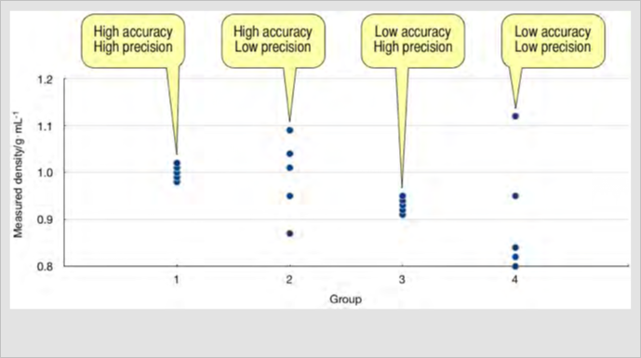

**Figure 5: accuracy vs. precision**

So how does a scientist express precision and accuracy to her reader? Three methods used by engineers and scientists are described here. The first, percent error, compares experimental data or results with a known or accepted reference values as a measure of accuracy.

1. **Percent error** describes how close an experimental measurement is to a known and accepted value. How close did your results come to those accepted?

Percent error = (experimental value – accepted value) (100)  
 accepted value

So, if a student gets 85 out of 100 points on an exam her percent error is 15%.

2. **Percent difference** is used to describe the precision of data or results when there is no accepted value available for comparison. How close are your repeated measurements to one another?

Percent difference = (largest value – smallest value) (100)  
 (average value)

So, if a student measures the mass of three similar objects as 10, 20 & 30 grams, percent error is 100%, and the student’s data certainly can’t be considered precise. If her colleague’s data set is 19, 20 & 21 grams, her percent error will be 10%, so her data is obviously more precise.

3. **Mean and standard deviation** are measures of precision more commonly used by scientists than engineers and are used to describe the average value of a data set and the deviation of each datum from the average.

 

Where: x bar is the mean; the Greek sigma (E-like) means sum; xi is an individual value x; and n is the number of values of x in the data set. In other words, sum all values of x and then divide by the number of x values in the set.

**In Excel**, the mean of the values in cells a1, a2 and a3 is calculated using the formula, “=average(a1:a3).

**In Excel,** the standard deviation (SD) of values in cells a1, a2 and a3 is calculated as, “=stdev(a1:a3)”.

To illustrate how means and standard deviation are used, let’s calculate the mean & SD of the two data sets from the previous example.

Set A: 10, 20, 30

Mean = (10 + 20 + 30)/3 = 20

SD = sq. root (((20 - 10)2 + (20 - 20)2 + (20 – 30)2)/(3-1))) = sq. root (200/2) = 10

Set B: 19, 20, 21

Mean = (19 + 20 + 21)/3 = 20

SD = sq. root (((20 – 19)2 + (20 – 20)2 + (20 – 21)2)/(3-1))) = sq. root (2/2) = 1

So, the examples demonstrate that while sets A & B have identical mean values, set B has less variation among its three values than set B. Scientists & engineers would prefer set B since it is more **precise**.

**Significant digits (aka significant figures)**

No matter how complicated, sophisticated and awesome the instrument, or how well trained and experienced the scientist, there will always be some degree of uncertainty in measurement. When several pieces of data are used to calculate a result, that result is no more precise or accurate than the least precise and accurate data value used in its calculation. **Significant digits** reflect this limitation: a value’s significant digits are limited by the least precise value used in the calculation of the value. This will be important when considering the correct number of significant figures to include in a result. Proper use of significant digits is an important aspect of reporting data and results.

Which digits are significant? Well, all non-zero digits are significant, but only some zeros are significant.

* Leading zeros, those that occur before a non-zero digit, are never significant. So, the number 0.0012 has only two significant digits.
* Trapped zeros, those occurring between non-zero digits, are always significant. So, 2009 has four significant digits.
* Trailing zeros, those that follow non-zero digits are significant only if the number has a decimal point. So, 3500 has only two significant digits, while 3500.0 has five significant digits.

**Calculation** impacts the number of significant digits in a result and the rules are different for **multiplication and division** vs. **addition and subtraction**.

For **multiplication and division**, the result has no more significant digits than the input number with the least significant digits. So, there are only two significant digits when 1.2 is multiplied by 3.456: 1.2 x 3.456 = 4.1472.

But for **addition and subtraction**, only the number of digits following the decimal is limited by the input number with the least number of digits following the decimal. So, there is only one digit after the decimal when 1.2 is added to 3.456: 1.2 + 3.456 = 4.656.

When the number of significant digits in an answer is limited the result must be **rounded**. Most scientist round down below 5 but up at or above 5. The most critical thing about rounding is consistency. Always round using the same rule rather than rounding for the most pleasing answer.

**The scientific method, experimental and computational methods**

**Lab HW set:**

*Type your answers into this Word document, or answer on green engineering graph paper.*

1. What makes for a good hypothesis?
2. Why is it impossible to prove a hypothesis correct?
3. What is the essential difference between data and results?
4. What is another name of the ‘SI system’ of units?
5. How many micrometers (μm) are in one meter?
6. What does the term least count mean?
7. What is the digit of uncertainty in the number 10.0728?
8. What two pieces of glassware should not be used to measure volume accurately?
9. What is a meniscus and how is it used in measuring liquids?
10. If you are trying to shoot a bulls-eye but all three of your shots it the same spot in an outer ring of the target, have you been precise or accurate?
11. Is percent error a measure of precision or accuracy?
12. Is percent difference a measure o precision or accuracy?
13. What does standard deviation say about a set of data?
14. Which type of zero is never significant?
15. What limits the number of significant digits in data and results?