CHE1031 Lecture 6 HW Problem

Problems must be solved, or written out, in their entirety with all work shown on engineering graph paper. You must label each set in the upper left hand corner with your name, the date and the chapter. Problems must be identified by number and all work must be shown with answers boxed. Be sure your handwriting is legible. An example is posted in the ‘course basics’ section of our Moodle page.

6.1: Atomic properties from electron configuration
1. What is true of the electron configuration of all atoms:
- in a single row of the periodic table; and
- in a single column of the periodic table?

6.2: The true nature of the atom?
2. It is possible to convert radiant energy into electrical energy using photovoltaic cells. Assuming equal efficiency of conversion, would infrared or ultraviolet light yield more electrical energy on a per-photon basis?

3. What were the two problems with the planetary model developed by Nagaoka in 1903?

4. What does the term quantum mean?

5. Einstein’s 1905 paper on the photoelectric effect was the first important application of Planck’s quantum hypothesis. Describe Planck’s original hypothesis, and explain how Einstein made use of it in his theory of photoelectric effect.

6.3: Developing a new physics for atoms
6. Young’s double-slit experiment showed that light behaves as a wave. What pattern was produced by light? What would have been expected if light behaved as particles?

7. How did the photoelectric effect show that light behaved as particles?

8. Does Heisenberg’s uncertainty principle affect the objects we deal with in our “macro” everyday lives? Why or why not?

6.4: Bohr’s planetary model
9. How does the Bohr model of the atom explain the fact that each element emits energy only at specific wavelengths after it has been ‘excited’. In other words, why do different gaseous elements produce different colors of light when used as fluorescent or “neon” lights?

10. Is energy emitted or absorbed when these transitions occur in hydrogen?
a. An electron moves from n = 4 to n = 2.
b. An electron moves from an orbit of radius 2.12 Å to an orbit of radius of 8.46 Å.
c. An electron adds to the H⁺¹ ion and ends up in the n = 3 shell.

6.5: Applying quantum mechanics to the atom
11. A certain quantum mechanical system has the energy levels corresponding to principle energy levels 1, 2, 3 and 4.
a. The transition that would require the most energy would involve excitement from principle energy level _________ to principle energy level ___________.
b. The transition that would require the least energy would involve excitement from principle energy level _________ to principle energy level ___________.

12. The contour representation of one of the orbitals of the n = 3 shell is shown below.
a. What type of orbital or subshell is this?
b. How would this diagram change to represent the analogous (corresponding) orbital for the n = 4 shell? Draw the 4p orbital on top of the orbital shown here.
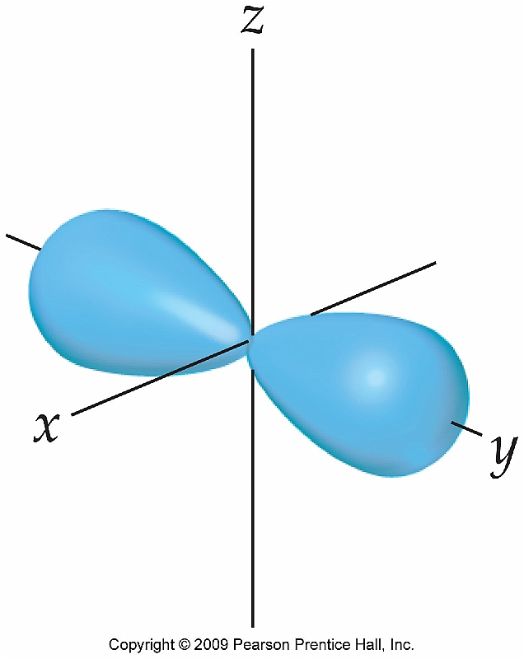

13. According to the Bohr model, an electron in the ground state of a hydrogen atom orbits the nucleus at a specific radius of 0.53 Å. In the quantum mechanical description of the hydrogen atom, the most probable distance of the electron from the nucleus is 0.53 Å. Why are these two statements different?

14. What are the similarities and differences between the 1s and the 2s orbitals of the hydrogen atom?

15. What can you say about the average distance from the nucleus of an electron in the 2s orbital as compared to the 3s orbital?

16. Look at Figure 6.18 (shown here as well). What is the relationship between the number of nodes in an s orbital and the value of the principle quantum number?
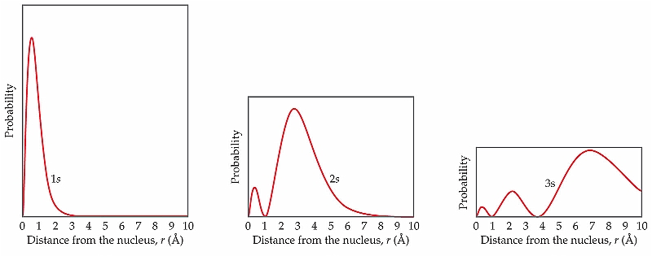

17. Why did the Stern-Gerlach experiment show two different electron ‘spots’?

6.6: Orbital filling & electron configuration
18. Where in the periodic table do you find an element whose valence electrons are 4s²4p¹?

19. Where are the “d-block” elements in the periodic table? What do we call them?

20. The average distance from the nucleus of a 3s electron in the chlorine atom is smaller than the distance for a 3p electron. So which orbital has the higher energy level?

21. State the Pauli exclusion principle in your own words.

22. Write the condensed (or abbreviated) electron configuration for these atoms:
a. Mg
b. Ge
c. Br

