CHE1031 Module 2 Quiz: Atoms, molecules & ions KEY

This is a take-home quiz. You may use any and all resources to answer the questions. However, be aware that this will not be the case for exams and quizzes are a chance to prepare for exams.
- Please show all work for full & partial credit.

2.1: Early ideas in atomic theory
1. Some of Dalton’s five postulates are no longer believed to be completely valid.
(a) State a non-valid postulate.
(b) Explain why it’s not strictly true.
(a) Every element is made of one type of atom with a characteristic mass. All atoms of one element are identical. OR Matter is composed of tiny particles called atoms: smallest unit of an element that can participate in chemical change.
(b) All atoms of a single element aren’t necessarily identical; isotopes have differing numbers of neutrons and thus mass. Atoms aren’t the smallest unit of matter as they are made of subatomic particles.

2.2: Evolution of atomic theory
2. How did Thomson’s cathode ray tube experiment lead him to believe that he’d discovered electrons?
Cathode rays were created without introducing new matter into the cathode ray tube device. The rays could be attracted to the positive end of a magnet and deflected away from the negative side of the magnet and were thus negatively charged.

2.3: Atomic structure and symbolism
3. The following are properties of isotopes of two elements that are essential in our diet. Determine the number of protons, neutrons and electrons in each and name them.
(a) atomic number 26, mass number 58, charge of 2+
(b) atomic number 53, mass number 127, charge of 1−
(a) 26 p+, 32 n (=58 – 26), 24 e- [iron]
(b) 53 p+, 74 n (=127 – 53), 54 e- [iodine]

4. Give the number of protons, electrons, and neutrons in neutral atoms of each of the following isotopes:
(a) ⁷₃Li
(b) ¹²⁵₅₂Te
(a) 3 p+, 4 n (=7 – 3), 3 e-
(b) 52 p+, 73 n (=125 – 52), 52 e-

5. Average atomic masses listed by IUPAC are based on a study of experimental results. Bromine has two isotopes 79Br and 81Br, whose masses (78.9183 and 80.9163 amu) and abundances (50.69% and 49.31%) were determined in earlier experiments.
Calculate the average atomic mass of bromine based on these experiments.
= (0.5069*78.9183) + (0.4931*80.9163) = 79.90 amu

2.4: Chemical formulas
6. Write the molecular and empirical formulas of the following compounds:
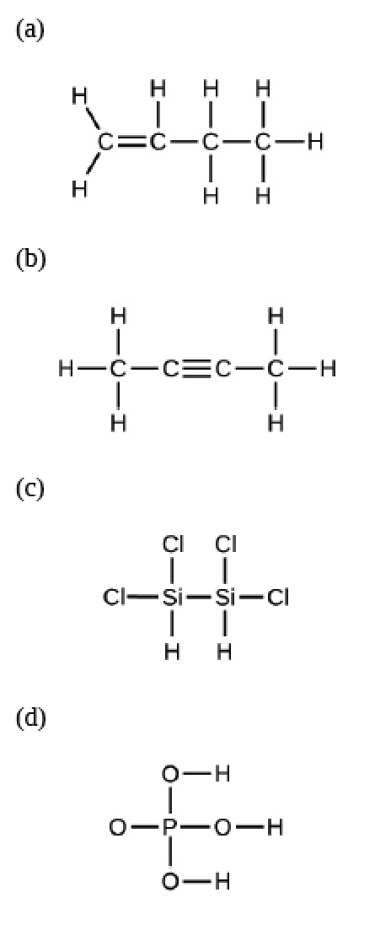
- C4H8 vs. CH2
- C4H6 vs. C2H3
- Si2Cl4H2 vs. SiCl2H
- PO4H3 for both empirical & molecular formulas

2.5: The periodic table
7. Using the periodic table, identify the heaviest member of each of the following groups:
(a) alkali metals
(b) chalcogens
(c) noble gases
(d) alkaline earth metals
(a) Fr
(b) Lv
(c) Og
(d) Ra

2.6: Molecular and ionic compounds
8. For each of the following compounds, state whether it is ionic or covalent, and if it is ionic, write the symbols for the ions involved:
(a) K(ClO4)
(b) H2S
(c) N2Cl4
(d) Co(NO3)2
(a) ionic: K⁺¹, (ClO4)⁻¹
(b) covalent
(c) covalent
(d) ionic: Co⁺², (NO3)⁻¹

9. For each of the following pairs of ions, write the formula of the compound they will form:
(a) K⁺¹, O⁻²
(b) NH4⁺¹ , PO4⁻³
(c) Al⁺³, O⁻²
(a) K2O
(b) (NH4)3(PO4)
(c) Al2O3

2.7: Chemical nomenclature (naming)
10. Name the following compounds:
(a) NaF
(b) Cu2O
(c) H2Se
(d) P4O6
(e) ICl3
(a) sodium fluoride
(b) copper (I) oxide
(c) hydroselenic acid
(d) tetraphosphorus hexoxide
(e) iodine trichloride

11. Write the formulas of the following compounds:
(a) lithium carbonate
(b) sodium perchlorate
(c) ammonium carbonate
(d) sulfuric acid
(e) sodium sulfite
(a) Li2(CO3)
(b) Na(ClO4)
(c) (NH4)2(CO3)
(d) H2(SO4)
(e) Na2(SO3)

