CHE1031 Module 7 Quiz: Chemical bonding

This is a take-home quiz. You may use any and all resources to answer the questions. However, be aware that this will not be the case for exams and quizzes are a chance to prepare for exams.
- Please show all work for full & partial credit.

7.1: Ionic bonding
1. Write the electron configuration for each of the following ions:
(a) I^{–1}
(b) Be⁺²
(c) O⁻²
(d) Li⁺¹
(e) N⁻³

7.2: Covalent bonding
2. Identify the more polar bond in each of the following pairs of bonds:
(a) HF or HCl
(b) SH or OH
(c) PCl or SCl

7.3: Lewis symbols and structures
3. Write the Lewis symbols of the ions in each of the following ionic compounds and the Lewis symbols of the atom from which they are formed:
(a) K2O
(b) Li3N
(c) KF

4. Write Lewis structures for the following:
(a) NH4⁺¹
(b) BF4⁻¹
(c) HCCH
(d) ClCN

7.4: Formal charges and resonance
5. Write resonance forms that describe the distribution of electrons in each of these molecules or ions.
(a) selenium dioxide, OSeO
(b) benzene, C6H6:
(c) the formate ion, HCO⁻¹
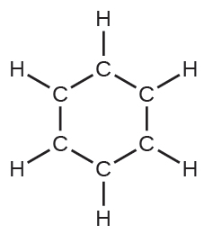
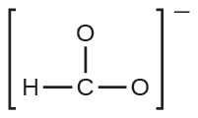

6. Calculate the formal charge of each element in the following compounds and ions:
(a) NO^{–1}
(b) BF4⁻¹

7.5: Strengths of ionic and covalent bonds
7. Using the bond energies in Table 7.2, determine the approximate enthalpy change for each of the following reactions:
(a) Cl2(g) + 3F2(g) ⟶ 2ClF3(g)
(b) H2C=CH2(g) + H2(g) ⟶ H3CCH3(g)
(c) 2C2H6(g) + 7O2(g) ⟶ 4CO2(g) + 6H2O(g)

8. The lattice energy of LiF is 1023 kJ/mol, and the Li–F distance is 201 pm. MgO crystallizes in the same structure as LiF but with a Mg–O distance of 205 pm. Which of the following values most closely approximates the lattice energy of MgO: 256 kJ/mol, 512 kJ/mol, 1023 kJ/mol, 2046 kJ/mol, or 4008 kJ/mol? Explain your choice.

