Chemistry Lab Safety Quiz

- What does SDS stand for? Where can you find SDS in this laboratory?

- Define these terms so that the difference between them is obvious:
- physical hazards
- health hazards

- Identify the following pictograms

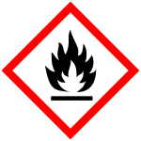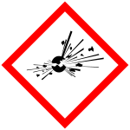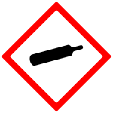

__________________ ________________ ________________

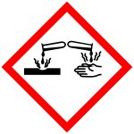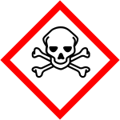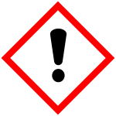

__________________ _________________ ________________

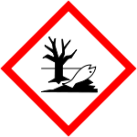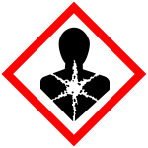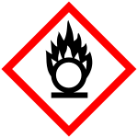

___________________ ___________________ __________________

- What are the differences between minor and major chemical spill?

- What three items of PPE should you consider wearing in this laboratory?

- What are the proper responses to a lab fire?

- What are the two phone numbers to call in case of an emergency on campus?

- How and where do you dispose of broken glass?

- What disciplinary action will result if you fail to follow the safety procedures?

