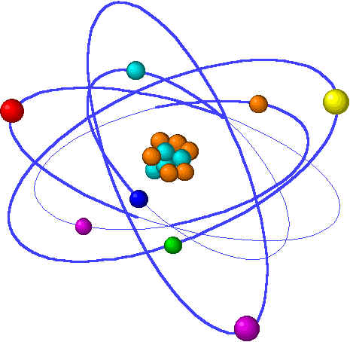
Joan Richmond-Hall, Ph.D.
Green 223 Find my schedule at richmond-hall.weebly.com
jrichmond@vtc.edu Email is the best way to contact me.

CHE-1031 General Chemistry I Fall 2017

Lecture: M,W,F @ 1 pm in CLK110; T,Th @ 2 pm in MOR132
Lab: T 8-11 am & W 3-6 pmin MOR123

Moodle links to my course web site: weebly.com/richmond-hall/che-1031.html

This course is intended for Engineering students and consists of the fundamentals of general and physical chemistry. Laboratory work is designed to give students hands-on experience with principles discussed in the lectures, provide and introduction to laboratory techniques, and introduce some methods of analysis currently used in the industry.

Brown, Lemay, Bursten, Murphy & Woodward (2012) Chemistry the Central Science, 12/e,
Pearson Prentice Hall
ISBN: 978-0-321-69672-4

Week Day Lecture
1 Introduction: science, matter, measurements & conversions
1 Syllabus, science & chemistry 1
2 Matter & measurement 1
3 Sig figs & dimensional analysis 1
Lab Measurements & lab exercise

2 Atoms, isotopes, ions & molecules
4 Atomic structure – historic & modern 2
5 Isotopes & basics of the periodic table 2
6 Molecules & ions 2
Lab Naming chemical compounds

3 Moles, formulae, chemical reactions & stoichiometry
7 Moles, formulae & conversions 3
8 EXAM 1: introduction through chemical naming
9 Stoichiometry & balanced chemical equations 3
Lab Formation of an ionic compound

4 Limiting reactions, aqueous solution chemistry
10 Types of reactions & limiting reactants 3
11 Intro to aqueous solutions & electrolytes 4
12 Concentration of solutions & precipitation rxns 4
Lab Chalk: precipitation & limiting reactions lab

5 Solution chemistry: precipitation & neutralization reactions
13 Complete ionic equations & neutralization rxns 4
14 Dilution & titration 4
15 Redox & oxidation numbers 4
Lab Acid titration lab

6 Dilution, titration & redox
16 Oxidation of metals by acid & salt 4
17 Introduction to electrochemistry & half-equations 5
18 Voltaic cells, fuel cells & corrosion 5
Lab Oxidation of magnesium lab

7 Quick quantum / electronic structure of the atom
19 Waves, quanta & line spectra 6
20 EXAM 2: moles through redox & fuel cells
21 Quantum mechanics & orbitals 6
Lab Aufbau: order of orbital filling and electron configuration WS

8 Basics of chemical bonding
22 Shapes of orbitals & energy levels 6
23 Bond types, Lewis structures & the octet rule 7
24 Ionic vs. covalent bonds, 7
Lab Lewis dot structure WS

9 Bonding, polarity & resonance, introduction to energy
25 Covalent polarity and electronegativity 7
26 Resonance & exceptions to the octet rule 7
27 Energy & thermodynamics 8
Lab Polarity & resonance WS

10 Thermochemistry
28 First law of thermodynamics & systems 8
29 Enthalpy & chemical reactions 8
30 Calorimetry & Hess’s Law 8
Lab Hess’s Law

11 Introduction to kinetics
31 EXAM 3: quantum atom through thermochemistry
32 Reaction rates & factors 10
33 Concentration, temperature & rate equations 10
Lab Atomic mass of Mg via ideal gas law

12 Introduction to kinetics
34 Rate equations & rate laws 10
35 Reaction mechanism & catalysts 10
36 Concept of equilibrium & equilibrium constants 11
Lab Introduction to reaction rates or iodine clock reaction

13 Equilibrium
37 Application of constants 11
38 Le Châtelier’s principle 11
39 Applying kinetics & equilibrium 10, 11
Lab Kinetics of sulfur precipitation lab
Lab Review for final exam

14 Spillover
40
41
42 EXAM 4: Kinetics & equilibrium
Lab Review for final exam

15 CUMULATIVE FINAL EXAM
[NOTE: The instructor reserves the right to change the syllabus at any time.]

Grading policy:
Exams = 10% each (total 40%)
Cumulative final exam = 10%*
Take-home chapter quizzes = 15%
Homework = 15%
Lab reports / exercises = 20%

Grading Notes:
- Homework problems: Homework problems for each chapter will be posted as we begin the chapter. I will assign some problems each day and those problems will be due at the beginning of the next lecture. These problems must be written up on green engineering graph paper. See homework notes posted on the web.
- Labs: Reports or exercises are due one week after lab, at the next lab meeting. Reports are accepted for no more than two days after due; grades drop by 3.3 points per day when late. Lab quizzes are worth 5 points on the reports. See the posted report format.
- Quizzes: All quizzes are given as take-home quizzes. Make-up quizzes are not given, but the lowest quiz of the semester is dropped as long as it’s not a zero.
- Exams: You may bring notes to hourly exams on one side of a 3”x5” notecard. Make-up exams will be given within a reasonable period of time if you notify me of need prior to or on the day of the exam.
- *Final exam: You may replace you individual exam grades with your grade for the corresponding section of the final exam if the latter grade is higher. If the grade for that section of the final is lower, no change of grade will be made. Zeros will not be replaced.

FINAL NOTE:
Students with disabilities, whether physical, psychological, or learning, who believe that they may need accommodations in this class are encouraged to contact the Learning Specialist as soon as possible to ensure that such accommodations are implemented in a timely fashion. Please meet with Robin Goodall to verify your eligibility for accommodation and/or academic assistance related to your disability. She can be reached at the Center for Academic Success, or by email (rgoodall@vtc.edu).

