CHE-2060 Naming Alkanes, -enes & -ynes Worksheet Key 0.33 ea
A. Draw bond-line drawings of the following alkanes:
NOTE: Some names may be incorrect. If so, correct them!
1. 2,2,3,3-tetramethylpentane

2. 2,3-dimethylbutane

3. 3,4,4,5-tetramethylheptane

4. 3,4-dimethyl-4-ethylheptane 4-ethyl-3,4-dimethylheptane

5. 2,4-dimethyl-4-ethylheptane 4-ethyl-2,4-dimethylheptane

6. 2,5-dimethylhexane

7. 2-methyl-3-ethylpentane 3-ethyl-2-methylpentane

8. 2,2,4-trimethylpentane

9. 2-bromo-5-methylheptane
Br

10. 1-ethyl-2-iodocyclopentane
I

11. bromocyclobutane
Br
12. 1,2,2-trimethylcyclopropane
13. 4-ethyl-2-methyl-1-propylcyclohexane 1-ethyl-2-methyl-4-propylcyclohexane

14. 1-chloro-5-methylhexane
Cl

15. ethylcyclohexane
16. 1-methyl-2-propylcyclopentane

B. Due in next week’s lab: Draw these alkanes
1. 3-methylhexane

2. 5-propylnonane

3. 4-ethyl-5-methyloctane

4. 4-methylheptane

5. 4-ethylheptane

6. 1-propylcyclohexane

7. 2-amino-4-bromo-6-chloro-3-methylheptane

8. 1,3-dichloropropane

9. 4-ethyl-3-iodononane

10. 3-chloro-4-(1,1-dimethylethyl)-heptane

11. 4-(1-methylethyl)-octane

12. 2-bromo-2-iodopropane

13. 3-aminomethylhexane

14. 1-ethyl-3-methylcyclopentane

15. 3-ethyl-5-(1-methylethyl)-4-methyloctane

16. 1-butylcyclobutane

17. 1-bromo-3-chloro-4-methylcyclohexane

18. 1-ethyl-2-iodocyclopentane

19. 1,1,1,2,2,2-hexafluoroethane

20. 4-(1-fluoromethyl)-octane

21. 1-(1-methylethyl)-4-(1-methylbutyl)-cyclohexane

22. 2-chlor-4-fluor-3,3-dimethylhexane

23. 3-ethylhexane
B. KEY

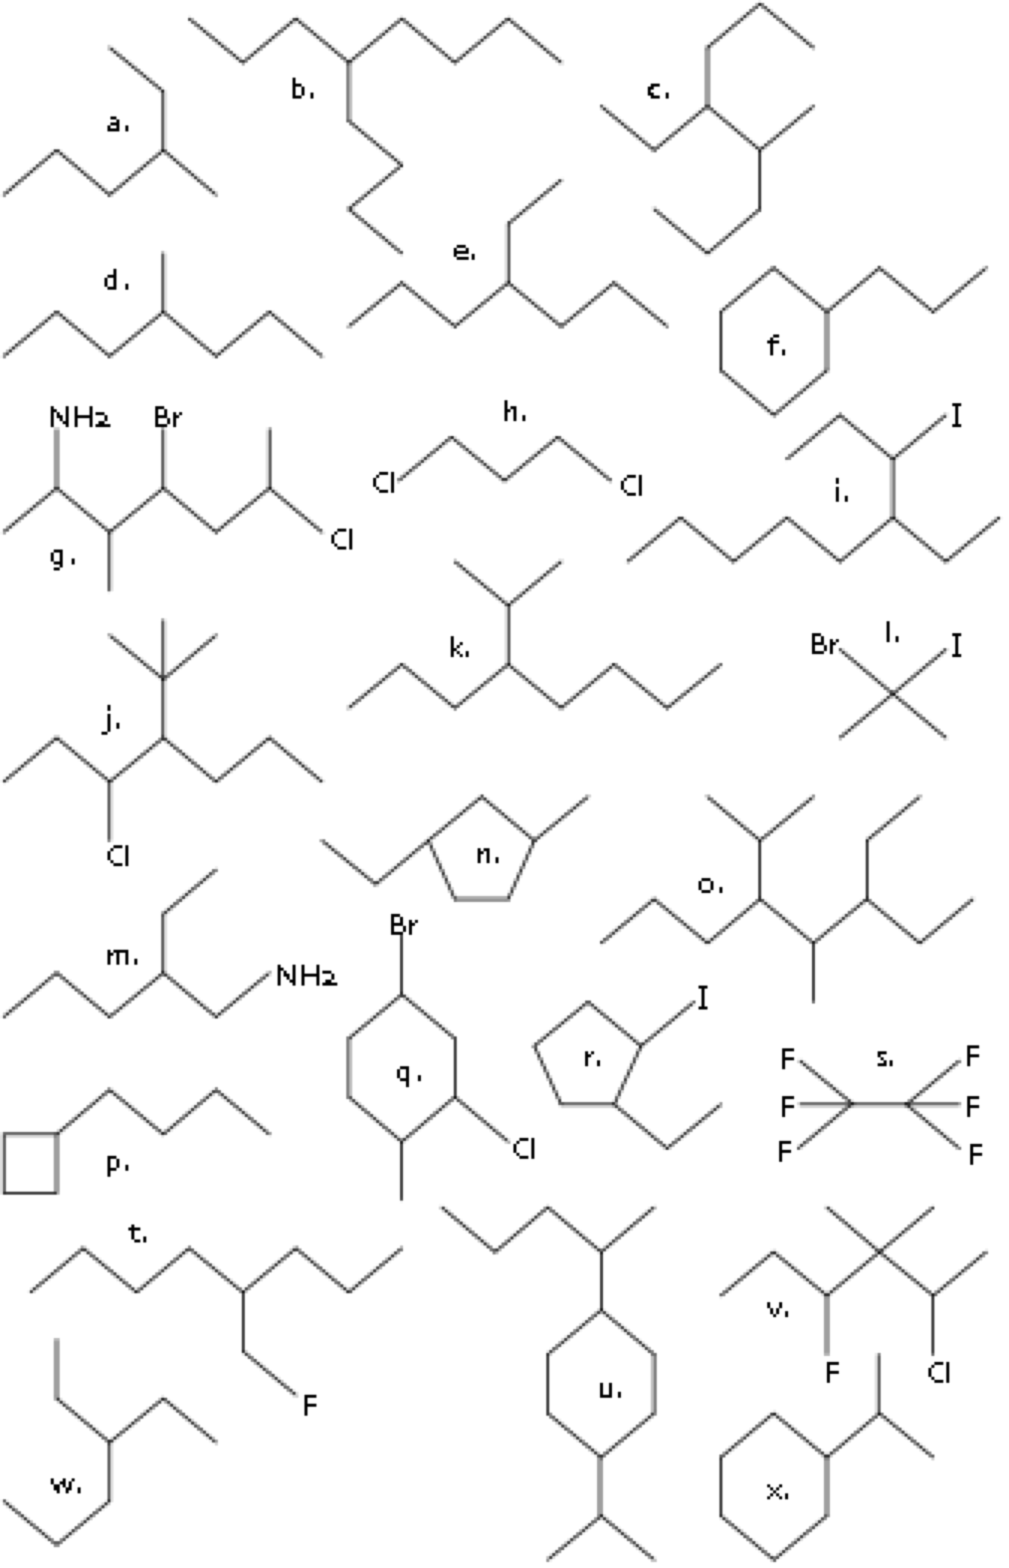

C. Draw these alkenes:
- 1-butene

- 4-methyl-2-pentene

- 3-methyl-3-heptene

- 2-propyl-1-hexene

- 3,6-dimethyl-3-octene

- 5-bromo-4-chloro-1-heptene
Cl
Br
- 2,5-dimethyl-4-octene

- 2-bromo-4-methyl-3-hexene
Br
- 2-bromo-4-ethyl-7-methyl-4-octene
Br
- 3,3-dimethylpentene

- 6-bromo-2,3-dimethyl-2-hexene
Br
- 3,8-dibromo-4-nonene
Br
Br
- 3-methyl-3-hexene

D. Draw these alkynes:
- 3-bromo-2-chloro-4-octyne
Cl
Br
- 1-chloro-5-methyl-3-hexyne
Cl
- 5,6-dimethyl-2-heptyne

- 5-ethyl-3-octyne

- 1-bromo-1-pentyne
Br

