**HW Set 1: Atoms, orbitals & bonding topics - Key**

Problems must be solved, or written out, in their entirety with all work shown on engineering graph paper. You must label each set in the upper left hand corner with your name, the date and the chapter. Problems must be identified by number and all work must be shown with answers boxed. Be sure your handwriting is legible.

**1.1: Very brief history of the development of chemistry**

1. In the lecture materials, I’ve very broadly sketched out four periods of the development of human knowledge:

1. Divine authority
2. Institutional authority that interprets divine authority
3. The pre-enlightenment period that developed alchemy
4. The enlightenment forward

In which of these periods was knowledge ‘received’ and in which was knowledge actively sought after?

In the first two periods, divine authority and institutional authority, man **received** knowledge from the divine, either directly or through a religious / governmental institution.  
During the dawn of the enlightenment, and in the enlightenment itself, man **actively** sought after knowledge through observation, experimentation and logic.

**1.2: What is organic chemistry?**

2. Using the molecules shown in the first chapter and lecture as examples, what are the most common atoms in organic compounds; name five.

C, H, O, N, P, S, F, Cl, Br, I

**1.3: All about orbitals**

3. Draw some diagrams to represent orbitals:

a. Draw one atom with these orbitals: 1s, 2s, 2p (all three ps)

b. Draw a nucleus with these orbitals: 2s, 3s, one p orbital in principle energy level 2 and one p orbital in principle energy level 3.

•

•

4. The s orbital:

a. Draw the shape of an s orbital.

b. Draw the electron density plot of the 1s orbital. The x-axis is distance from the nucleus & y-axis is energy level. ^ energy

|

|

|

|

____________________|____________________

distance from nucleus

c. Do nodes ever appear in s orbitals? If so, draw a picture or diagram to show where.

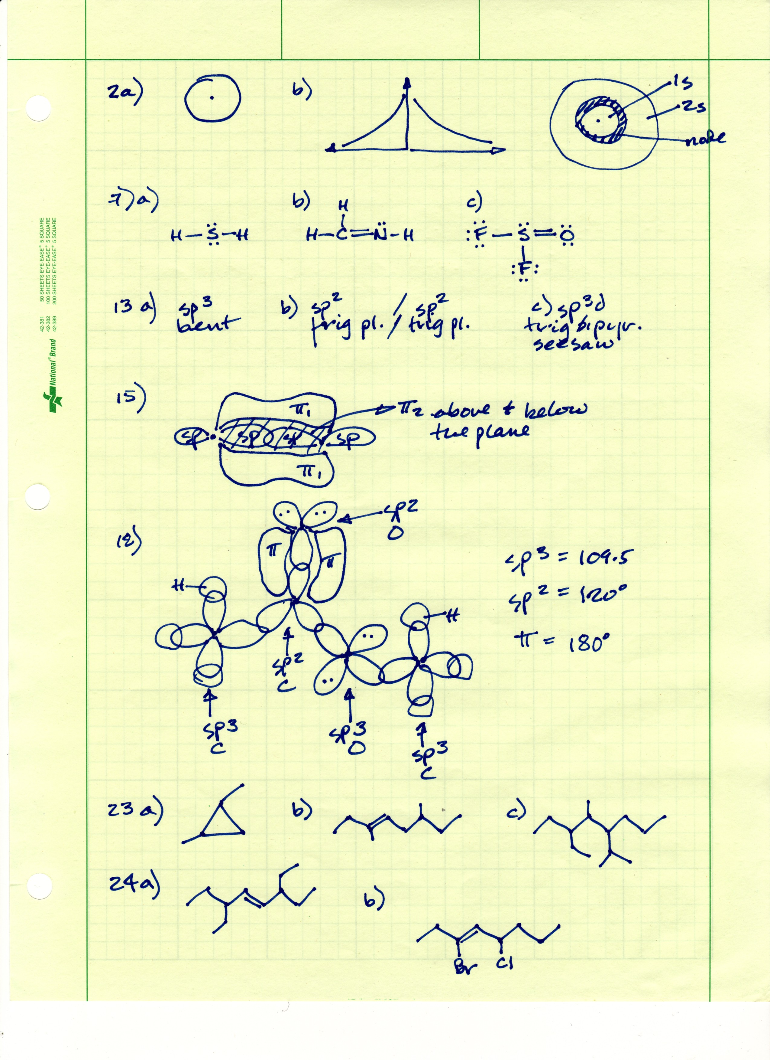

5. How do orbitals change with principle quantum numbers?

a. Draw p orbitals at three different principle quantum numbers (or shells): 1, 2 and 3.

b. Add an arrow showing in which direction energy levels of these orbitals increases.

c. Add an arrow showing in which direction orbital size increases.

d. Add an arrow showing in which direction distance from the nucleus increases.

a. All p orbitals are ‘dumbell’ shaped.

b. Energy level increases 1 🡪 3.

c. Orbital size increases 1 🡪 3.

d. Distance from the nucleus increases 1 🡪 3.

**1.4: How orbitals fill: electron configuration**

6. All electrons in each atom occupy an assigned (or “ground-state”) energy level.

a. Can that energy level be increased? yes

b. If so, how? By an input of energy: light, heat, radiation

c. Is the change permanent or reversible? Reversible – energy is emitted as the electron falls back to ground.

7. Find calcium in the periodic table.

a. Write the electron configurations for the calcium atom. 1s2 2s2 2p6 3s2 3p6 4s2

b. How many valence electrons does calcium have? Two (4s)

c. How many core electrons does calcium have? 18 (all but the ve-)

d. Write the electron configuration of the calcium ion. 1s2 2s2 2p6 3s2 3p6

e. Is calcium likely to be found in an organic molecule? No

8. Describe how you understand the term “spin” used by Pauli.

Spin is an electromagnetic property of electrons; angular momentum. Electrons in an atom seem evenly divided into those with positive and those with negative spin.

9. Write the complete abbreviated electron configurations of the third row elements, Na through Ar.

Na 1s2 2s2 2p6 3s1 [Ne] 3s1

Mg 1s2 2s2 2p6 3s2 [Ne] 3s2

Al 1s2 2s2 2p6 3s2 3p1 [Ne] 3s2 3p1

Si 1s2 2s2 2p6 3s2 3p2 [Ne] 3s2 3p2

P 1s2 2s2 2p6 3s2 3p3 [Ne] 3s2 3p3

S 1s2 2s2 2p6 3s2 3p4 [Ne] 3s2 3p4

Cl 1s2 2s2 2p6 3s2 3p5 [Ne] 3s2 3p5

Ar 1s2 2s2 2p6 3s2 3p6 [Ne] 3s2 3p6

**1.7: Basic bonding: valence electrons & molecular orbitals**

10. Draw the Lewis dot structures of these atoms and their ions.

Atom Ion

Ca 2 dots no dots, +2 charge

N 5 dots 8 dots, -3 charge

P 5 dots 8 dots, -3 charge

Mg 2 dots no dots, +2 charge

C 4 dots 4 dots, no charge NO ION!

O 6 dots 8 dots, -2 charge

11. Methane is formed by the covalent bonding of one carbon and four hydrogen atoms.

a. How many molecular orbitals are formed? Eight

b. How many of those are molecular bonding orbitals? Four

c. How many of those are molecular anti-bonding orbitals? Four

d. Which have higher energy levels, bonding or anti-bonding? Anti-bonding

12. How can a spring be used to represent how bond energies change as the distance between two nuclei travels from too close, through optimal bond length, and then past that bond length?

When the spring is at rest (normal length, untouched) it represents the optimal bonding length and optimal bonding energy (lowest energy point) of a chemical bond.  
Pull on either end of the spring and make it longer. This represents the input of energy required to pull two atoms apart and break their bond.  
Push the ends of the spring in to compress it, shortening its length. This represent the input of energy required to push two atoms together closer than there are at their optimal boding distance.

**1.6: Lewis dot structures of molecules**

13. Draw the Lewis dot structures of the molecules listed below and show all valence electrons (all necessary dots).

a. H2S

b. CH2NH

c. SOF2



14. Draw the Lewis dot structure of hydroxylamine, H3NO, and calculate the formal charge of each atom.

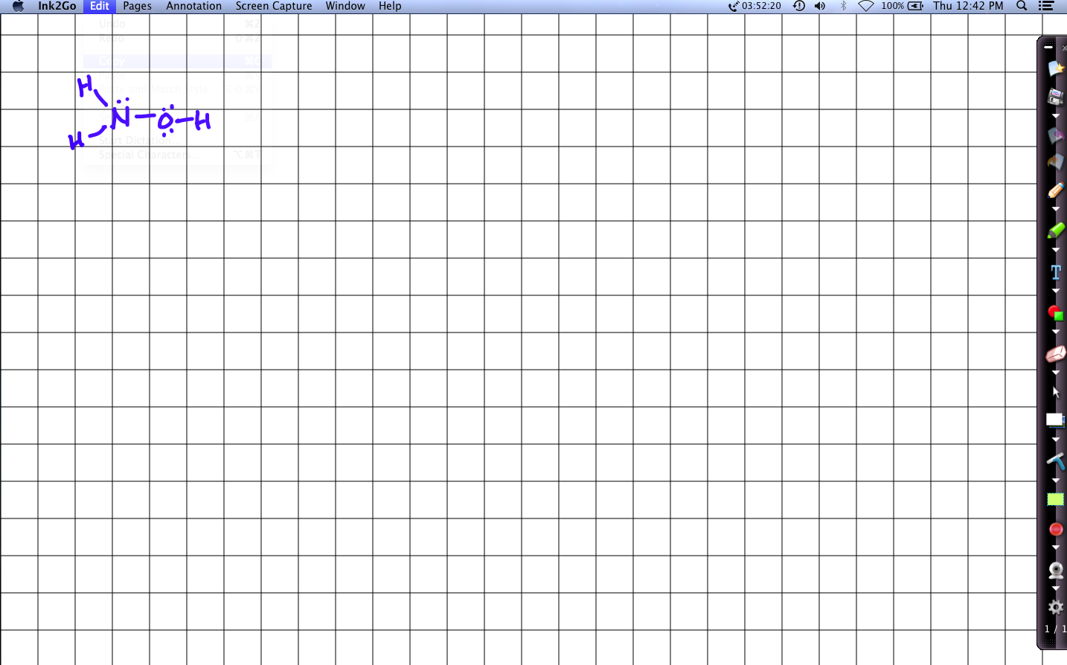 No formal charges

15. Complete these Lewis dot structures by adding π bonds and free electron pairs as needed. None of the molecules have formal charges. Don't add any atoms!

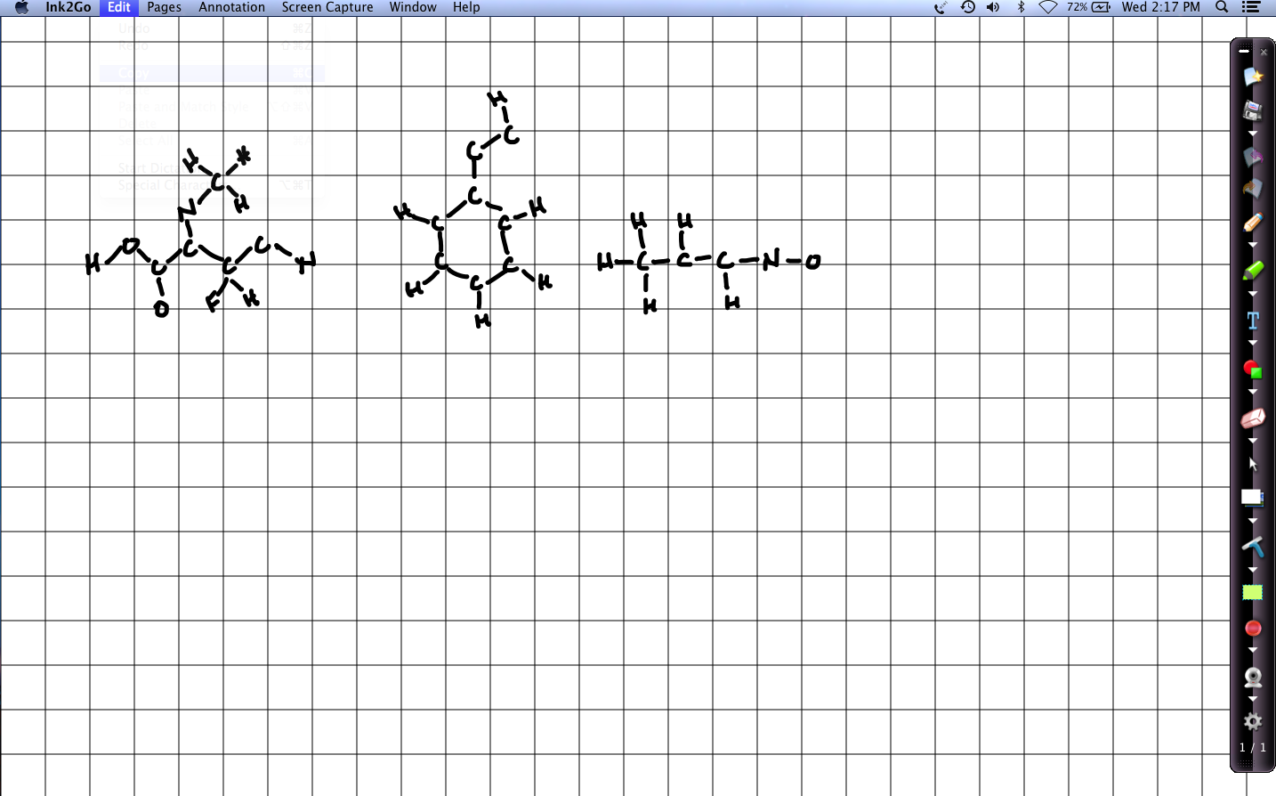

16. Draw Lewis dot structures for each of these molecules:

1. CH5N (There is a bond between C and N.) 14 ve-
2. CH3NO2 (There is a bond between C and N, but not between C and O.) 24 ve-
3. CH2O 12 ve-
4. CH2Cl2 20 ve-
5. BrCN 14 ve-

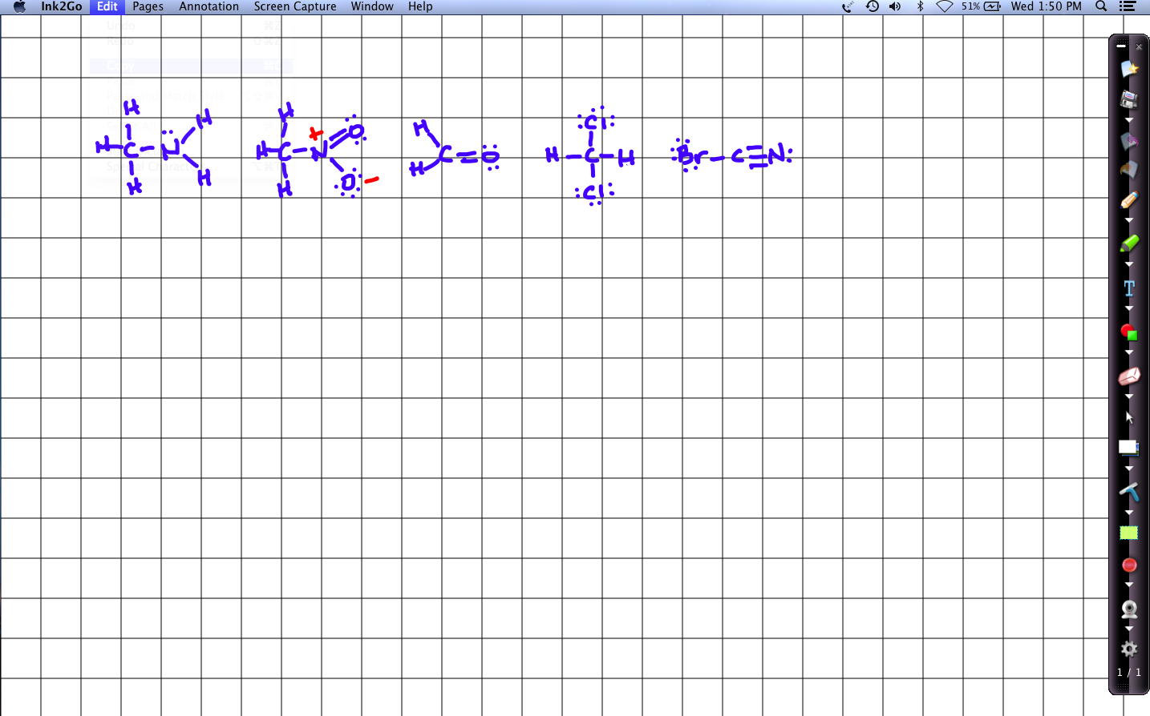

**1.7: Electronegativity & bond polarity**

17. These two bonds have polarities of opposite direction. Show the direction of each and explain.

ICl 🡪 toward Cl because its EN is higher

FCl 🡨 towards F because its EN is higher

18. For each of these molecules:

1. draw the Lewis structure showing all valence electrons;
2. draw a polarity arrow to show direction of polarity; and
3. classify the molecule as nonpolar covalent, polar covalent or ionic.

HBr

H2O

LiI

BrCl

NH3

KF

*Answers attached at the end of this document.*

19. Working with the Lewis dot structure shown here,

a. Add free electron pairs to complete the structure; and

b. Calculate formal charge for each atom in the structure.

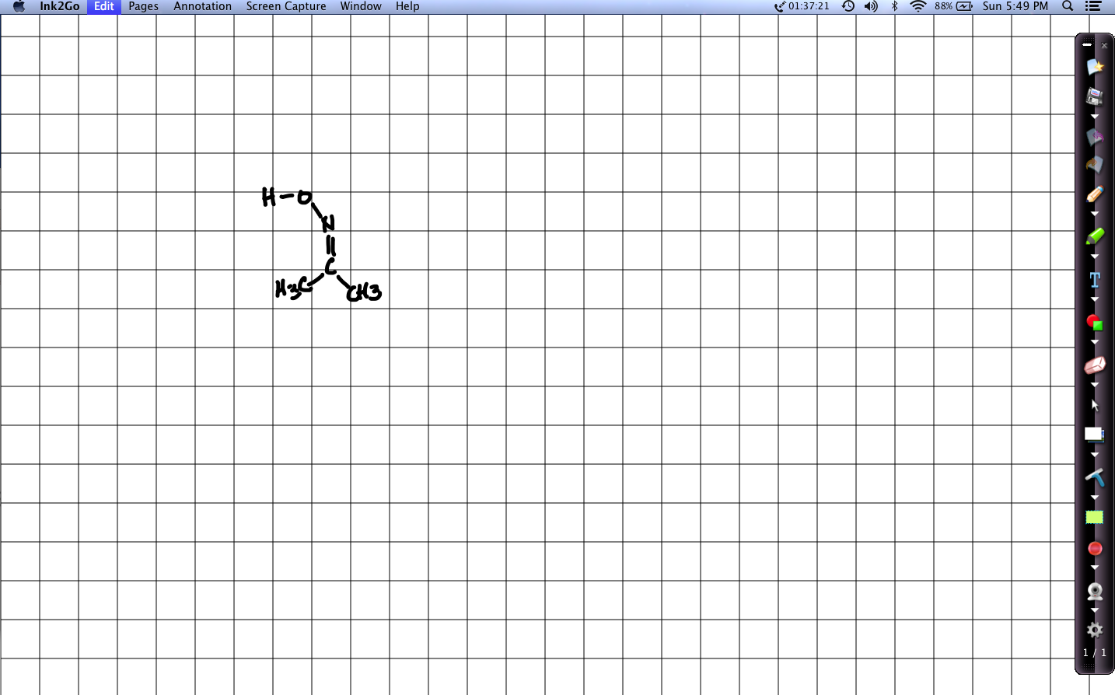

1. Add two free electron pairs to the oxygen atom & one pair to the N.
2. All H = 0   
   N = 0  
   O = 0  
   All C = 0

**1.8: Resonance: a critical concept**

20. Nitromethane, CH3NO2, is a molecule with resonance.

a. Draw the two Lewis dot resonance structures of this uncharged molecule.

b. Calculate the formal charges on all atoms of one resonance structure.

c. Draw the resonance hybrid.

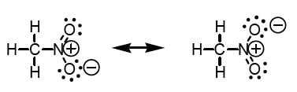

21. Draw all resonance structures ***and*** the resonance hybrid of the carbonate ion, CO3-2.

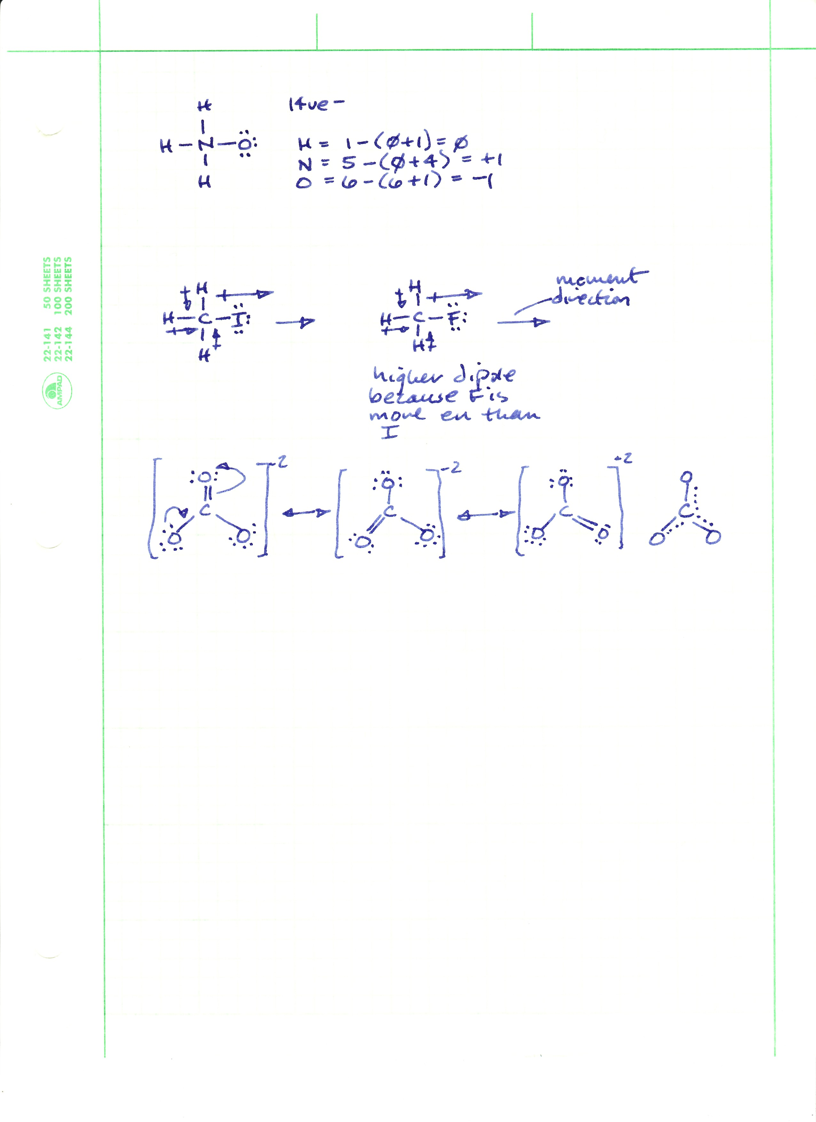

22. Add arrows to the first resonance structure to create the second resonance structure.



23. This enamine is a resonance structure.

a. Draw the second resonance structure by moving the π bond and free electron pair.

b. Add arrows to move π bonds and free electron pairs to convert the first structure to the second and vice versa.

c. Which resonance structure is more stable; the major contributor?

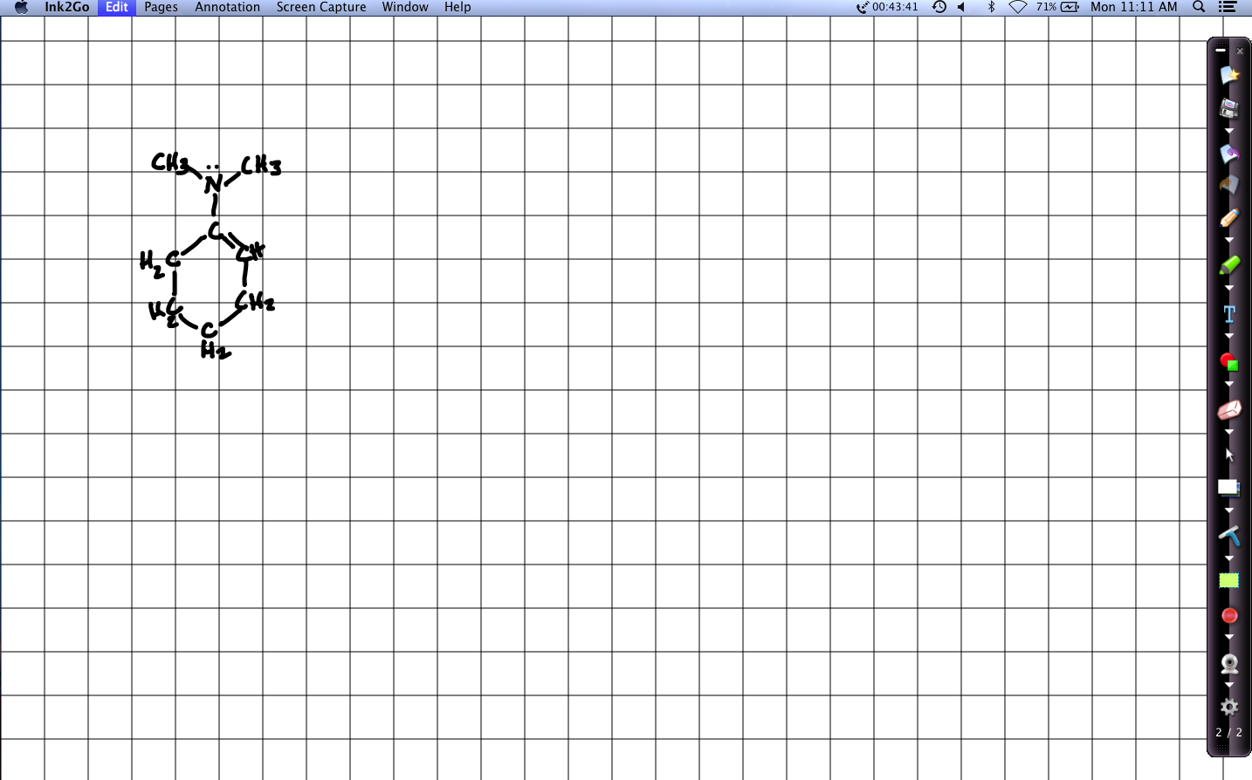 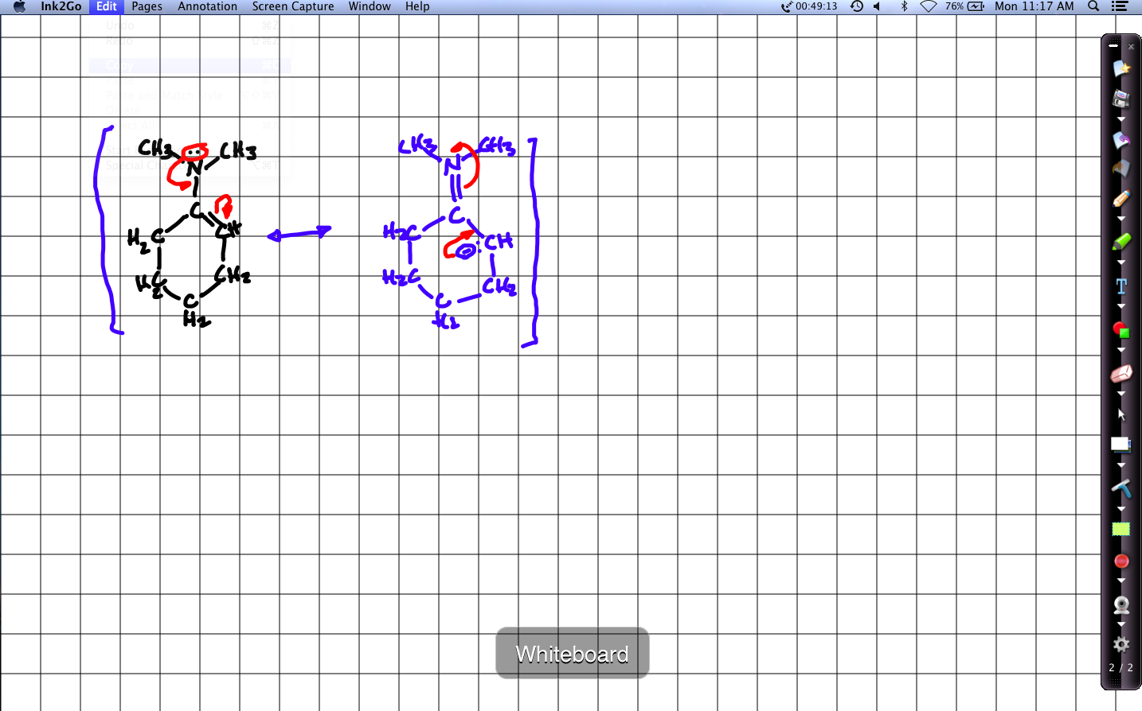

**1.9: Orbital hybridization: key to carbon’s “flexibility”: sp3, sp2 & sp**

24. Draw slot-dot diagrams to show the hybridization of the valence electrons of N in ammonia.

1s22s22p3 🡪 four sp3 orbitals containing 3 single e- and one pair  
The singles pair with the e- of three Hs, and the pair is a “lone pair”

25. Norethidrone is used in oral contraceptives. On the structure shown here, locate an example of each of these features:

* A nonpolar covalent bond CH2 – CH2
* A highly polar covalent bond O – H
* An sp hybridized carbon Either triple-bonded carbon
* An sp2 hybridized atom All single bonded ring carbons
* An sp3 hybridized atom The methyl carbon (CH3)
* A bond between atoms of different hybridization Methyl to ring carbons

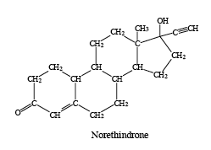

26. Allene has the structure CH2 = C = CH2.

1. What is the hybridization of each carbon? CH2 is sp2 & central C is sp hybridized.
2. What orbitals are involved in each bond? H – C is s to sp2 / C – C is sp2 to sp
3. What is the molecule’s shape? Planar with linear carbons & trigonal hydrogens

The CH2 (methylene) carbons are sp2, as they make three sigma bonds and one pi bond. The central carbon makes two sigma bonds and two pi bonds and is sp hybridized.

Methylenes use two sp2 orbitals to sigma bond to hydrogens, and one to sigma bond to centra carbon’s sp orbital. Their unhybridized p orbital is used to pi bond to the central carbons p orbitals.

Linear or slightly bent shape.

**1.10: Free electron pairs & radicals**

27. Think about atoms as they are presented in the periodic table. Some are radicals and some are not. Look at row two and classify each of its elements as a radical or not.

Atoms in odd columns are radicals because they have one upaired electron. This is especially true of elements in column 1A. Elements in even columns have only paired electrons.

**1.11 VSEPR: classifying molecular geometry & orbital hybridization**

28. Create a diagram that shows a molecule of two carbon atoms joined by a triple bond and bound to two hydrogen atoms (acetylene or ethyne). Show atoms, all orbitals (hybridized and not hybridized), and all bond angles.



29. Using the VESPR table and Lewis dot structures for these three molecules, determine the:

i. central atom hybridization; and

ii. molecular geometry

a. H2S

b. CH2NH (C & N are both central)

c. SOF2

