CHE2060 Lecture 3 HW Key

Problems must be solved, or written out, in their entirety with all work shown on engineering graph paper. You must label each set in the upper left hand corner with your name, the date and the chapter. Problems must be identified by number and all work must be shown with answers boxed. Be sure your handwriting is legible. An example is posted in the ‘course basics’ section of our Moodle page.

3.1: Alkane conformation
1. Draw the two eclipsed conformations of butane using Newman projections looking down the axis between carbons 2 and 3.

2. Draw all possible staggered and eclipsed conformations of 1-bromo-2-chloroethane:
  - Using Newman projections
  - Using dash-wedge line-bond drawings

3. Sketch an energy diagram for the C1-C2 bond of 1-iodopropane.
a. Identify the conformation at each energy minima & maxima.
b. How does this diagram differ from that of propane?

3.3: Ring stereoisomers: cis vs. trans
4. Draw conformational line-bond structures for all possible dichlorocyclohexanes, including cis-trans isomers.

5. Which is more stable, cis- or trans-1,4-di-tert-butylcyclohexane? Draw conformational diagrams of each.

6. Name both members of these simple cis-trans pairs:
a. cis-1,3-dibromocyclohexane and trans-1,3-dibromocyclohexane
b. trans-1-bromo-2-methylcyclonexane and cis-1-bromo-2-methylcyclohexane

7. Create line-bond drawings of these substituted cycloalkanes. All are stereoisomers.
a. cis-1-chloro-4-methylcyclohexane
b. cis-1-ethyl-2-methylcyclobutane
c. trans-1,2-dimethylcyclopropane
d. trans-1-ethyl-3-iodocyclopentane
e. trans-1,3-dimethylcyclohexane
f. cis-1,2-dibromocyclobutane

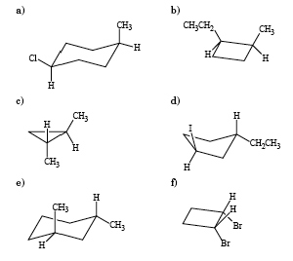

8. Create configurational line-bond drawings for both conformations of these molecules and indicate which is more stable.
  - cis-1-iodo-4-methylcyclohexane
  - cis-1-tert-butyl-4-methylcyclohexane
  - cis-1,3,5-trimethylcyclohexane

9. Draw a line-bond diagram of the more stable form of each:
- trans-1-fluoro-3-methylcyclohexane
- cis-1-iodo-3-methylcyclohexane
- cis-1-tert-butyl-4-methylcyclohexane
- cis-1,3,5-trimethylcyclohexane

10. Describe each of the pairs shown below as structural, conformational or constitutional isomers.
b. conformational
c. conformational
d. structural
e. identical

