CHE2060 Lecture 4 Take-Home Quiz

Note: While I’m not requiring you to do so, writing line-bond drawings of each molecule would be great practice and will help you answer the questions.

4.1: Physical properties of organic molecules
1. Why does adding heat (or other forms of energy) transform solids to liquids and liquids to gases? What’s going on at the molecular level?

4.2: Types of intermolecular interactions
- Which types of intermolecular interaction can each of these molecules participate in as pure solutions?
Van der Waals dipolar H-bonding
  - (CH3CH2)2NH  
  - (CH3CH2)3N  
  - CH3CH2CH2OH  
  - (CH3CH2CH2)2O  
  - CH3(CH2)3CH3  

- Draw the hydrogen bonding that happens between two molecules of ethanol.

- Draw a diagram of five molecules of methanol that are linked, intermolecularly, by H-bonds.

- Rank these molecules in order of increasing boiling point. (DIAGRAM THESE)
  - 2,2-dimethylpropane
  - hexane
  - 2,3-dimethylbutane
  - pentanol
  - 2-methylbutan-2-ol

- Which has a higher boiling point? Why?
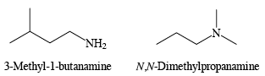

- 1,6-hexanediol has a boiling point of 250°C. 2,5-hexanediol has a boiling point that differs by 33°C. Is its boiling point higher or lower?
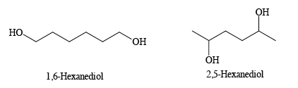

4.3: Solubility
- Which molecule is more soluble in water? Why? Explain in terms of intermolecular bonding.
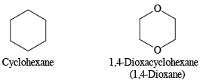

- Which molecule is more soluble in pentane? Why?
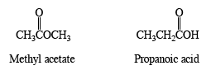

- Circle the member of each pair that is most soluble in water.
  - CH3CH2OCH2CH3 or CH3(CH2)3CH3
  - CH3CH2NHCH3 or CH3(CH2)2CH3
  - CH3CH2OH or CH3(CH2)3OH

4.4: Surfactants
- Draw a large mixed micelle of fatty acids and surfactants with a core of nearly non-polar cholesterol. You can confine detailed structure to a wedge of the spherical structure, but you need to show the basic structure of fatty acids, surfactants and cholesterol and show how they are oriented within the larger structure.

