CHE2060 Lecture 4 Take-Home Quiz Key

Note: While I’m not requiring you to do so, writing line-bond drawings of each molecule would be great practice and will help you answer the questions.

4.1: Physical properties of organic molecules
1. Why does adding heat (or other forms of energy) transform solids to liquids and liquids to gases? What’s going on at the molecular level?
At the molecular level, adding heat makes the molecules move. As molecules move relative to one another, intermolecular bonds break, changing physical state.

4.2: Types of intermolecular interactions
- Which types of intermolecular interaction can each of these molecules participate in as pure solutions?
Van der Waals dipolar H-bonding
  - (CH3CH2)2NH ☑ ☑ ☑
  - (CH3CH2)3N ☑ ☑
  - CH3CH2CH2OH ☑ ☑ ☑
  - (CH3CH2CH2)2O ☑ ☑
  - CH3(CH2)3CH3 ☑

- Draw the hydrogen bonding that happens between two molecules of ethanol.

- Draw a diagram of five molecules of methanol that are linked, intermolecularly, by H-bonds.
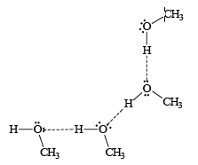

- Rank these molecules in order of increasing boiling point. (DIAGRAM THESE)
  - 2,2-dimethylpropane lowest = 1
  - hexane 3
  - 2,3-dimethylbutane 2
  - pentanol highest = 5
  - 2-methylbutan-2-ol 4

- Which has a higher boiling point? Why?
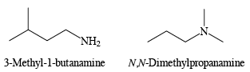
Both molecules have similar MWs, but 3-methyl-1-butanamine has a higher boiling point. While both molecules experience van der Waals attractions, only 3-methyl-1-butanamine is able to H-bond intermolecularly. This added intermolecular bonding increases the amount of energy needed to move molecules apart into a gaseous phase.

- 1,6-hexanediol has a boiling point of 250°C. 2,5-hexanediol has a boiling point that differs by 33°C. Is its boiling point higher or lower?
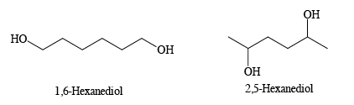
The boiling point of 2,5-hexanediol is 33°C lower than that of 1,6-hexanediol because it is more highly branched and experiences lower van der Waals attractions. Both molecules have equivalent H-bonding capacities.

4.3: Solubility
- Which molecule is more soluble in water? Why? Explain in terms of intermolecular bonding.

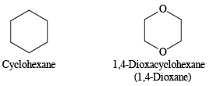
Cyclohexane is completely non-polar and is therefore not soluble in water. 1,4-dioxane is a polar molecule (C – O) bonds and is therefore more soluble in water.

- Which molecule is more soluble in pentane? Why?
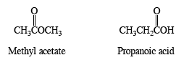

Methyl acetate, the less polar molecule, is more soluble in pentane. Methyl acetate is an ester, while propanoic acid is a carboxylic acid. Methyl acetate interacts with itself using van der Waals force and dipolar bonds. But propanoic acid uses these forms of bonding AND hydrogen bonding.

- Circle the member of each pair that is most soluble in water.
  - CH3CH2OCH2CH3 or CH3(CH2)3CH3
^^^^^^^^^^^^^^
  - CH3CH2NHCH3 or CH3(CH2)2CH3
^^^^^^^^^^^^
  - CH3CH2OH or CH3(CH2)3OH
^^^^^^^^^

4.4: Surfactants
- Draw a large mixed micelle of fatty acids and surfactants with a core of nearly non-polar cholesterol. You can confine detailed structure to a wedge of the spherical structure, but you need to show the basic structure of fatty acids, surfactants and cholesterol and show how they are oriented within the larger structure.
Fatty acids are found on the surface with their charged carboxylic acid groups (hydrophilic) pointing outwards and associating with water and their non-polar and hydrophobic tail groups pointing into the center of the sphere. The orientation of the surfactants is the same. Cholesterol is packed into the center of the sphere. Cholesterol’s single hydroxyl group doesn’t associate with the hydrophobic non-polar tails of the fatty acids and surfactants.

