CHE-2060 Lecture 6 HW

Problems must be solved, or written out, in their entirety with all work shown on engineering graph paper. You must label each set in the upper left hand corner with your name, the date and the chapter. Problems must be identified by number and all work must be shown with answers boxed. Be sure your handwriting is legible.

6.1: Symmetry & asymmetry
1. Label each as chiral or achiral.
a. teacup
b. shoe
c. pencil
d. football
e. corkscrew

2. Create line-bond drawings and circle the stereogenic carbons in each molecule.
a. 3-iodohexane
b. 2,3-dibromobutane
c. 3-methylcyclohexane
d. 1-bromo-1-fluoroethane

3. Draw a line-bond drawing to create a chiral molecule with each of these formulas:
a. C4H10O
b. C5H11Cl
c. C4H8(OH)2
d. C6H12

4. Label each pair as identical or as enantiomers.

6.2: Nomenclature of stereocenters
5. Assign C-I-P priorities to these groups.

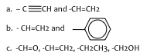

6. Assign C-I-P priorities to these set of groups.
a. –CH3, -CH(CH3)2, -H, -NH2
b. –OH, -F, -CH3, -CH2OH
c. –OCH3, -NHCH3, -CH2NH2, -OH
d. –CH2CH3, -CH2CH2CH3, -C(CH3)3, -CH(CH3)2

7. Determine whether these molecules are R or S.

8. Is this molecule of carvone (the odor of caraway seeds) R or S?

6.3: Properties of asymmetric molecules
9. Ibuprofen is a chiral anti-inflammatory drug. The S-enantiomer is the active form of the drug, and the R-enantiomer has no effect.

a. Label the chiral carbon(s) in the image shown here.
b. Draw it with dash-wedges to show the S-enantiomer.

10. Ketamine is a chiral drug used by veterinarians. The S-form is an anesthetic, but the R-form acts as hallucinogen.

a. Label the chiral carbon.
b. Add a dashed line and a wedge to create the S-enantiomer.
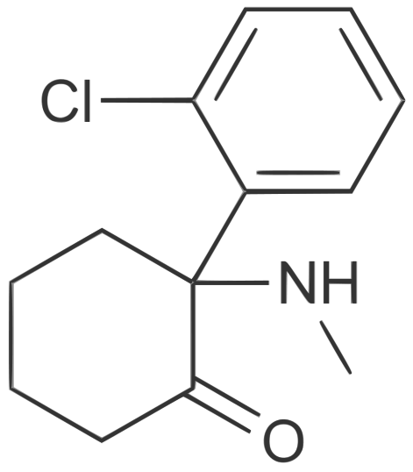

6.4: Optical isomerism
11. A chemist observes that a substance doesn’t rotate plane-polarized light. Can she conclude that the substance is not chiral? Why or why not?

6.5: Fisher projections
12. Draw Fisher diagrams for cis-1,2-dimethylcyclohexane. What types of stereoisomers are possible?

13. Draw Fisher diagrams of (R)-2-bromobutane. Be sure the stereoisomerism is obvious in your drawing.

14. This Fisher diagram shows 2-chlorobutane. Is it the R or S enantiomer?

15. Which Fisher projection (a, b or c) has the same configuration as A AND which (a, b or c) is an enantiomer?

6.6: Molecules with two stereocenters
16. Muscarine is a toxic chemical found in some mushrooms.

a. Is the molecule chiral?
b. How many stereoisomers are possible?

17. Draw a diastereomer of this Fisher projection of glucose.

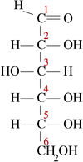

6.7: Resolution of enantiomers
18. The first step in resolving (or separating) stereoisomers is fusing a molecule to each enantiomer. Why does the molecule added (or fused) have to be chiral?

6.8: Stereocenters other than carbon
19. How is it possible for N or P atoms that are only bound to three other atoms to be chiral sterocenters?

