**CHE2060 Lecture 7 Quiz: Reaction mechanism overview Key**

Use any and all resources available to you.

**7.1: Reaction energies & transition states**

1. Sketch a reaction profile (energy curve) for the reaction shown below.

1. Label products
2. Label reactants
3. Label transition state / intermediates
4. Label activation energy



**7.2: Review of acid-base reaction mechanisms**

2. An acid base reaction is started for you below.

1. Label the acid and the base.
2. Label the electrophile (E+) and the nucleophile (Nu:).
3. Draw arrows to show movement of electrons between the two reactants.
4. Predict the product(s), and draw their Lewis dot structures.
5. Predict whether reactants or products predominate. The pKa of acetic acid is 4.76 and the pKa of protonated methyl amine is 10.7.





**7.3: Writing reactions as transformations**

3. Write the previous reaction as a transformation.



**7.4: Substitution reactions**

4. Label the substrates MOST and LEAST likely to react with sodium ethoxide   
 (CH3CH2O-/Na+) by SN2 reaction.

a) CH3 b) CH3 c) CH3CH2CH2CH2Br

| |

CH3CH2CHBr CH3CHCH2Br

least likely (2°) most likely (1°)

5. Stereoinversion:

a. Which organic reaction mechanism causes stereoinversion of the product? SN2

b. Why? Draw an example of this mechanism and be sure to clearly demonstrate the stereoinversion of reactant as it is transformed into product. Choose an appropriate substrate and reactant



**7.5: Addition reactions**

6. Addition mechanism:

H – Br:

..

..

1. What type of addition mechanism occurs? Electrophilic addition
2. Label the Nu: and E+ in each step.
3. Use arrows to move electrons.
4. Show by-products (if they exist).
5. Draw Lewis dot structure of the product(s).
6. Clearly show and label intermediate(s) if they exist.
7. Are new chiral carbons created? If so, label them with asterisks.



7. Explain why or how carbonyl groups are able to act as electrophiles. You may use a diagram, but you MUST also explain the diagram using complete sentences.

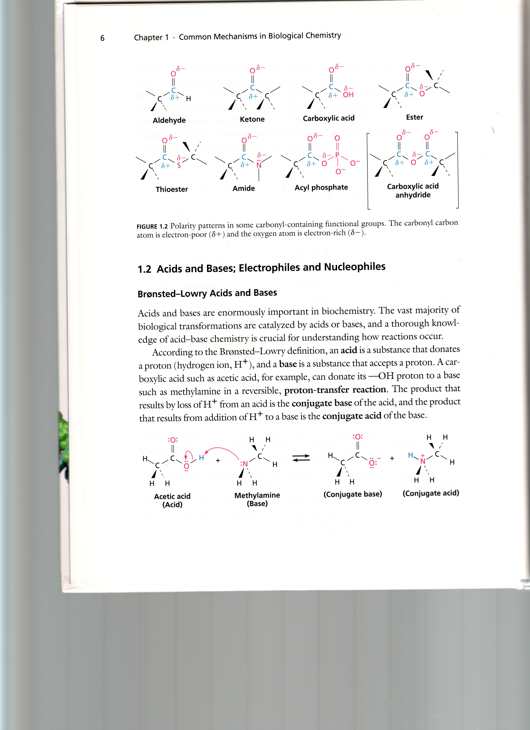Electrons of the carbon atom are pulled toward the double-bonded oxygen atom by its higher electronegativity value (3.5 vs. 2.5). The “pulled” electrons give the oxygen atom a partial (or dipolar) negative charge, δ-, and leave the carbonyl carbon with a δ+ charge. The partial positive charge causes the carbon

to act as an electrophile, E+.

**7.6: Elimination reactions**

8. Elimination:



1. What type of elimination mechanism occurs? E2 is also possible.
2. Label the Nu: and E+ in each step.
3. Use arrows to move electrons.
4. Show by-products (if they exist).
5. Draw Lewis dot structure of the product(s).
6. Clearly show and label intermediate(s) if they exist.
7. Are new chiral carbons created? If so, label them with asterisks.



9. Elimination:



1. What type of elimination mechanism occurs?
2. Label the Nu: and E+ in each step.
3. Use arrows to move electrons.
4. Show by-products (if they exist).
5. Draw Lewis dot structure of the product(s).
6. Clearly show and label intermediate(s) if they exist.
7. Are new chiral carbons created? If so, label them with asterisks. No

