CHE2060 take-home quiz 1: Atoms, orbitals & bonding topics KEY

Please ask if questions are not clear to you or if you wonder whether your answer is adequate. A periodic table and table of electronegativity values is attached.

1.1: Very brief history of the development of chemistry
1. What are the tools that allowed for the development of modern chemistry from alchemy?
logic & experimentation

1.2: What is organic chemistry?
2. Define these terms:
- organic chemistry
- vitalism
(a) the chemistry of living things; carbon-based chemistry
(b) VItalism: only God could create biomolecules.

1.3: All about orbitals
3. Draw the shapes of each of these orbitals:
(a) s
(b) p
(c) d
(a) spherical
(b) dumbbell-shaped, 3 orbitals
(c) propeller-shaped, 5 orbita.s

4. In which of these orbitals does an electron possess the most potential energy?
- 4s
- 5s
- 5p
- 5d
- 4d

5. Which orbitals have both positive and negative “lobes”?
s orbtials
p orbitals
d orbitals

1.4: How orbitals fill: electron configuration
6. State Hund’s Rule.
When electrons fill orbitals of equal energy level, like the three p orbitals, each orbital receives one electron before any receives two.

7. The term “aufbau” is a German word used to describe how electrons fill atomic orbitals by increasing energy level. At what orbital/energy level does electron filling deviate from the order you would expect? How does the actual order of filling differ from the expected order?
Aufbau gets ‘out of order’ following 3p, which is followed by 4s rather than 3d.
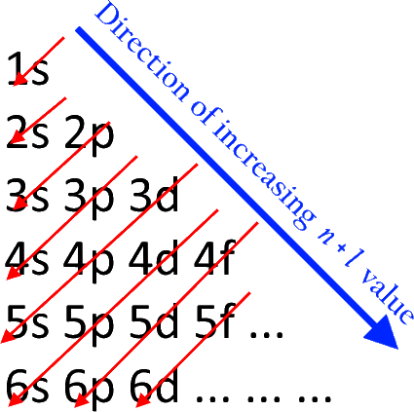

8. Write electron configurations for the elements listed below. Use either the abbreviated system or a box-arrow diagram.
(a) calcium, Ca
(b) nitrogen, N
(a) [Ar] 4s²
(b) [He] 2s²2p³

1.5: Basic bonding: valence electrons & molecular orbitals
9. Two atomic orbitals combine to form:
(a) a bonding molecular orbital
(b) an anti-bonding molecular orbital
(c) new atomic orbitals

- (a) only
- (a) and (b) and (c)
- (c) only
- (a) and (b) only

10. Why are anti-bonding orbitals rarely filled with electrons?
The energy level of anti-boding orbitals is far higher than the energy level of bonding orbitals. In chemistry, the low-energy solution is favored.
1.6: Lewis dot structures of molecules
11. Draw the Lewis structures of isocyanic acid (HNCO) and cyanic acid (HOCN).
- These structures are not resonance structures. Explain.
- When either acid loses a proton, the same ion results. Explain.
The order of atomic connectivity differs when the molecules still have hydrogen. In resonance structures, only electrons can differ.
When hydrogen atoms are removed, the order of connectivity becomes the same (C in the center of both). Location of electrons in the first molecule shifts so that charge sits on the most electronegative atom, oxygen.

12. Complete this Lewis dot structure by adding bonds and electron pairs where needed.

1.7: Electronegativity & bond polarity
13. Rank these bonds in order of increasing polarity.
- C – O
- C – H
- C – N
- C – F
- C – I
(a) |2.5 - 3.5| = 1.0
(b) |2.5 – 2.1| = 0.4
(c) |2.5 – 3.0| = 0.5
(d) |2.5 – 4.0| = 1.5
(e) |2.5 – 2.5| = 0
Increasing polarity: e < b < c < a < d

14. Draw the Lewis dot structures for these two molecules: CH3I and CH3F.
(a) Show polarity arrows.
(b) Which molecule has the larger dipole moment? Why?
(c) Show the direction of the dipole moment.
(a) From C to I or C to F
(b) CH3F has the larger dipolar moment
(c) Dipole moment from C out towards F and beyond

15. Which of these bonds should be longest, weakest, and therefore most reactive?
C – F 135 pm 488 kJ/mol
C – Cl 177 pm 330 kJ/mol
C – Br 194 pm 288 kJ/mol
C – I 214 pm 216 kJ/mol longest & weakest

1.8: Resonance: a critical concept
16. Warfarin, the compound shown here, is marketed as the anticoagulant coumadin, and was the 18th most prescribed drug in 2006. It’s also a potent rat poison.
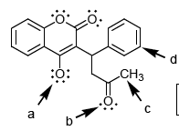

Circle the atom in warfarin whose formal charge that is not zero.
(a) has a charge of -1

17. The structure of proteins depends on the amide functional group that links amino acids to form proteins. The amide group is actually a resonance structure, making for a stable protein backbone.
:O:
C
..
N
- Write both resonance structures.
- Write the resonance hybrid.

18. Which of the two resonance structures shown below makes a greater (the major) contribution to the resonance hybrid? [NB: Formal charges are not shown below!]
major minor
(no formal charges) (formal charges)

1.9: Orbital hybridization: key to carbon’s “flexibility”: sp3, sp2 & sp
19. Explain why the valence shell electrons of carbon must hybridize in order to form methane when bonding with four hydrogen atoms.
In methane, carbon forms four equal bonds with four hydrogen atoms. Each of these bonds has the same length and strength. This suggests that the four electrons of carbon have equal energy levels. In its ground state, 2s2 2p2, the valence electrons of carbon have 2 different energy levels. Thus, hybridization is required.

20. Draw “slot-dot” hybridization orbitals for these sp2 hybridized atoms:
sp2 carbon
sp2 nitrogen
sp2 oxygen

1.10: Free electron pairs & radicals
21. Consider each of these highly reactive carbon species. Calculate the formal charge on each species.
H H H H
| | | |
H – C H – C . H – C : H – C :
| | |
H H H
+1 zero -1 zero

1.11: VSEPR: classifying molecular geometry & orbital hybridization
22. Draw a detailed structure of this molecule, acetaldehyde, showing:
a. all atoms
b. all unhybridized and hybridized orbitals (including those that hold free e- pairs)
c. bond angles
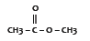

23. Sulfur dioxide has a dipole moment, but carbon dioxide does not, even though C – O bonds are more polar than S – O bonds. Why?
In the dioxide structures, sulfur has a pair of electrons but carbon doesn’t. The free pair is responsible for the dipole moment of SO2.

