**Resonance worksheet lab: learning to push electrons[1]**

It’s critical to understand **resonance**, and to be able to detect its presence in a two-dimensional molecular structure, in order to understand how organic molecules react and behave. Drawings treat electrons as particles that exist in specific locations, but the truth is more subtle. Rather, electrons exist in “clouds” that cluster over specific regions of a molecule’s structure. So, students have to:

1. learn to recognize molecular structures that involve resonance;
2. realize that these 2D drawings are imperfect; and
3. use their mind’s eye to visualize molecules with clouds of “delocalized” electron density that cluster over – or are spread across – the atoms involved in resonance.

Since the vast majority of reactions we’ll cover in this course occur because molecules with areas of low electron density react with molecules with regions of high electron density, you must have a basic understanding of resonance and electron density in order to understand reactions and their mechanisms.

**A. Patterns that indicate resonance**

Pattern recognition is a very useful skill for students of organic chemistry and most other sciences. If you see any of these five patterns when looking at a structure, you know that a molecule possesses resonance.

1. : next to a π

**

*“Next to” means separated by a single bond. Note that a negative charge (shown here in a circle) indicates the presence of a lone pair of electrons, usually shown as :*

**

2. : next to a + charge

*Here both + and - charges are shown in circles.*

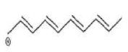3. π next to a + charge



4. A π between two atoms, where one atom is more electronegative

*Oxygen is more electronegative than carbon.*

5. A ring with π all the way around it.

*Most ring examples involved benzene and its derivatives.*

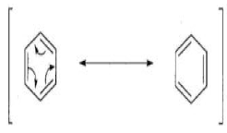

**B. Double-headed arrows move : or π from electronegative areas to electropositive areas.**

* Don’t use arrows to move electrons from positive to negative areas.
* Electrons moved by arrows have to have a destination; don’t send them off into “space”; obey the law of conservation of mass!

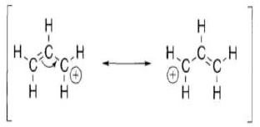

*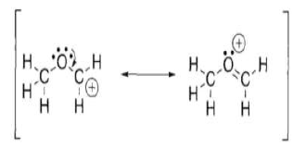Here the arrow moves π electrons toward a positively charged carbon to quench its charge. Note that this move simply switches position of π and +.*

*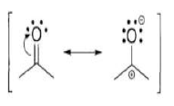Here the arrow moves a : from an electronegative area (the O atom) to a charged carbon to quench its + charge. A π bond is formed as a result, and the + charge moves to the O.*

*Here the arrow moves π electrons that become a : on   
the oxygen atom. Both + and – charges are created.*

**Now you try it:**

1. Draw an arrow on the second resonance structure of each pair to return : or *π* to their original positions.
2. In each example, which resonance structure is the most stable? Why?

**C. The two “commandments” of moving electrons**

These two rules must always be obeyed when moving electrons within resonance structures:

1. Do not break single bonds; and
2. Do not violate the octet rule by giving an atom more electrons that it can handle.

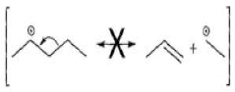

*Here the arrow moves electrons of a single bond and breaks it.*

*Breaking bonds is* ***not allowed****!*

*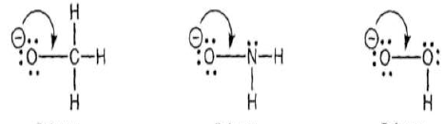Here all arrows create a fifth bond for the central atom.*

***Not allowed!***

**D. So how do you know when and where to move electrons?**

Look for these common patterns. You want to use arrows to create the following moves:

1. Convert : to π
2. Convert π to :
3. Convert π to π *[This is really just moving a π.]*

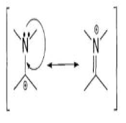

*Example of : to π (and vice versa).*

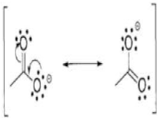

*Example of two coordinated electron movements. Both must occur to avoid violation of the two commandments.*

*Are they simultaneous or sequential?*

***Lab exercises:***

**B. Drawing good arrows to move : or π**

Draw in the arrows need to transform the first resonance structure into the second and vice versa.

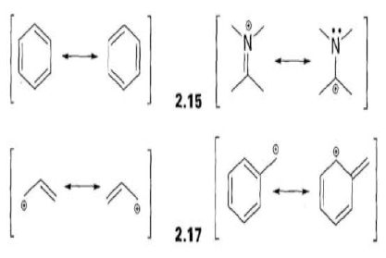

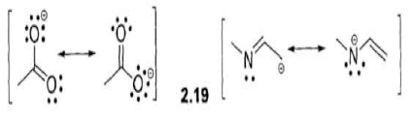



**C. Are these moves allowed by the two commandments?**

For each of the structures below, determine whether movement of electrons by the arrow is “legal”. If it is, show the new structure.

***Legal? New structure:***



**D. Moving electrons can move formal charge:**

Draw the structure created by moving electrons as shown with the arrows. Note that formal charges move as well. Be sure to calculate and show all formal charges.





**E. How many resonance structures are there?**

There can be quite a few and it’s not always easy to see the all of the possibilities.

Try to find all of the possible resonance structures for these two structures.





1. *This worksheet is adapted from Chapter 2 of Kline’s “Organic Chemistry as a Second Language: Translating the Basic Concepts”.*