CHE 2060: Common bonding patterns

Carbon: uncharged bonding patterns
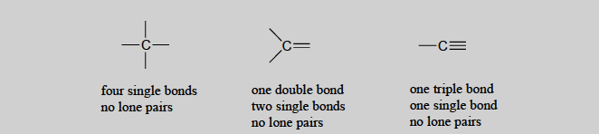

Carbon: charged, and therefore unstable, bonding patterns
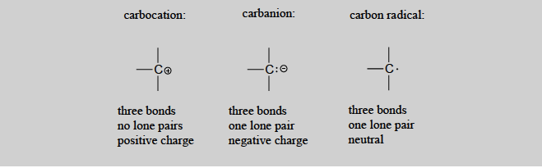

Hydrogen forms a single covalent bond, or becomes a hydrogen cation (no electrons) or a hydride anion (one lone pair.

Oxygen: bonding patterns
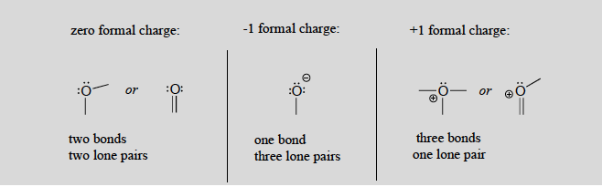

Sulfur generally forms the same bonding patterns as oxygen, but can also be hexavalent and form structures that give the sulfur atom more than an octet.

Nitrogen: typical bonding patterns
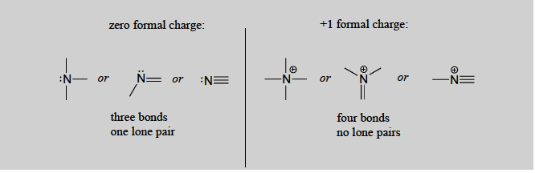
- Nitrogen can also form amide anions, NH2⁻¹, with two lone pairs on the N.

Phosphorus typically forms five bonds without a formal charge.
- Usually P bonds to four oxygen atoms.

Halogens are the elements found in column 7 of the periodic table.
- These atoms are important tools in organic chemistry labs.
- They are less common in nature.
