CHE-2060 VSEPR Molecular Geometry Worksheet Key

This week’s lab will require the ‘Practical VSEPR’ Table, a periodic table, an atomic model set and some patience and teamwork.

Formula | # Bonds | # e- Pairs | Hybrid | Molecular geometry | Angles (°) | Dipole?
BeCl2 | 2 | 0 | sp | Linear | 180 | No
BF3 | 3 | 0 | sp2 | Trigonal planar | 120 | No
SnCl2 | 2 | 1 | sp2 | Bent | 120 | Yes
CH4 | 4 | 0 | sp3 | Tetrahedral | 109.5 | No
NH3 | 3 | 1 | sp3 | Trigonal pyramidal | 109.5 | Yes
H2O | 2 | 2 | sp3 | Bent | 109.5 | Yes
PCl5 | 5 | 0 | sp3d | Trigonal bipyramidal | 120, 90 | No
SF4 | 4 | 1 | sp3d | Saw horse | 120, 90 | Yes
BrF3 | 3 | 2 | sp3d | T-shaped | 90, 180 | Yes
XeF2 | 2 | 3 | sp3d | Linear | 180 | No
SF6 | 6 | 0 | sp3d2 | Octahedral | 90 | No
IF5 | 5 | 1 | sp3d2 | Square based pyramid | 90 | Yes
XeF4 | 4 | 2 | sp3d2 | Square planar | 90 | no

NOTE: Columns 2 & 3 refer to the number of bonding electron pairs & lone electron pairs, respectively, on the molecule’s central atom.

Part A:
For each of the molecules listed in the table above:
- Draw a Lewis bond structure – include all valence electrons;
- Count & record the number of bonding electron pairs (Note: count single, double & triple bonds as one bonding pair.);
- Count & record the number of free electron pairs (lone pairs);
- If possible, record the type of orbital hybridization;
- Use the ‘practical VSEPR table’ to determine molecular geometry & bond angles;
- Determine whether the molecule has an overall molecular dipole.

Part B:
For each ‘bolded’ molecules in the table:
- Build a model;
- Determine whether any geometric isomers are possible;
- Do the models or isomers have a dipole moment;
- Which isomer do you think is preferred by VSEPR?

Part C:
Resonance structures – draw resonance structures for each & determine hybridization of the central atom for the molecules listed below.
- N3⁻¹
- CO3⁻²
- NO3⁻¹
- BF4⁻¹
Part D:
Since lone electron pairs (lp) are larger than bonding electron pairs (bp), interactions between lone pairs are very repulsive. Repulsion: lp-lp > lp-bp > bp-bp.
For each molecule listed here, draw Lewis structures & state how bond angles are probably distorted from the normal or expected bond angles.
- OF2
- SCl2
- PF3

Part A:
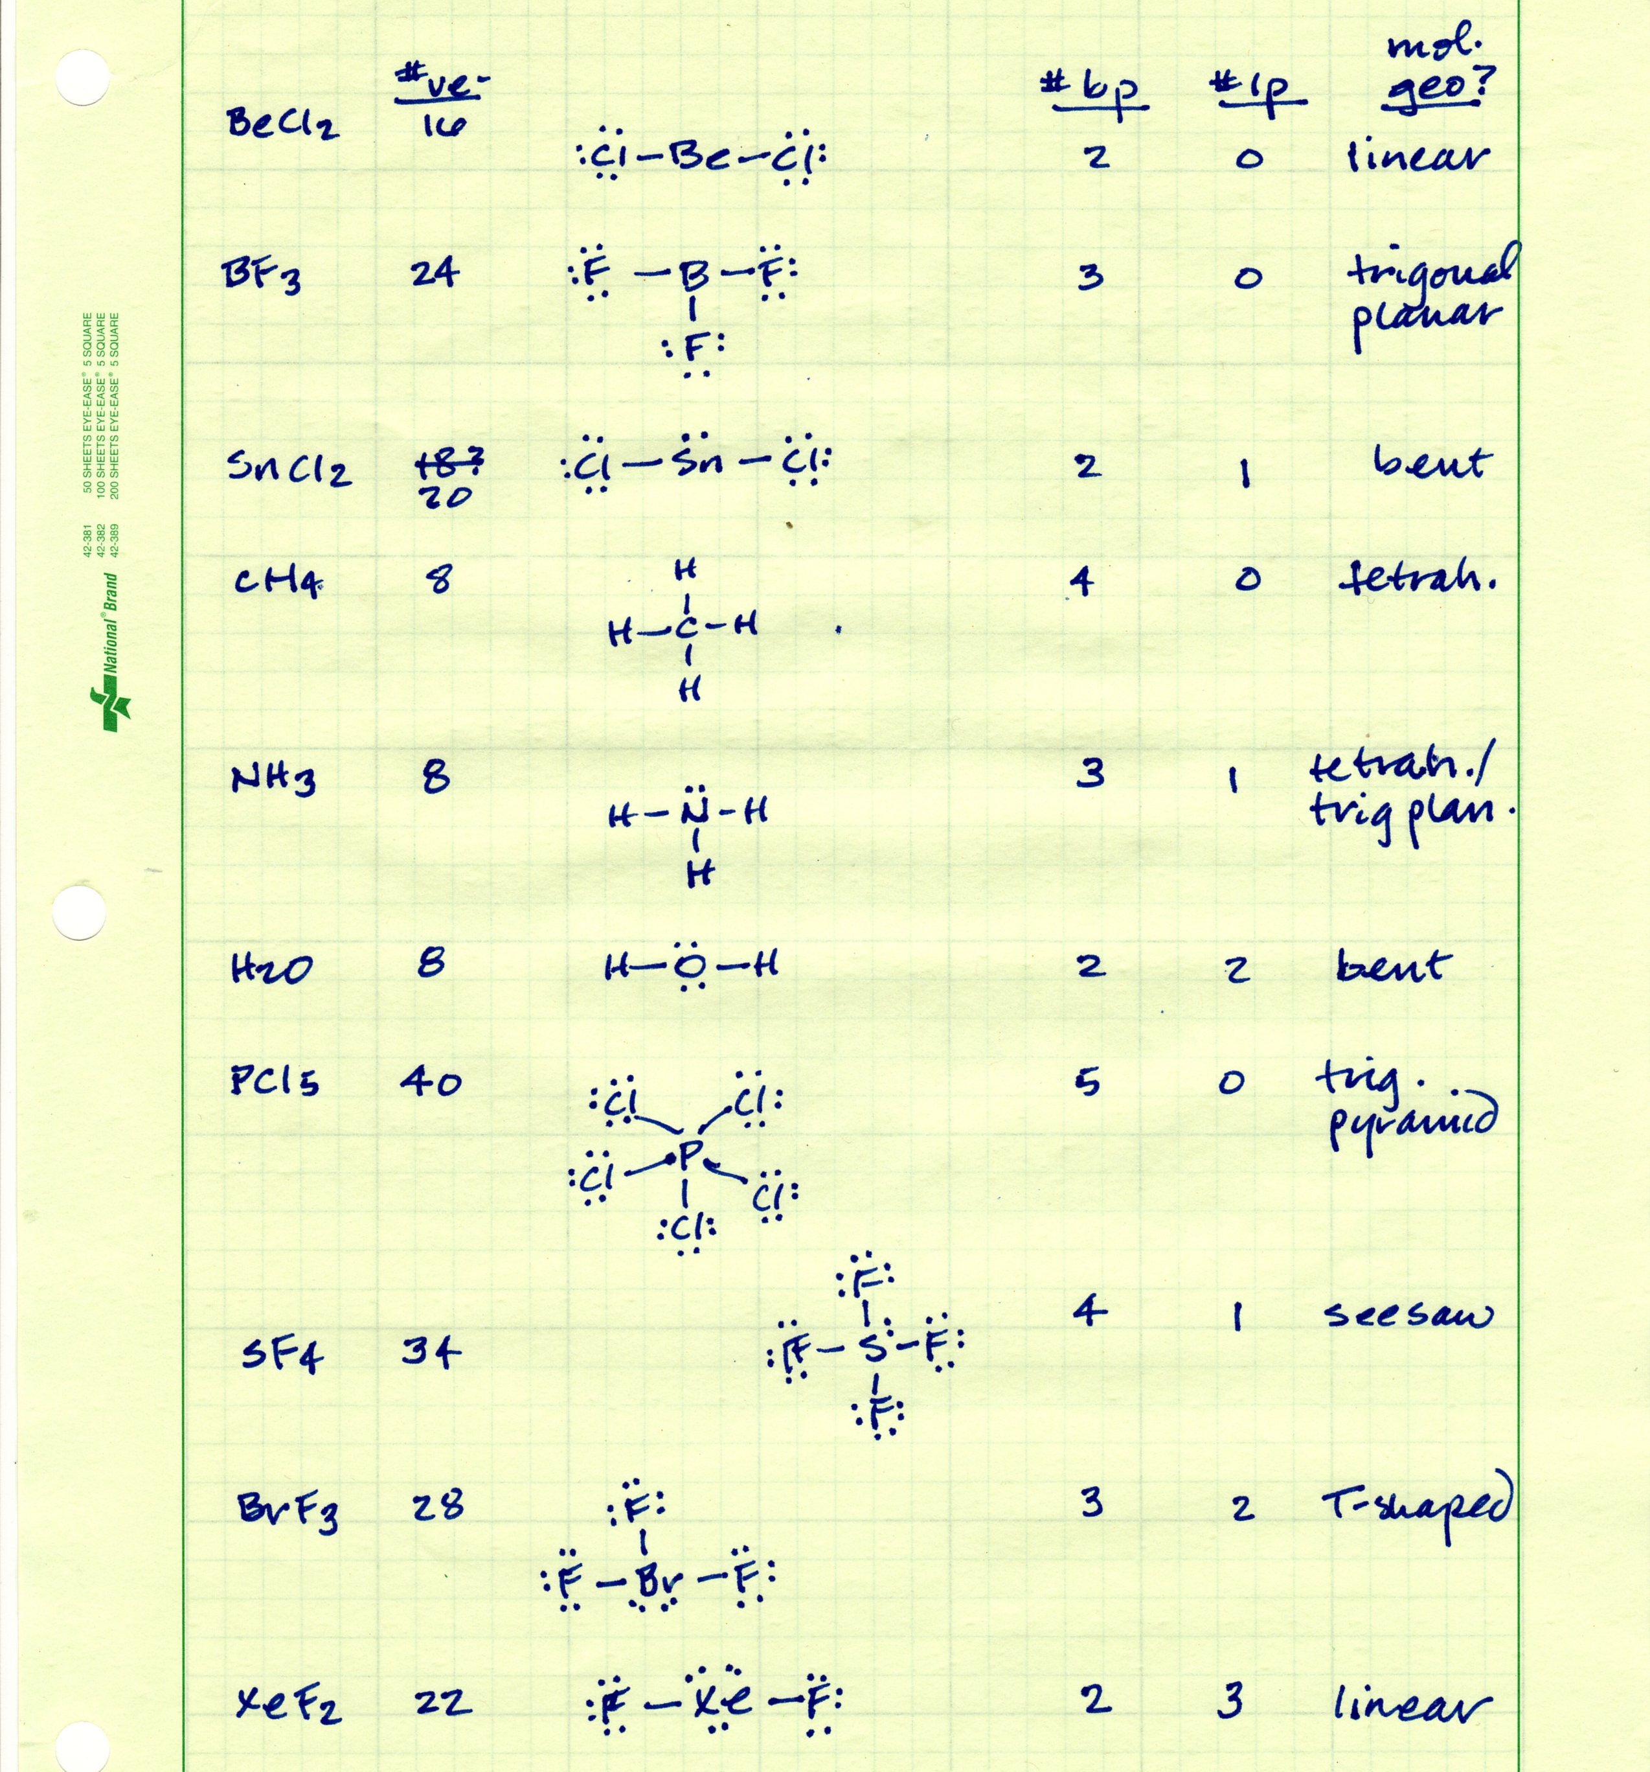

Part B:

Part C:

Part D:

Roughly 1 pt per question.

