CHE1031: Atoms and isotope review exercises

Basics:
- Atoms and isotopes are identified by the numbers of protons, electrons, and neutrons that they contain
- The number of protons, electrons, and neutrons in atoms determines the chemical properties of the elements
- A knowledge of the number of protons and electrons in an atom will help you understand how atoms combine to form molecules

Model: Two Isotopes of Sodium
- The diagram below shows a representation of the sodium isotopes
- The proton has a charge of +1, the electron -1, and the neutron 0
Note: the diameter of an atom is about 10,000 times larger than the diameter of the atomic nucleus so the relative sizes of the atom and the nucleus are not accurately depicted
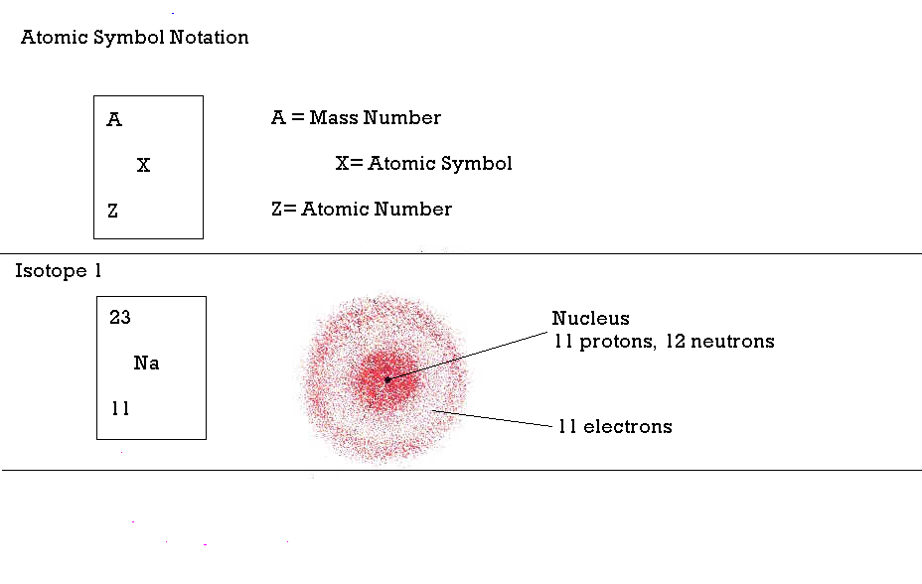

Questions:

1. What do the two sodium isotopes in the model have in common and how do they differ?

2. How is the mass number, A, determined?

3. What information is provided by the atomic number, Z?

4. What is the relationship between the number of protons and the number of electrons in an atom?

5. Because of the relationship between the number of protons and the number of electrons in an atom, what is the electrical charge of an atom?

6. Where are the electrons, protons, and neutrons located in an atom?

7. Where is most of the mass located in an atom?

8. What do all sodium isotopes have in common that distinguishes them from atoms and isotopes of other elements?

Exercises:

1. Write the atomic symbols for two isotopes of carbon, one with the mass number of 12 the other with the mass number of 13.

2. Fill in the missing information in the following table:

Name | Symbol | Atomic Number Z | Mass Number A | Number of Neutrons | Number of Electrons
oxygen | 16  O  8 | 8 | 16 | 8 | 8
 |  | 7 |  | 7
 | ³⁴ S
deuterium (hydrogen) |  | 1 |  | 1
tritium (hydrogen) |  | 1 | 3
 |  | 9 | 19
beryllium |  |  | 9
 |  | 12 | 24
 |  | 12 | 25
 |  |  | 238 |  | 92
chlorine |  |  | 35
 |  | 17 | 37
 | Kr |  | 84 |  | 36
 |  | 26 | 56
silver |  |  |  | 60
 |  |  |  | 70 | 51
 |  |  | 195 | 117
 |  | 79 |  | 118

Adapted from the New England Association of Chemistry Teachers

