CHE1031 Electron Configuration Worksheet

For the elements listed below fill in the information required for the table below and then use the orbital box diagrams to write out the electron configuration of each element. To save time you may use a slash through boxes (orbitals) that hold two electrons but use a single up arrow to represent a single electron. Think about how electron configuration would change if and when the element becomes an ion. Show that change by altering the electron configuration you’ve written with another color pen or with pencil.

Element | Column | Row | Atomic  number | Ionic  charge?
Na
Mg
Al
Si
P
S
Cl
Ar
K
Ca
Fe
Co
Ni
Cu
Zn
Br
Kr

Phosphorus, the element
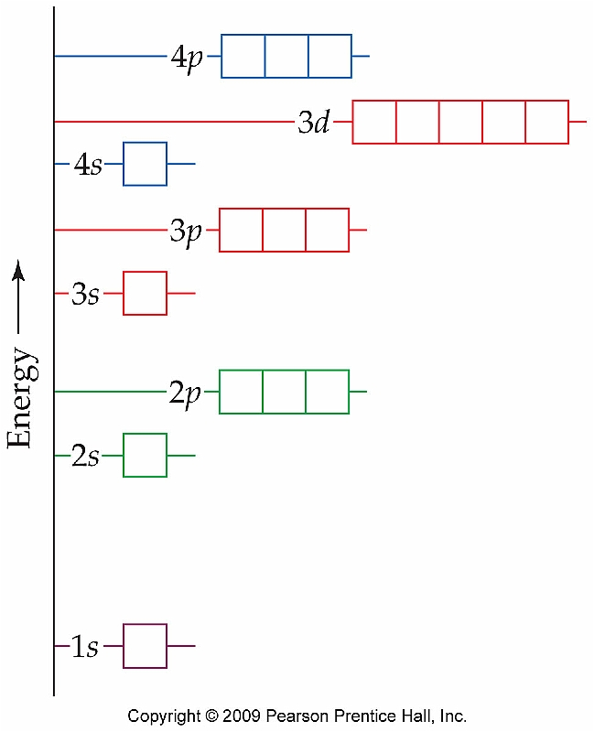

Phosphorus ion
