CHE1031 module 6 HW: Electronic structure & periodic properties

Please solve these problems on green engineering graph paper.
Problems are assigned at each class meeting and are due at the next class.
Please number each problem, show all work for credit and box your answer.

6.1: Electromagnetic energy
1. The light produced by a red neon sign is due to the emission of light by excited neon atoms. Qualitatively describe the spectrum produced by passing light from a neon lamp through a prism.

6.2: The Bohr model
2. Why is the electron in a Bohr hydrogen atom bound less tightly when it has a quantum number of 3 than when it has a quantum number of 1?

3. What does it mean to say that the energy of the electrons in an atom is quantized?

4. How are the Bohr model and the Rutherford models of the atom similar? How are they different?

5. The spectra of hydrogen and of calcium are shown in Figure 6.13.
(a) What causes the lines in these spectra?
(b) Why are the colors of the lines different?
(c) Suggest a reason for the observation that the spectrum of calcium is more
complicated than the spectrum of hydrogen.
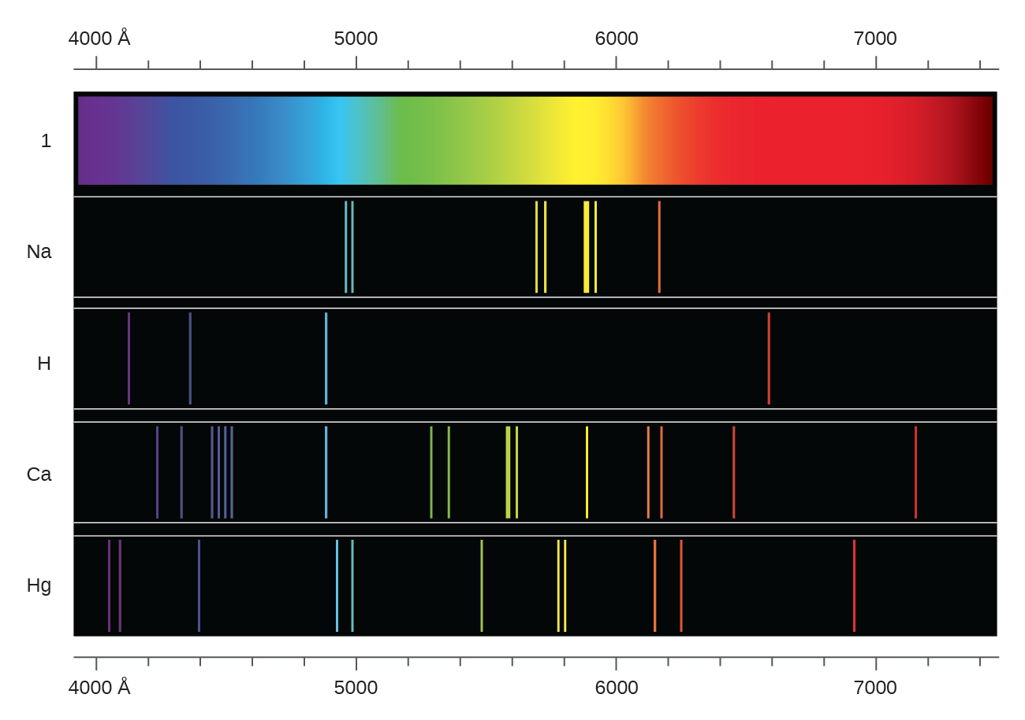

6.3: Development of quantum theory
6. How are the Bohr model and the quantum mechanical model of the hydrogen atom similar? How are they different?

7. Describe the properties of an electron associated with each of the following four quantum numbers: n, l, ml, and ms.
8. Which types of subshells can be described as ‘degenerate’? How many degenerate orbitals are in each type?

9. Sketch the boundary surface of a dx2 −y2 and a py orbital. Be sure to show and label the axes.

10. State the Heisenberg uncertainty principle. Describe briefly what the principle implies.

6.4 Electronic structure of atoms (electron configuration)
11. Using box-arrow diagrams (not abbreviations, 1s²2s²2p⁶, and so forth), write the electron configuration of each of the following atoms:
(a) C
(b) P
(c) V
(d) Sb

12. Is 1s²2s²2p⁶ the symbol for a macroscopic property or a microscopic property of an element? Explain your answer.

13. What additional information do we need to answer the question “Which ion has the electron configuration 1s²2s²2p⁶3s²3p⁶”?

14. Using complete subshell notation (1s²2s²2p⁶, and so forth), predict the electron configurations of the following ions.
(a) N⁻³
(b) Ca⁺²
(c) S^{–1}
(d) Cs⁺²
(e) Cr⁺²

15. Which of the following atoms contains only three valence electrons: Li, B, N, F, Ne?

16. Which of the following has two unpaired electrons?
(a) Mg
(b) Si
(c) S
(d) Both Mg and S
(e) Both Si and S.
17. Cobalt–60 and iodine–131 are radioactive isotopes commonly used in nuclear medicine. How many protons, neutrons, and electrons are in atoms of these isotopes? Write the complete electron configuration for each isotope.

