CHE1031 module 7 HW: Chemical bonding

Please solve these problems on green engineering graph paper.
Problems are assigned at each class meeting and are due at the next class.
Please number each problem, show all work for credit and box your answer.
Note that answers to quantitative problems are provided in blue.

7.2: Covalent bonding
1. Why is it incorrect to speak of a molecule of solid NaCl?

2. From its position in the periodic table, determine which atom in each pair is more electronegative:
(a) Br or Cl
(b) N or O
(c) S or O
(d) P or S

3. Predict which of the following compounds are ionic and which are nopolar or polar covalent, based on the location of their constituent atoms in the periodic table:
(a) Cl2CO
(b) MnO
(c) NCl3
(d) CoBr2
(e) K2S

4. Which is the most polar bond?
(a) C–C
(b) C–H
(c) N–H
(d) O–H
(e) Se–H

7.3: Lewis symbols and structures
5. Write the Lewis symbols for each of the following ions:
(a) As-3
(b) I–1
(c) Be+2
(d) O-2

6. Write the Lewis symbols of the ions in each of the following ionic compounds and the Lewis symbols of the atom from which they are formed:
(a) MgS
(b) Al2O3
(c) GaCl3

7. Write Lewis structures for the following:
(a) HBr
(b) PCl3
(c) H2CCH2
(d) HNNH
(e) NH4⁺¹
(f) NO^{–1}

8. Write Lewis structures for the following:
(a) SeF6
(b) XeF4

9. The arrangement of atoms in several biologically important molecules is given here. Complete the Lewis structures of these molecules by adding multiple bonds and lone pairs. Do not add any more atoms.
- the amino acid serine
(b) urea
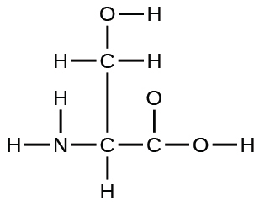

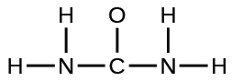

7.4: Formal charges and resonance
10. Write resonance forms that describe the distribution of electrons in each of these molecules or ions.
(a) nitrate ion, NO3⁻¹
(b) nitric acid, HNO3 (N is bonded to an OH group and two O atoms)
(c) sulfur dioxide, SO2
(d) carbonate ion, CO3⁻²

11. Write the Lewis structures for the following, and include resonance structures where appropriate. Indicate which has the strongest carbon-oxygen bond.
(a) CO2
(b) CO

12. Determine the formal charge of each element in the following:
(a) H3O⁺¹
(b) SO4⁻²
(c) NH3
(d) O2⁻²
(e) H2O2
13. Based on formal charge considerations, which of the following would likely be the correct arrangement of atoms in nitrosyl chloride: ClNO or ClON?
14. Based on formal charge considerations, which of the following would likely be the correct arrangement of atoms in hypochlorous acid: HOCl or OClH?

7.5: Strengths of ionic and covalent bonds
15. Which bond in each of the following pairs of bonds is the strongest?
(a) C–C or C = C
(b) C–H or O–H
(c) C–N or C–O

16. Using the bond energies in Table 7.2, determine the approximate enthalpy change for each of the following reactions:
(a) H2(g) + Br2(g) ⟶ 2HBr(g)
(b) CH4(g) + I2(g) ⟶ CH3 I(g) + HI(g)
(c) C2H4(g) + 3O2(g) ⟶ 2CO2(g) + 2H2O(g)
(a) ΔH = - 114 kJ
(b) ΔH = + 30 kJ
(c) ΔH = - 1055 kJ

17. When a molecule can form two different structures, the structure with the stronger bonds is usually the more stable form. Use bond energies to predict the correct structure of the hydroxylamine molecule:
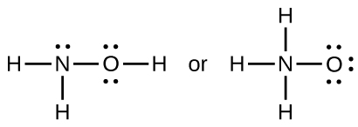

Left: = 1444 kJ likely stronger
Right: = 1370 kJ

