CHE1031 Lecture 2 examples

1. Do the chemical reactions shown here obey the five postulates of Dalton’s atomic theory? If not, why?

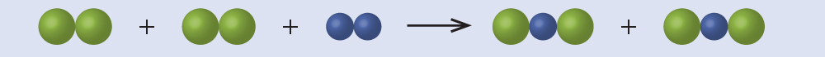

2. Compounds A & B are both clear & odorless gases. A sample of compound A is found to contain 4.27 g of C and 5.69 g of O. A sample of compound B is found to have 5.19 g of C and 13.84 g of O. Are A & B examples of the law of definite proportions, the law of multiple proportions, or neither?

3. Iodine is atomic number 53 and has a mass of 127 amu. Iodine gains one electron to form iodide ions, I⁻¹. How many protons, neutrons & electrons are there in an iodide ion?

4. An ion of platinum has a mass number of 195 and has 74 electrons. How many protons & neutrons does it have? What is its charge?

5. Boron occurs in two isotopes: 19.9% have a mass of 10.0129 amu & 80.1% have a mass of 11.0093. Calculate the average atomic mass of boron.

6. A meteorite found in central Indiana contains traces of neon gas picked up from solar wind. Analysis shows 91.84% ²⁰Ne (19.9924 amu), 0.47% ²¹Ne (20.9940 amu), and 7.69% ²²Ne (21.9914 amu). Calculate the average atomic mass of neon in solar wind.

7. Naturally occurring chlorine has two isotopes, ³⁵Cl (34.96885 amu) and ³⁷Cl (36.96590 amu). The average atomic mass is 35.453 amu. Calculate the abundance (frequency) of each chlorine isotope.

8. Write the molecular & empirical formulas for these molecules:
