CHE1031 HW set 2: Atoms, molecules & ions - KEY

Please solve these problems on green engineering graph paper.
Problems are assigned at each class meeting and are due at the next class.
Please number each problem, show all work for credit and box your answer.
Note that answers to quantitative problems are provided in blue.

2.1: Early ideas in atomic theory
1. Which postulate of Dalton’s theory is consistent with the following observation concerning the weights of reactants and products? When 100 grams of solid calcium carbonate is heated, 44 grams of carbon dioxide and 56 grams of calcium oxide are produced.
Law of conservation of mass. Dalton said that chemical reactions didn’t create or destroy atoms or mass, but rearranged atoms: 5th postulate. Postulate number 4 is also relevant: atoms are combined at constant ratios to create molecules or compounds.

2. Samples of compound X, Y, and Z are analyzed, with results shown here.
compound | description | carbon (g) | hydrogen (g)
X | clear, colorless liquid; strong odor | 1.776 | 0.148
Y | clear, colorless liquid; strong odor | 1.974 | 0.329
Z | clear, colorless liquid; strong odor | 7.812 | 0.651

(a) Do these data provide example(s) of the law of definite proportions, the law of multiple proportions, neither, or both?
(b)What do these data tell you about compounds X, Y, and Z?
(a) Mass ratios: X = 12:1; Y = 6:1; Z = 12:1 All compounds are examples of the law of definite proportion (aka law of constant composition). This is also an example of the law of multiple proportions as all are carbon and hydrogen but are combined at two different ratios 12C:1H or 6C:1H.
(b) X and Z may, or may not be identical. Two compounds with the same molecular empirical formula (as here) may have different structural formulas and thus different chemical identities and properties.
2.2: Evolution of atomic theory
3. The existence of isotopes violates one of the original ideas of Dalton’s atomic theory. Which one?
Isotopes violate the postulate that says all atoms of an element are identical.

4. How are protons and neutrons similar? How are they different?
Protons are both subatomic particles, they have very similar masses and both are found in the nucleus of the atom. However, protons have a positive charge while neutrons are uncharged.

5. Predict and test the behavior of α particles fired at a “plum pudding” model atom.
(a) Predict the paths taken by α particles that are fired at atoms with a Thomson’s plum pudding model structure. Explain why you expect the α particles to take these paths.
(b) If α particles of higher energy than those in (a) are fired at plum pudding atoms, predict how their paths will differ from the lower-energy α particle paths. Explain your reasoning.
(c) Now test your predictions from (a) and (b). Open the Rutherford Scattering simulation (http://openstaxcollege.org/l/16PhetScatter) and select the “Plum Pudding Atom” tab.
- Set “Alpha Particles Energy” to “min,” and select “show traces.”
- Click on the gun to start firing α particles. Does this match your prediction from (a)? If not, explain why the actual path would be that shown in the simulation.
- Hit the pause button, or “Reset All.” Set “Alpha Particles Energy” to “max,” and start firing α particles. Does this match your prediction from (b)? If not, explain the effect of increased energy on the actual paths as shown in the simulation.
(a) Most alpha particles be scattered as most of the volume of the plum pudding model is occupied by heavy dense material.
(b) Higher energy alpha particles should also be deflected.

2.3: Atomic structure and symbolism
6. Write the symbol for each of the following ions:
(a) the ion with a +1 charge, atomic number 55, and mass number 133
(b) the ion with 54 electrons, 53 protons, and 74 neutrons
(c) the ion with atomic number 15, mass number 31, and a -3 charge
(d) the ion with 24 electrons, 30 neutrons, and a +3 charge
(a) Cs⁺¹
(b) I⁻¹
(c) P⁻³
(d) Co⁺³

7. Open the Build an Atom simulation (http://openstaxcollege.org/l/16PhetAtomBld) and click on the Atom icon.
(a) Pick any one of the first 10 elements that you would like to build and state its symbol.
(b) Drag protons, neutrons, and electrons onto the atom template to make an atom of your element. State the numbers of protons, neutrons, and electrons in your atom, as well as the net charge and mass number.
(c) Click on “Net Charge” and “Mass Number,” check your answers to (b), and correct, if needed.
(d) Predict whether your atom will be stable or unstable. State your reasoning.
(e) Check the “Stable/Unstable” box. Was your answer to (d) correct? If not, first predict what you can do to make a stable atom of your element, and then do it and see if it works. Explain your reasoning.

8. Determine the number of protons, neutrons, and electrons in the following isotopes that are used in medical diagnoses:
(a) atomic number 9, mass number 18, charge of 1−
(b) atomic number 43, mass number 99, charge of 7+
(c) atomic number 53, atomic mass number 131, charge of 1−
(d) atomic number 81, atomic mass number 201, charge of 1+
(e) Name the elements in parts (a), (b), (c), and (d).
(a) F: 9 p+, 9 n (=18 – 9), 10 e-
(b) Tc: 43 p+, 56 n (=99 – 43), 36 e-
(c) I: 53 p+, 78 n (=131 – 53), 54 e-
(d) Tl: 81 p+, 120 n (=201 – 81), 80 e-

9. Give the number of protons, electrons, and neutrons in neutral atoms of each of the following isotopes:
(a) ¹⁰₅B
(b) ¹⁹⁹₈₀Hg
(c) ⁶³₂₉Cu
(d) ¹³₆C
(e) ⁷⁷₃₄Se
(a) 5 p+, 5 n (=10 – 5), 5 e-
(b) 80 p+, 119 n (=199 – 80), 80 e-
(c) 29 p+, 34 n (=63 – 29), 29 e-
(d) 6 p+, 7 n (=13 – 6), 6 e-
(e) 34 p+, 43 n (=77 – 34), 34 e-

10. Click on the site (http://openstaxcollege.org/l/16PhetAtomMass) and select the “Mix Isotopes” tab, hide the “Percent Composition” and “Average Atomic Mass” boxes, and then select the element boron.
(a) Write the symbols of the isotopes of boron that are shown as naturally occurring in significant amounts.
(b) Predict the relative amounts (percentages) of these boron isotopes found in nature. Explain the reasoning behind your choice.
(c) Add isotopes to the black box to make a mixture that matches your prediction in (b). You may drag isotopes from their bins or click on “More” and then move the sliders to the appropriate amounts.
(d) Reveal the “Percent Composition” and “Average Atomic Mass” boxes. How well does your mixture match with your prediction? If necessary, adjust the isotope amounts to match your prediction.
(e) Select “Nature’s” mix of isotopes and compare it to your prediction. How well does your prediction compare with the naturally occurring mixture? Explain. If necessary, adjust your amounts to make them match “Nature’s” amounts as closely as possible.
(a) ¹⁰B &¹¹B (11.00931 amu)
(b) There should be more of the heavier isotope because the periodic table gives B’s mass as 10.81 amu and because the black box shows that the heavier isotope is more abundant.
(c) OK… Need about 4:1 ¹¹B:¹⁰B
(d) Matches: actual abundance is 19.9% ¹⁰B & 80.1% ¹¹B. Avg atomic mass matches periodic table.

11. An element has the following natural abundances and isotopic masses: 90.92% abundance with 19.99 amu, 0.26% abundance with 20.99 amu, and 8.82% abundance with 21.99 amu. Calculate the average atomic mass of this element.
= (0.9092*19.99) + (0.0026*20.99) + (0.0882*21.99) = 20.17 amu

12. Variations in average atomic mass may be observed for elements obtained from different sources. Lithium provides an example of this. The isotopic composition of lithium from naturally occurring minerals is 7.5% 6Li and 92.5% 7Li, which have masses of 6.01512 amu and 7.01600 amu, respectively. A commercial source of lithium, recycled from a military source, was 3.75% 6Li (and the rest 7Li). Calculate the average atomic mass values for each of these two sources.
= (0.075*6.01512) + (0.925*7.01600) = 6.94093 amu
= (0.0375*6.01512) + (0.9625*7.01600) = 6.978467 amu

2.4: Chemical formulas
13. Explain why the symbol for an atom of the element oxygen and the formula for a molecule of oxygen differ.
Molecular oxygen is formed by bonding two atoms of oxygen together, thus O2 vs. O.

14. Write the molecular and empirical formulas of the following compounds:
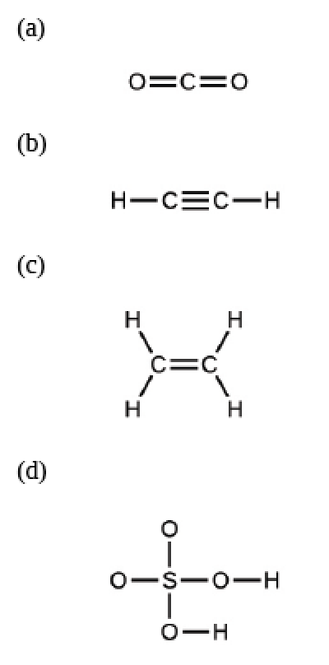
- CO2 for both empirical & molecular
- C2H2 vs. CH
- C2H4 vs. CH2
- SO4H2 for both empirical & molecular

15. Determine the empirical formulas for the following compounds:
(a) caffeine, C8H10N4O2
(b) fructose, C12H22O11
(c) hydrogen peroxide, H2O2
(d) glucose, C6H12O6
(e) ascorbic acid (vitamin C), C6H8O6
(a) C4H5N2O
(b) C12H22O11
(c) HO
(d) CH2O
(e) C3H4O3

16. Write the empirical formulas for the following compounds:
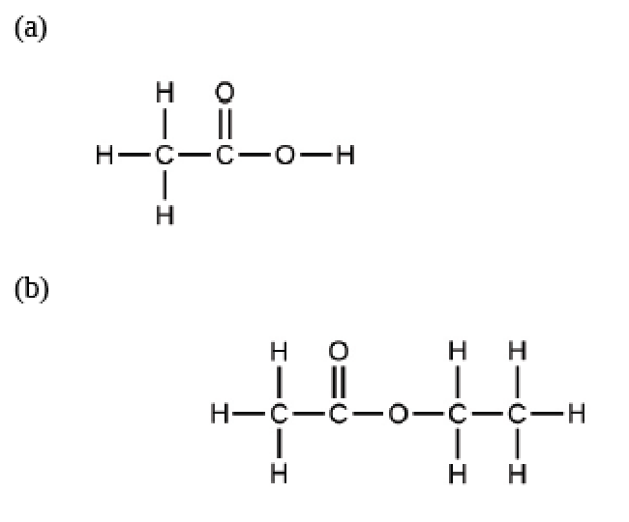
- C2H4O2 molecular & CH2O empirical
- C4H8O2 molecular & C2H4O empirical

17. Open the Build a Molecule simulation (http://openstaxcollege.org/l/16molbuilding) and select the “Larger Molecules” tab.
- Select an appropriate atoms “Kit” to build a molecule with two carbon and six hydrogen atoms.
- Drag atoms into the space above the “Kit” to make a molecule. A name will appear when you have made an actual molecule that exists (even if it is not the one you want).
- You can use the scissors tool to separate atoms if you would like to change the connections.
- Click on “3D” to see the molecule, and look at both the space-filling and ball-and-stick possibilities.
(a) Draw the structural formula of this molecule and state its name.
(b) Can you arrange these atoms in any way to make a different compound?
Didn’t open

2.5: The periodic table
18. Using the periodic table, classify each of the following elements as a metal or a nonmetal, and then further classify each as a main-group (representative) element, transition metal, or inner transition metal:
(a) uranium
(b) bromine
(c) strontium
(d) neon
(e) gold
(f) americium
(g) rhodium
(h) sulfur
(i) carbon
(j) potassium
(a) U, metal, inner transition metal
(b) Br, nonmetal, main group
(c) Sr, metal, main group
(d) Ne, nonmetal, main group
(e) Au, metal, transition
(f) Am, metal, inner transition
(g) Rh, metal, transition metal
(h) S, nonmetal, main group
(i) C, nonmetal, main group
(j) K, metal, main group

19. Using the periodic table, identify the lightest member of each of the following groups:
(a) noble gases
(b) alkaline earth metals
(c) alkali metals
(d) chalcogens
(a) He
(b) Be
(c) H
(d) O

20. Use the periodic table to give the name and symbol for each of the following elements:
(a) the halogen in the same period as the alkali metal with 11 protons
(b) the alkaline earth metal in the same period with the neutral noble gas with 18 electrons
(c) the noble gas in the same row as an isotope with 30 neutrons and 25 protons
(d) the noble gas in the same period as gold
(a) Cl
(b) Mg
(c) Kr
(d) Rn

21. Write a symbol for each of the following neutral isotopes. Include the atomic number and mass number for each.
(a) the chalcogen with a mass number of 125
(b) the halogen whose longest-lived isotope is radioactive
(c) the noble gas, used in lighting, with 10 electrons and 10 neutrons
(d) the lightest alkali metal with three neutrons
(a) Te
(b) At
(c) Ne
(d) Li

2.6: Molecular and ionic compounds
22. Using the periodic table, predict whether the following chlorides are ionic or covalent: KCl, NCl3, ICl, MgCl2, PCl5, and CCl4.
ionic, covalent, covalent, ionic, covalent, covalent

23. For each of the following compounds, state whether it is ionic or covalent. If it is ionic, write the symbols for the ions involved:
(a) NF3
(b) BaO,
(c) (NH4)2(CO3)
(d) Sr(H2PO4)2
(e) IBr
(f) Na2O
(a) covalent
(b) ionic: Ba⁺², O⁻²
(c) ionic: (NH4)⁺¹, (CO3)⁻²
(d) ionic: Sr⁺², (H2PO4)⁻¹
(e) covalent
(f) ionic: Na⁺¹, O⁻²

24. For each of the following pairs of ions, write the formula of the compound they will form:
(a) Ca⁺², S⁻²
(b) NH4⁺¹ , SO4⁻²
(c) Al⁺³, Br⁻¹
(d) Na⁺¹, HPO4⁻²
(e) Mg⁺², PO4⁻³
(a) CaS
(b) (NH4)2(SO4)
(c) AlBr3
(d) Na2(HPO4)
(e) Mg3(PO4)2

2.7: Chemical nomenclature (naming)
25. Name the following compounds:
(a) CsCl
(b) BaO
(c) K2S
(d) BeCl2
(e) HBr
(f) AlF3
(a) cesium chloride
(b) barium oxide
(c) potassium sulfide
(d) beryllium chloride
(e) hydrogen bromide [also hydrobromic acid]
(f) aluminum fluoride

26. Write the formulas of the following compounds:
(a) rubidium bromide
(b) magnesium selenide
(c) sodium oxide
(d) calcium chloride
(e) hydrogen fluoride
(f) gallium phosphide
(g) aluminum bromide
(h) ammonium sulfate
(a) RbBr
(b) MgSe
(c) Na2O
(d) CaCl2
(e) HF
(f) GaP
(g) AlBr3
(h) (NH4)2(SO4)

27. Write the formulas of the following compounds:
(a) chlorine dioxide
(b) dinitrogen tetraoxide
(c) potassium phosphide
(d) silver (I) sulfide
(e) aluminum nitride
(f) silicon dioxide
(a) ClO2
(b) N2O4
(c) K3P
(d) Ag2S
(e) AlN
(f) SiO2

28. Each of the following compounds contains a metal that can exhibit more than one ionic charge. Name these compounds:
(a) Cr2O3
(b) FeCl2
(c) CrO3
(d) TiCl4
(e) CoO
(f) MoS2
(a) chromium (III) oxide
(b) iron (II) chloride
(c) chromium (VI) oxide
(d) titanium (IV) chloride
(e) cobalt (II) oxide
(f) molybdenum (IV) sulfide

29. The following ionic compounds are found in common household products. Write the formulas for each compound:
(a) potassium phosphate
(b) copper(II) sulfate
(c) calcium chloride
(d) titanium (IV) dioxide
(e) ammonium nitrate
(f) sodium bisulfate (the common name for sodium hydrogen sulfate)
(a) K3(PO4)
(b) Cu(SO4)
(c) CaCl2
(d) TiO2
(e) (NH4)(NO3)
(f) Na(HSO4)

