CHE 2060: HW Set 1

1.1A: Formal charge
1. The figure below illustrates a section of an intermediate compound that forms during the protein synthesis process in the cell. Lone pairs are not shown, as is typical in drawings of organic compounds.
(a) Add missing lone electron pairs.
(b) Calculate and add formal charges.
(c) How many hydrogen atoms are on this structure?
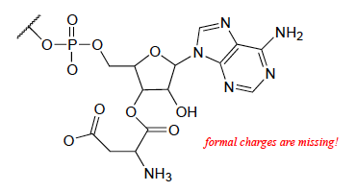

2. Most amino acids exist at zwitterions at neutral pH. Using the table of amino acids posted on the Module 1 webpage, chose three of the twenty amino acids.
(a) Draw the complete structure of those amino acids.
(b) Calculate formal charges of all atoms, showing calculations for those atoms whose formal charges are not zero.
(c) Are any of your three amino acids not zwitterions? If not, why not?

1.1B & C: Common bonding patterns, Lewis structures and line-bond drawings
3. Create Lewis structures for two molecules in which S is the central atom and forms six bonds.
(a) two single and two double bonds (total of six)
(b) six single bonds to six atoms

4. Draw correct Lewis structures for ozone (O3), azide ion, (N3⁻¹), and bicarbonate ion, (HCO3⁻¹). Include lone pair electrons and formal charges.

1.1D. Constitutional (aka structural) isomers
5. Draw all constitutional isomers of these molecular formulas.
- C4H10O
- C3H9N

6. Draw structures of four different amides with molecular formula C3H7NO. They are constitutional isomers.

1.2A: Functional groups
7. Using the table of common coenzymes posted on the Module 1 webpage, find and label examples of the following:
(a) a thiol
(b) an amide
(c) a secondary alcohol
(d) an aldehyde

8. Using the table of amino acid structures posted on the Module 1 webpage, find examples of the following:
(a) a secondary alcohol
(b) an amide
(c) a thiol
(d) a sulfide

9. Draw one example each of compounds fitting the descriptions below, using line structures. Be sure to include all non-zero formal charges. All atoms should fit one of the common bonding patterns discussed in this chapter. There are many possible correct answers - be sure to check your drawings with your instructor or tutor.
(a) an 8-carbon molecule with secondary alcohol, primary amine, amide, and cis-alkene groups
(b) a 12-carbon molecule with carboxylate, diphosphate, and lactone (cyclic ester) groups.

10. Three of the four structures below are missing formal charges.
(a) Fill in all missing formal charges (assume all atoms have a complete octet of valence electrons).
(b) Identify the following functional groups or structural elements (there may be more than one of each): carboxylate, carboxylic acid, cyclopropyl, amide, ketone, secondary ammonium ion, tertiary alcohol.
(c) Determine the number of hydrogen atoms in each compound.

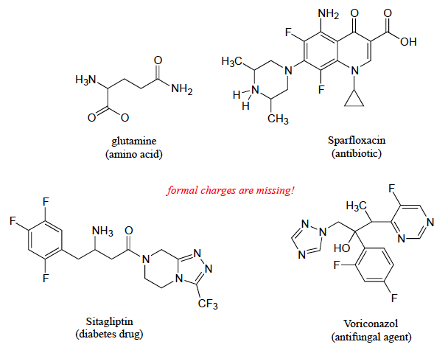

1.2B: Naming organic compounds
11. Draw line-bond structures corresponding to the following compounds. Show all lone pair electrons (and don't forget that non-zero formal charges are part of a correctly drawn structure!)
(a) 2,2,4-trimethylpentane
(b) 3-phenyl-2-propenal
(c) 6-methyl-2,5-cyclohexadienone
(d) 3-methylbutanenitrile
(e) 2,6-dimethyldecane
(f) 2,2,5,5-tetramethyl-3-hexanol
(g) methyl butanoate
(h) N-ethylhexanamide
(i) 7-fluoroheptanoate
(j) 1-ethyl-3,3-dimethylcyclohexene

1.2C: Abbreviated organic structures
12. Reaction A below is part of the biosynthetic pathway for the amino acid methionine, and reaction B is part of the pentose phosphate pathway of sugar metabolism.
(a) What is the functional group transformation that is taking place in each reaction? Circle the affected functional groups.
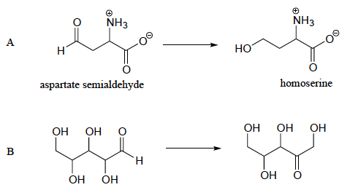
(b) Keeping in mind that the 'R' abbreviation is often used to denote parts of a larger molecule which are not the focus of a particular process, which of the following abbreviated structures could be appropriate to use for aspartate semialdehyde when drawing out details of reaction A?
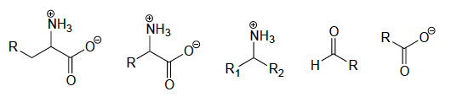
(c) Again, using the 'R' convention, suggest an appropriate abbreviation for the reactant in reaction B.

1.3A: Lipids
13. Draw examples of these fatty acids.
(a) 12-carbon saturated fatty acid
(b) 12-carbon monounsaturated fatty acid
(c) 12-carbon polyunsaturated fatty acid

14. How many acetyl Co-A ‘units’ would be needed to create a 12-carbon fatty acid?
15. Explain how the name triacylglycerol (TAG) describes the three different parts of this lipid molecule.

16. Are each of these parts of an amphipathic phospholipid molecule hydrophilic or hydrophobic?
(a) fatty acid tails
(b) glycerol backbone
(c) phosphatidylcholine head group

17. Is isopentyl diphosphate amphipathic? Draw its structure here and label the hydrophilic and hydrophobic portions of the molecule.
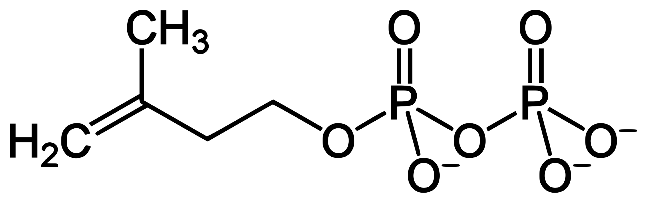

1.3B: Biopolymer basics
18. How many monomers does it take to make a polymer?

1.3C: Carbohydrates
19. What aspect of carbohydrate structure, what functional group, is responsible for the hydrophilic nature of carbohydrates?

20. What monosaccharide is cellulose a polymer of?

1.3D: Amino acids & proteins
21. How many atoms is the central alpha-carbon of an amino acid bonded to?

22. How many amino acids occur in nature and what part of them is unique?

23. What functional groups join together to form the peptide bond that polymerizes amino acids and forms the backbone of proteins?

1.3E: Nucleic acids (DNA & RNA)
24. How could you tell whether a nucleic acid was RNA or DNA by looking at its nucleotide sequence?

25. How would you describe the difference between RNA and DNA bases? What’s chemically different?

26. The two strands of DNA that make up a DNA double-helix run in ___________ directions.

