CHE 2060: HW Set 1 - KEY

1.1A: Formal charge
1. The figure below illustrates a section of an intermediate compound that forms during the protein synthesis process in the cell. Lone pairs are not shown, as is typical in drawings of organic compounds.
(a) Add missing lone electron pairs.
(b) Calculate and add formal charges.
(c) How many hydrogen atoms are on this structure?
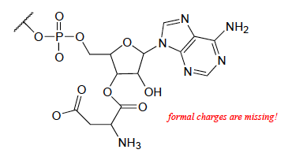
- : missing on all O and N
- See drawing for O-1 (x2) and N+1
- 17 H atoms

2. Most amino acids exist at zwitterions at neutral pH. Using the table of amino acids posted on the Module 1 webpage, chose three of the twenty amino acids.
(a) Draw the complete structure of those amino acids.
(b) Calculate formal charges of all atoms, showing calculations for those atoms whose formal charges are not zero.
(c) Are any of your three amino acids not zwitterions? If not, why not?
(b) Amino end +1; carboxy end -1; R may or may not be charged.
(c) All amino acids are zwitterions unless their R is also charge
1.1B & C: Common bonding patterns, Lewis structures and line-bond drawings
3. Create Lewis structures for two molecules in which S is the central atom and forms six bonds.
(a) two single and two double bonds (total of six)
(b) six single bonds to six atoms
(a) one version of H2SO4 (many possible answers)
(b) SF6 (many possible answers)

4. Draw correct Lewis structures for ozone (O3), azide ion, (N3⁻¹), and bicarbonate ion,(HCO3⁻¹). Include lone pair electrons and formal charges.

1.1D. Constitutional (aka structural) isomers
5. Draw all constitutional isomers of these molecular formulas.
- C4H10O
- C3H9N
- Butan-1-ol, butan-2-ol, 2-methyl-propan-1-ol, 2-methyl-propan-2-ol, methylpropyl ether, diethyl ether, (1-methylethyl)methyl ether
- Propylamine, 1-methylethylamine, N-methylethylamine, trimethylamine

6. Draw structures of four different amides with molecular formula C3H7NO. They are constitutional isomers.

1.2A: Functional groups
7. Using the table of common coenzymes posted on the Module 1 webpage, find and label examples of the following:
(a) a thiol
(b) an amide
(c) a secondary alcohol
(d) an aldehyde
(a) coenzyme A
(b) coenzyme A
(c) S-adenosyl methionine (SAM)
(d) pyridoxal phosphate (PLP)

8. Using the table of amino acid structures posted on the Module 1 webpage, find examples of the following:
(a) a secondary alcohol
(b) an amide
(c) a thiol
(d) a sulfide
(a) Threonine contains a secondary alcohol.
(b) Glutamine and asparagine contain amides.
(c) Cysteine contains a thiol.
(d) Methionine contains a sulfide.

9. Draw one example each of compounds fitting the descriptions below, using line structures. Be sure to include all non-zero formal charges. All atoms should fit one of the common bonding patterns discussed in this chapter. There are many possible correct answers - be sure to check your drawings with your instructor or tutor.
(a) an 8-carbon molecule with secondary alcohol, primary amine, amide, and cis-alkene groups
(b) a 12-carbon molecule with carboxylate, diphosphate, and lactone (cyclic ester) groups.

10. Three of the four structures below are missing formal charges.
(a) Fill in all missing formal charges (assume all atoms have a complete octet of valence electrons).
(b) Identify the following functional groups or structural elements (there may be more than one of each): carboxylate, carboxylic acid, cyclopropyl, amide, ketone, secondary ammonium ion, tertiary alcohol.
(c) Determine the number of hydrogen atoms in each compound.

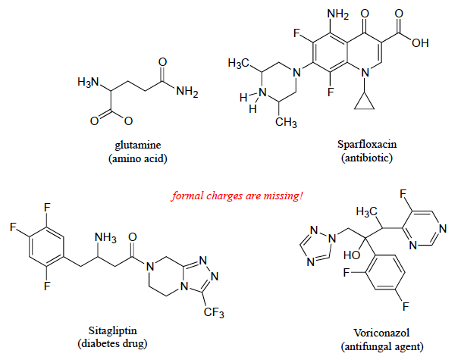

1.2B: Naming organic compounds
11. Draw line-bond structures corresponding to the following compounds. Show all lone pair electrons (and don't forget that non-zero formal charges are part of a correctly drawn structure!)
(a) 2,2,4-trimethylpentane
(b) 3-phenyl-2-propenal
(c) 6-methyl-2,5-cyclohexadienone
(d) 3-methylbutanenitrile
(e) 2,6-dimethyldecane
(f) 2,2,5,5-tetramethyl-3-hexanol
(g) methyl butanoate
(h) N-ethylhexanamide
(i) 7-fluoroheptanoate
(j) 1-ethyl-3,3-dimethylcyclohexene

1.2C: Abbreviated organic structures
12. Reaction A below is part of the biosynthetic pathway for the amino acid methionine, and reaction B is part of the pentose phosphate pathway of sugar metabolism.
(a) What is the functional group transformation that is taking place in each reaction? Circle the affected functional groups.
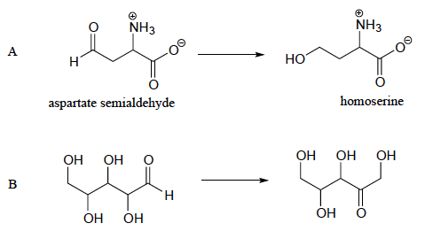
(b) Keeping in mind that the 'R' abbreviation is often used to denote parts of a larger molecule which are not the focus of a particular process, which of the following abbreviated structures could be appropriate to use for aspartate semialdehyde when drawing out details of reaction A?
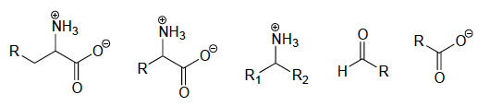
(c) Again, using the 'R' convention, suggest an appropriate abbreviation for the reactant in reaction B.
(a) A: aldehyde to primary alcohol;
B: secondary alcohol to ketone; aldehyde to primary alcohol
(b) Fourth from the left.
(c) The first three carbons and their substituents become R.

1.3A: Lipids
13. Draw examples of these fatty acids.
(a) 12-carbon saturated fatty acid
(b) 12-carbon monounsaturated fatty acid
(c) 12-carbon polyunsaturated fatty acid

X. How many acetyl Co-A ‘units’ would be needed to create a 12-carbon fatty acid?
Six 2-carbon acetyl Co-A units

14. Explain how the name triacylglycerol (TAG) describes the three different parts of this lipid molecule.
Tri stands for the three fatty acid chains or tails.
Glycerol stands for the glycerol backbone.
Acyl stands for the type of ester (or acyl) linkage that joins the fatty acid tails to the glycerol backbone.

15. Are each of these parts of an amphipathic phospholipid molecule hydrophilic or hydrophobic?
(a) fatty acid tails
(b) glycerol backbone
(c) phosphotidylcholine head group
(a) hydrophobic
(b) hydrophilic
(c) hydrophilic

16. Is isopentyl diphosphate amphipathic? Draw its structure here and label the hydrophilic and hydrophobic portions of the molecule.
The left side (hydrocarbon) is hydrophobic while the right side (pyrophosphate) is hydrophiic.
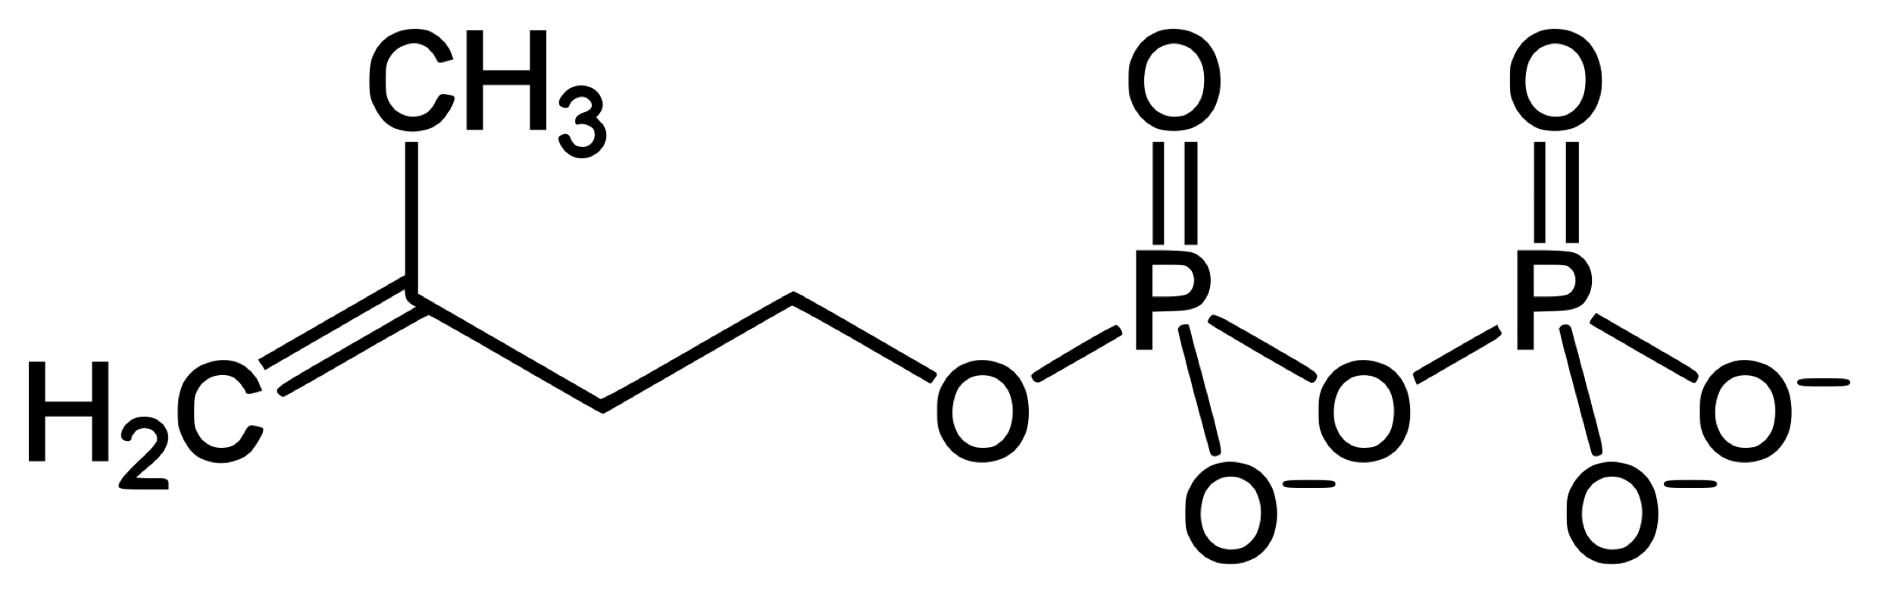

1.3B: Biopolymer basics
17. How many monomers does it take to make a polymer?
Indeterminate: the number of monomers in a polymer can vary greatly from very few to a massively huge number.

1.3C: Carbohydrates
18. What aspect of carbohydrate structure, what functional group, is responsible for the hydrophilic nature of carbohydrates?
Hydroxyl groups are responsible for much of the hydrophilic nature of carbohydrates.

19. What monosaccharide is cellulose a polymer of?
Glucose

1.3D: Amino acids & proteins
20. How many atoms is the central alpha-carbon of an amino acid bonded to?
The central alpha-carbon of amino acids is bonded to four other atoms: amino N; carboxy C; H; and the first atom of R.

21. How many amino acids occur in nature and what part of them is unique?
There are 20 natural amino acids and they are distinguished by their differing R groups.

22. What functional groups join together to form the peptide bond that polymerizes amino acids and forms the backbone of proteins?
Amide bonds (aka peptide bonds) are formed when the carboxy group of one amino acid bonds to the amino group of the next.

1.3E: Nucleic acids (DNA & RNA)
23. How could you tell whether a nucleic acid was RNA or DNA by looking at its nucleotide sequence?
Each has four bases and they share adenine, guanine, and cytosine. DNA has thymidine but RNA has uracil instead.

24. How would you describe the difference between RNA and DNA bases? What’s chemically different?
The ribose of RNA has a hydroxy group at carbon 2, while DNA has a deoxy ribose.

25. The two strands of DNA that make up a DNA double-helix run in ___________ directions.
opposite

