**CHE 2060: Module 3 HW – KEY**

**3.1: Conformation of open-chain organic molecules**

**1.** Draw an energy vs dihedral angle graph for rotations about the C2-C3 bond of 2-methylbutane. For each energy peak and valley, draw a corresponding ponding Newman projection.

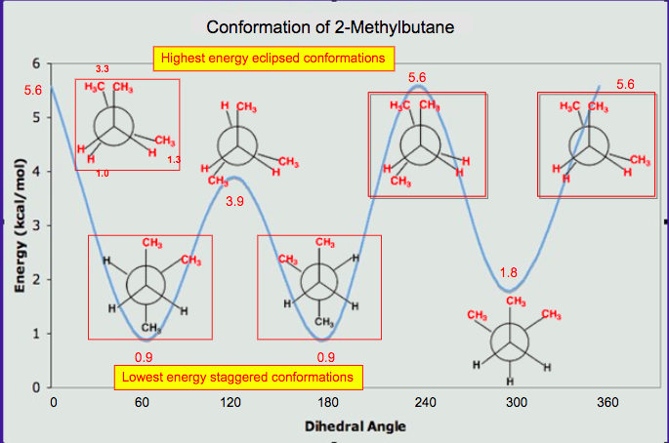

**2**. 1,2-ethanediol (aka ethylene glycol)

(a) Draw Newman projections of the gauche and the anti conformations.

(b) Why might the gauche conformation be expected to be the less stable of the two?

(c) Do you think that gauche is also the most stable conformation of 1,2-dimethoxyethane? Explain.





**3.2: Conformation of cyclic organic molecules**

**3.** Which of these diaxial chair conformations has the highest energy? Explain why.

(a) trans-1,2-dimethylcyclohexane

(b) cis-1,3-dimethylcyclohexane

(c) trans-1,4-dimethylcyclohexane

The energy of (b) cis-1,3-dimethylcyclohexane is highest as the two methyl groups are not only axial but are on the same side of the ring. In the structures of (a) and (c), the methyl groups are on opposite sides of the ring and cause less steric hinderance.

**4.** Which of the following are *trans* disubstituted cyclohexanes?



Trans: B, D, E

**3.3: Chirality and stereoisomers**

**5.** Circle all chiral centers. (Hint: Don't panic! Remember - you are looking for sp3-hybridized carbons with four different substituents.)



**3.4: Labeling chiral centers**

**6.** Below is an experimental drug for Alzheimer's disease that was mentioned in the March 13, 2007 issue of Chemical and Engineering News.

(a) Label the chiral center(s) R or S.

(b) Draw the enantiomer of the molecule shown.

 

**7.** Three of the four structures below are chiral. Assign R/S designations to all chiral centers and identify the achiral molecule.



**3.5: Optical activity**

**8.** Why do meso compounds appear to have no optical activity?

Meso compounds have chiral centers with opposite orientation. Each chiral center rotates plane polarized light equally in opposite directions. Those opposite rotations cancel one another out.

**3.6: Compounds with multiple chiral centers**

**9.** The sugar below is one of the stereoisomers that we have been discussing. The only problem is, it is drawn with the carbon backbone in a different orientation from what we have seen. Determine the R or S configuration at each chiral center. 

**10.** Draw the R,R stereoisomers of the structures below.



**11.** Below are the structures of sucralose, the artificial sweetener with the brand name Splenda (TM), and the cancer drug Paclitaxel. Give an R or S designation to chiral centers indicated with an arrow.



**12.** What is the relationship between each pair of molecules? Your choices are:

* Identical
* Not isomers
* Constitutional (aka structural) isomers
* Diastereomers but not epimers
* Epimers
* Enantiomers











* **Diastereomers** (two chiral centers are flipped).
* **Enantiomers** (all five chiral centers are flipped).
* **Identical** (drawing is flipped vertically but they are the same structure).
* **Identical** (the carbon which appears to be flipped in the drawing is not a chiral center).
* **Constitutional isomers** (same molecular formula, but notice that inositol does not have a

ring oxygen. Is not a monosaccharide, it is a cyclohexane with six hydroxyl substituents.)

**13.** Identify the relationships between each of the following pairs of pentose sugars

(not isomers, constitutional isomers, diastereomers but not epimers, epimers, enantiomers, identical).



**3.7: Meso compounds**

**14.** Draw a diagram that shows how 1,3-dimethylcyclohexane can – and cannot – be a meso compound.



**3.8: Fischer and Haworth projections**

**15.** Try this visualization challenge: two fluorinated derivatives of Epivir were also mentioned in the C&E News article. The structures are below, drawn in what is referred to as a 'Haworth projection'. What is the relationship between them? (Your choices: not isomers, constitutional isomers, diastereomers but not epimers, epimers, enantiomers, identical.)



The lower, S-containing, 5-member ring has two chiral carbons with equal and opposite chirality in A and B, so the molecules are enantiomers.

**16.** Secramine is a synthetic compound that has been shown to interfere with the transport of newly synthesized proteins in the cell (see Chemical and Engineering News Nov. 28, 2005, p. 27). Also drawn below is a (hypothetical) isomer of secramine.

(a) Identify the relationship between the two isomers: are they constitutional isomers, conformational isomers, enantiomers, or diastereomers?

(b) Locate a five-membered ring in the secramine structure.



(a) The two structures are diastereomeric.

(b) The five-membered ring is sandwiched between the aromatic, seven-membered, and six-membered rings, with the ether oxygen as the free corner.

**3.9: Stereochemistry of alkenes**

**17.** Draw the enantiomer of each the compounds below, and assign configurations to all chiral centers and stereogenic alkenes. How many diastereomers are possible for each of the structures you drew?



The enantiomers of the compounds shown are below. Note that the chiral centers

are flipped, but the stereogenic alkenes are not.

**18.** The natural product bistramide A has been shown to bind to actin, an important structural protein in the cell, and suppress cell proliferation (see Chemical and Engineering News Nov. 21, 2005, p. 10).

(a) Label the alkene functional groups as E, Z, or N (no E/Z designation possible)

(b) Theoretically, how many diastereomers are possible for bistramide A?



(a) Both alkene groups are E.

(b) In addition to the two alkene groups, there are 10 chiral carbons in the molecule. Therefore, there are 212 possible stereoisomers.

**3.10: Stereochemistry in biology and medicine**

**19.** Ephedrine, found in the Chinese traditional medicine ma huang, is a stimulant and appetite suppressant. Both pseudoephedrine and levomethamphetamine are active ingredients in over-the-counter nasal decongestants. Methamphetamine is a highly addictive and illegal stimulant, and is usually prepared in illicit 'meth labs' using pseudoephedrine as a starting point. What are the relationships between these pairs of molecules? Your choices are: not isomers, constitutional isomers, diastereomers, enantiomers, or same molecule

(a) Between ephedrine and pseudoephedrine?

(b) Between methamphetamine and levomethamphetamine?

(c) Between pseudoephedrine and methamphetamine?



(a) Ephedrine and pseudoephedrin are diastereomers (epimers). There are two chiral centers, and one of them (the OH) is flipped.

(b) Methamphetamine and levo-methamphetamine are enantiomers (only one chiral center, and it is flipped). Methamphetamine technically should be called dextromethamphetamine.

(c) Not isomers; different molecules

**3.11: Prochirality**

**20.** Assign pro-R and pro-S designations to all prochiral groups in the amino acid leucine. (Hint: there are two pairs of prochiral groups!).

