CHE2060 Lecture 2 HW:
Simple structures, functional groups and hydrocarbons

Problems must be solved, or written out, in their entirety with all work shown on engineering graph paper. You must label each set in the upper left hand corner with your name, the date and the chapter. Problems must be identified by number and all work must be shown with answers boxed. Be sure your handwriting is legible. An example is posted in the ‘course basics’ section of our Moodle page.

2.1 Drawing molecular structures
1. Write complete structures (showing all atoms) for each of these line-bond structures.

2. For each of molecules drawn below, draw a line-bond representation.

2.2 Arrow formalism & molecular framework
3. Draw curved arrows to shift these resonance structures.

4. Draw curved arrows to show how electrons move to form the product on the right from
the reactants on the left.

5. Label each of the molecules shown here as:
- Linear or branched
- Carbocyclic
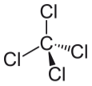
- heterocyclic
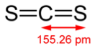
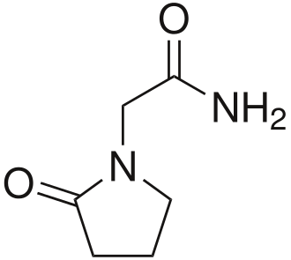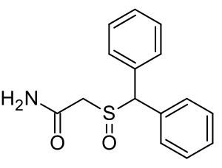

2.3 & 2.5 Introduction to alkanes / IUPAC naming
6. Give the molecular formula for a 20-carbon cycloalkane.

7. Why are alkanes called “saturated” hydrocarbons?

8. Write line-bond drawings of each of these alkanes:
- 2,2,3-trimethylbutane
- 2,2,3,3-tetramethylbutane
- 3,4,6-trimethyl-5-propyloctane
- 5,6-diethyl-2-methylnonane

2.4 Isomers
9. Draw structural formulas for all possible isomers with each of these molecular formulas:
- C4H9F
- C3H6

2.6 Alkyl halides and cycloalkanes
10. Write line-bond drawings for each of these alkyl halides:
- 1-ethyl-3-fluorocyclohexane
- 1,3-dichloro-4-ethyl-4-fluorocyclopentane

11. Write line-bond drawings of each of these cycloalkanes:
a. 4-cyclopropyl-1-ethyl-2-methylcyclohexane
b. cyclopropylcyclobutane

2.7 Functional groups
12. Draw structures or line-bond drawings for each of these molecules whose molecular
formulas are shown next to their functional group names:
- an alcohol, C4H10O
- an aldehyde, C3H6O
- a carboxcylic acid, C4H8O2

13. Compare these pairs of functional groups. Which is more polar and therefore more reactive?
a. alcohols or thiols?
b. nitriles or amines?
c. alkenes or arenes?
d. alcohols or ethers?

2.8 & 2.9 Alkenes & alkynes
14. Draw line bond examples of molecules with:
a. isolated double or triple bonds
b. conjugated double bonds
c. cumulated double bonds

15. Create line-bond drawings of these alkenes:
a. 2-methyl-1-butene
b. 2-methyl-1,3-butadiene
c. 2-methylpropene

16. Create line-bond drawings of these alkynes:
a. 1-pentene-4-yne
b. 4-methyl-2-pentyne

2.10 Alkene isomers
17. Which of these compounds exist as cis-trans isomers? Draw both isomers if possible.
a. propene
b. 3-hexene
c. 2-methyl-2-butene
d. 2-hexene

2.11 – 2.13 Organohalogens, arenes & molecular formulas
18. Can any / all conjugated ring systems be called arenes? Why or why not?

19. Create line-bond drawings for these aromatic compounds:
a. 1,3,5-trichlorobenzene
b. o-chlorophenol
c. p-dibromobenzene

20. This is the pesticide known as ethylene dibromide (EDB). It’s found in trace amounts in algae & kelp but it’s main source is man as we synthesize large amounts of it. Years ago, EDB was used to be an additive to leaded gasoline and as fumigant & soil pesticide. It’s use now confined to treating stored logs and to killing moths in beehives, and in preparation of dyes and waxes. EDB is a potent carcinogen and causes brain effects like depression & collapse.
a. Give the proper IUPAC name for EDB as shown below.
b. What is the molecular formula of EDB?
c. Does your name include the molecule’s conformation?
d. Draw the other (alternate) conformation and compare its stability to the form shown here.
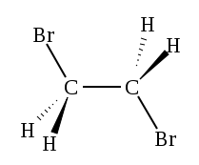

21. This small molecule is another fumigant, DBCP. This compound no longer used in American agriculture (banned in 1979), but it was the active ingredient in the nematicide Nemagon, aka Fumazone. Sadly it causes sterility in male mammals at high concentrations. DBCP continutes to be a groundwater contaminant and is very persistent in the environment.
a. What is the IUPAC name of this banned pesticide?
b. What is its molecular formula?
c. How many isomers can it take? Draw them all!
d. Do you think the isomers would have the same chemical and biological effects as DBCP?

