**CHE 2060: Line-Bond Structure WS[1]**

**Line-bond drawings** are a simplified way of representing complex chemical structures and is particularly useful for the carbon-based organic compounds.



*complete abbreviated line-bond*

*structure structure drawing*

**Complete structures** show every atom as a letter and every bond as a line.

**Abbreviated structures** break the molecule down into functional groups and show them from left to right.

**Line-bond drawings** show only heteroatoms (non-C and non-H) as alphabetical symbols. Each line segment represents a carbon-carbon bond and one carbon atom is assumed to be at either end of every line segment. Hydrogen atoms are not shown, but are assumed to fill the remaining valences or bonds to carbon.

Note that both complete structures and line-bond drawing show *bond angles* and *free electron pairs*, but abbreviated structures do not.

**Example: *How many carbons are there in each of these molecules?***



**Multiple bonds are shown with double or triple lines.**

Notice that double bonds do not alter tetrahedral bond angles, but triple bonds create a stretch of linear structure that spans the triple bond and an atom on either side.

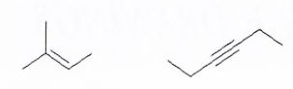

So…

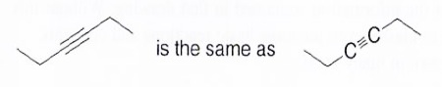

**Example: *How many carbon atoms are there in these molecules?***



**Unseen hydrogen atoms:**

Since line-bond drawings don’t show H atoms unless they are bonded to heteroatoms, how do you know how many hydrogen atoms a molecule has and where they are? Well, carbon and other heteroatoms have common bonding patterns as shown here. So carbon has a total of four bonds, nitrogen has three bonds, and oxygen prefers two bonds.

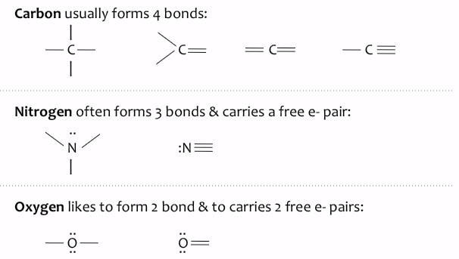

So, if a line bond drawing of carbon shows two bonds (or lines) the other two bonds must be unseen bonds to hydrogen.

**Example: *How many hydrogen atoms are there in the two molecules shown here.***



**Guidelines for creating line-bond drawings to represent complete molecular structures:**

1. Remember that carbon chains should be drawn in a zig-zag pattern.
2. Draw double bonds above the point (outside of the angle) of a zig-zagging carbon chain rather than within the point (or angle).
3. It doesn’t matter whether zig-zags are right-side up or upside down.
4. Never give carbon more than four bonds.
5. Show hydrogen atoms with letter only when they are bonded to a non-C (hetero) atom.

**Formal charge** is most often carried on heteroatoms, though carbon can carry a charge. Formal charge is calculated as:

Formal charge = (# valence electrons) – (dots + sticks)

**Finding lone pairs that are not drawn:**

Lone, or unbounded, pairs of electrons affect a molecule’s physical and chemical properties and are one of the keys to understanding the reaction mechanisms of organic chemistry. However, molecules are often depicted without lone pairs, particularly in line-bond drawings. So how do you know where they are?

1. If an atom carries a negative charge, then it must have an extra valence electron beyond those indicated by its position in the periodic table.
2. If an atom carries a positive charge, it must be missing a valence electron.

**Example: *Draw in the lone pairs for the negatively charged oxygen shown below. Here, a negative symbol is shown in a circle in the upper right.***

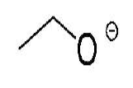

**Part A: Convert these complete structures to line-bond drawings.**

* And add missing lone pairs (aka free electron pairs) as you go.



**Part B: Convert these line-bond drawings into complete structures**

* And add missing lone pairs (aka free electron pairs) as you go.

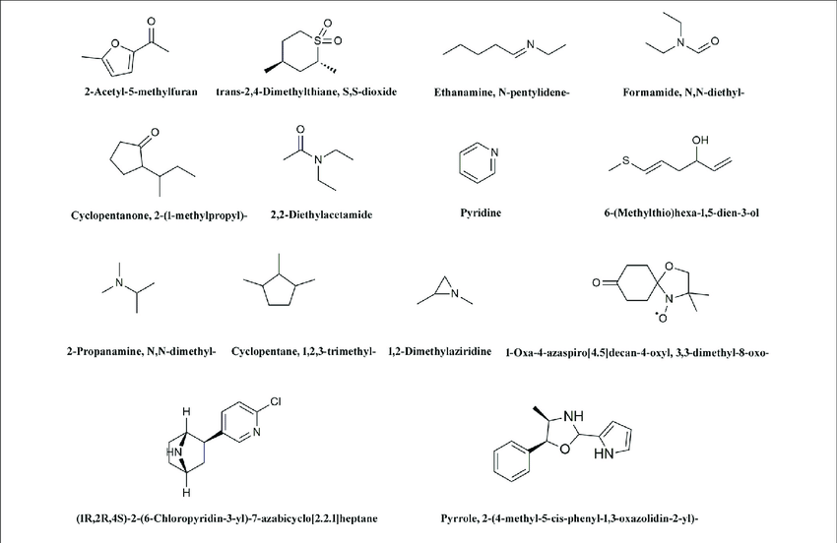

1. This worksheet was adapted from chapter 1 of Kline’s (2004) *Organic chemistry as a second language*.