**CHE 2060: Practice problems 2 – KEY**

**2.1: Covalent bonding in organic molecules**

**1.** What kinds of orbitals are overlapping in bonds b-i indicated below? Be sure to distinguish between σ and π bonds.



f: σ = overlap of sp3 orbitals of both Cs

g: σ = overlap of sp2 orbitals of both Cs

π = overlap of unhybridized ps of both Cs

h: σ = overlap of H’s s, C’s sp2

i: σ = overlap of sp2 orbitals of both Cs

**2.** Draw, in the same style as the figures above, orbital pictures for the bonding in methylamine.



**2.2: Molecular orbital theory**

**3.** H atoms bond to form H2, but He atoms don’t form He2 molecules. *Why not?*



The e- configuration of He is 1s2, so it’s s orbital is full.

* Therefore, if 2 He atoms overlapped and tried to bond, both bonding *and* antibonding obitals would be filled.
* Overlapped molecular energy levels aren’t lower than nonoverlapped atomic energies.
* Therefore, formation of the He2 molecule is not favored.

**2.3: Resonance**

**4.** Draw four resonance contributors for this molecule and label each major or minor.



**5.** Draw four resonance contributors that show how the positive charge on the side chain of the amino acid arginine can be delocalized.





**6.** Draw three resonance contributors of methyl ethanoate and order them by relative importance. Explain your reasoning

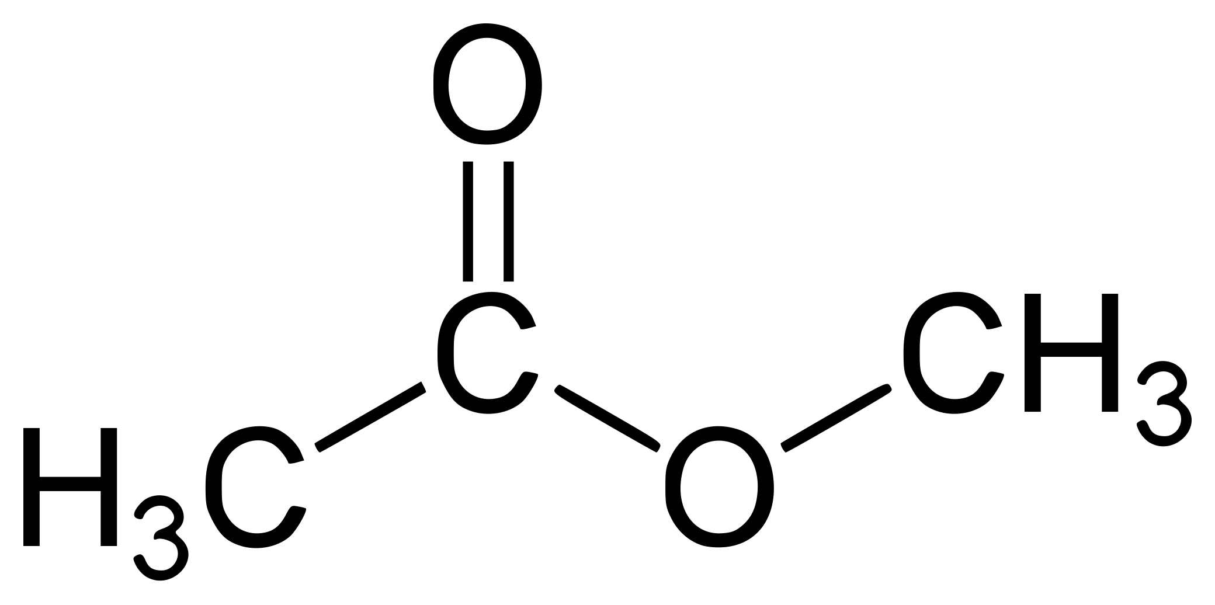



**7.** Draw two pictures showing the unhybridized p orbitals and the location of π electrons in the 'enolate' anion shown below.

* One picture should represent the major resonance contributor…
* the other the minor contributor.
* How many overlapping p orbitals are sharing how many π-bonded electrons?



**8.** For each of the compounds below, several minor resonance contributors can be drawn in which the atom indicated by an arrow bears a negative formal charge. Circle all atoms which could bear the corresponding positive formal charge.





**2.4: Non-covalent interactions**

**9.** Define each of these terms:

(a) covalent bond

(b) hydrogen bond

(c) dipole-dipole bond

(d) van der Waals bond

(a) A shared pair of electrons, generally one from each bonded atom.

(b) A strong dipolar but noncovalent bond between a donor (polar H bonded to an O, N or F) and an acceptor (O, N or F).

(c) A non-covalent bond between atoms or groups with partial positive and negative charges.

(d) A weak and transient interaction between temporarily polarized molecules.

**10.** Is van der Waals attraction an example of an inductive effect or a field effect?

VdW attractions are a field effect.

**11.** Do linear or branched molecules of the same carbon number experience greater van der

Waals attraction? Why?  
Linear molecules experience greater van der Waals attractions because they pack or overlay more efficiently; more extensive surface contact.

**12.** What are the essential similarities and differences between dipolar and hydrogen bonding interactions?

All hydrogen bonds are dipolar bonds, not all dipolar bonds are hydrogen bonds. Hydrogen bonds are a very specific form of hydrogen bond.

**2.5: Physical properties of organic compounds**

**13.** For each pair of molecules below, choose the one that is more water-soluble, and explain your choice.



(d) The compound on the left is more soluble (capable of hydrogen bonding)

(e) The compound on the right is more soluble (fewer hydrophobic carbons)

**14.** Give the expected trend (lowest to highest) in boiling points for the following series of compounds.



1. 2 and 3 have two fluorines and are more polar than 1, so they have stronger intermolecular dipole-dipole interactions. 3 has one more carbon than 2, and therefore stronger van der Waals interactions. 4 is capable of hydrogen bonding, so it has the strongest intermolecular interactions and the highest boiling point.



1. 1 and 2 have only van der Waals interactions, but 2 has more carbons so these

interactions are slightly stronger. 3 has a polar carbonyl group, and 4 is capable of hydrogen bonding.

