**CHE 2060: Module 4 Quiz: Overview of organic reactivity - KEY**

**4.1: A first look at some organic reaction mechanisms**

**1.** What type of reaction is this? Acid base reaction



**2.** Identify and label the nucleophile and electrophile in the previous reaction ***and*** add curved arrow(s) to show the movement of electrons.



**3.** What type of reaction is this? Nucleophilic substitution, specifically SN2



**4.** Identify and label the nucleophile, electrophile and the transition state in the previous reaction ***and*** add curved arrow(s) to show the movement of electrons.



**4.2: A quick review of thermodynamics and kinetics**

**5.** Reactions can be either endothermic or exothermic, but nearly all reactions require an input of energy. What is that energy used for?

Activation energy input is used to change the conformation of the substrate to enable formation of the transition state and / or to do chemistry to change reactant to product.

**6.** Label this reaction coordinate diagram.

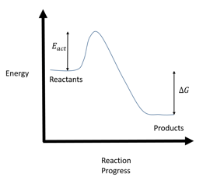

**4.3: Catalysis**

**7.** You don’t have a catalyst! What **two** other methods could you use to boost reaction kinetics?

(1) increase concentration of reactants

(2) increase temperature

**8.** Define the term ‘catalyst’.

Catalyst: a substance that interacts with reactants to speed the kinetics (reaction rate or speed) of a chemical reaction. Catalysts are not changed by the reaction and can be used over and over again. All catalysts decrease activation energy.

**9.** This diagram demonstrates one way in which enzymes can act as catalysts.

(a) Please add labels to the diagram to help tell the story of what the diagram is showing.

(b) How do you think this enzyme is doing its work? What method(s) is it using act as a catalyst?





**4.4: Comparing biological and laboratory reactions**

**10.** List two advantages of doing chemical reactions in a laboratory rather than in a biological system.

In the lab we can control many factors, including temperature, concentration of reactants, pH, etc.