CHE2060 Lab: Recrystallization of acetanilide

Background
Most organic substances are initially produced in an impure form, contaminated with unreacted reagents, side products, and impurities. Solid compounds can often be purified by recrystallization.

Recrystallization is a process in which the solid of interest is dissolved in a hot solvent that is then slowly cooled. The compound of interest is slowly and selectively precipitated, while the impurities remain dissolved in the solution, or are removed from the hot solution (before recrystallization occurs) by decolorizing carbon. The crystals are separated from the solution by filtration. The solvent selected is based on the solubility of the compound of interest. The compound of interest should be highly soluble at high temperatures but only slightly soluble at room temperatures. The selection of solvent is usually on a trial and error basis unless a chemical reference can be found which recommends a solvent. Often, a mixture of solvents is used. The compound of interest is dissolved in a small amount of hot solvent in which it is highly soluble. While still hot, a second solvent (in which the compound of interest is far less soluble) is slowly added until cloudiness appears as the compound begin to precipitate out. The first solvent is then slowly added until the cloudiness just disappears. The mixture is then slowly cooled and the product recrystallizes. Repeated recrystallization may be necessary to obtain the desired purity.

The boiling point of solvents used in recrystallization should be lower than the melting point of the compound of interest. Otherwise, the compound may melt into the solvent rather than dissolve in it; this is called "oiling out". The melted product often contains a great deal of impurities and if allowed to cool, will recrystallize in an impure state.

Decolorizing carbon can be used to remove colored impurities from the solution. The carbon has a large active surface area that attracts and absorbs impurities. The carbon is added to the hot solution, preventing recrystallization of the compound of interest while the carbon is absorbing impurities. The carbon is removed via ‘hot filtration’ to prevent recrystallization until the carbon and bound impurities are gone.

Acetanilide (below left) is a small molecule used in the synthesis of many compounds including drugs like antibiotics. Acetanilide was used as a painkiller or analgesic and antipyretic. However, it caused severe side effects, like methemoglobemia, liver and kidney damage. Research showed that the human body metabolized acetanilide to a molecule called acetaminophen that was responsible for the pain relief. Acetaminophen, aka Tylenol, (below right), is now used instead.
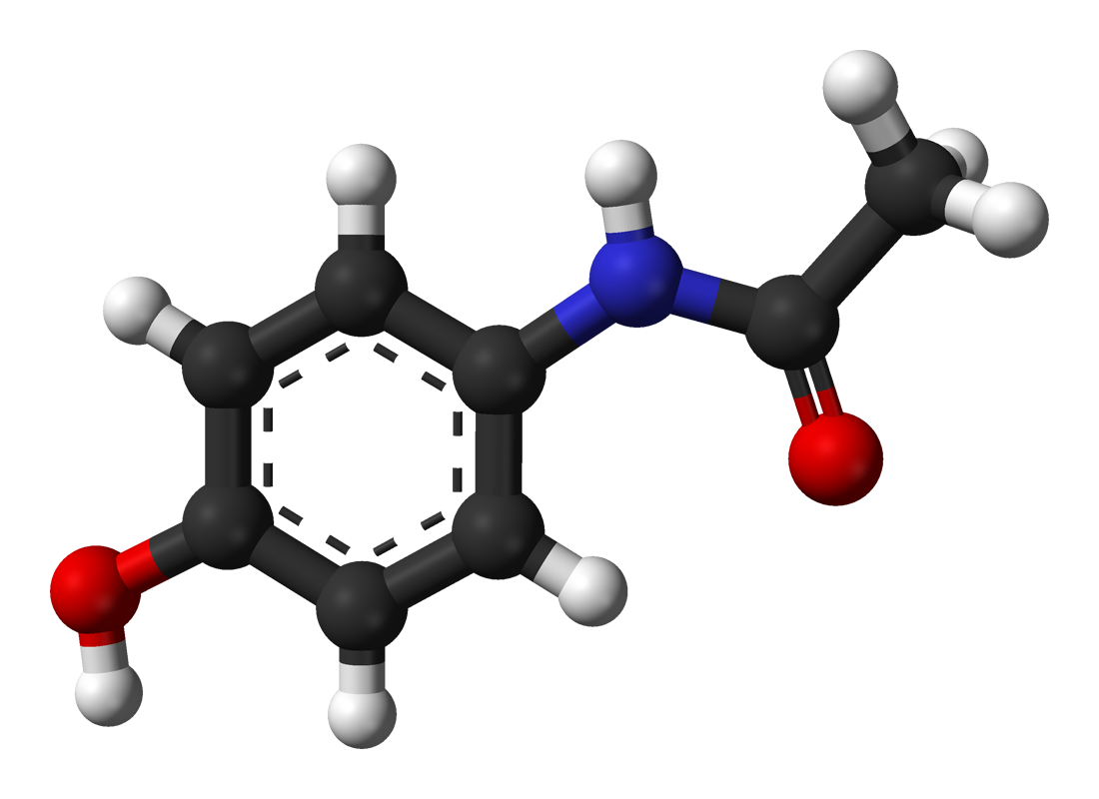
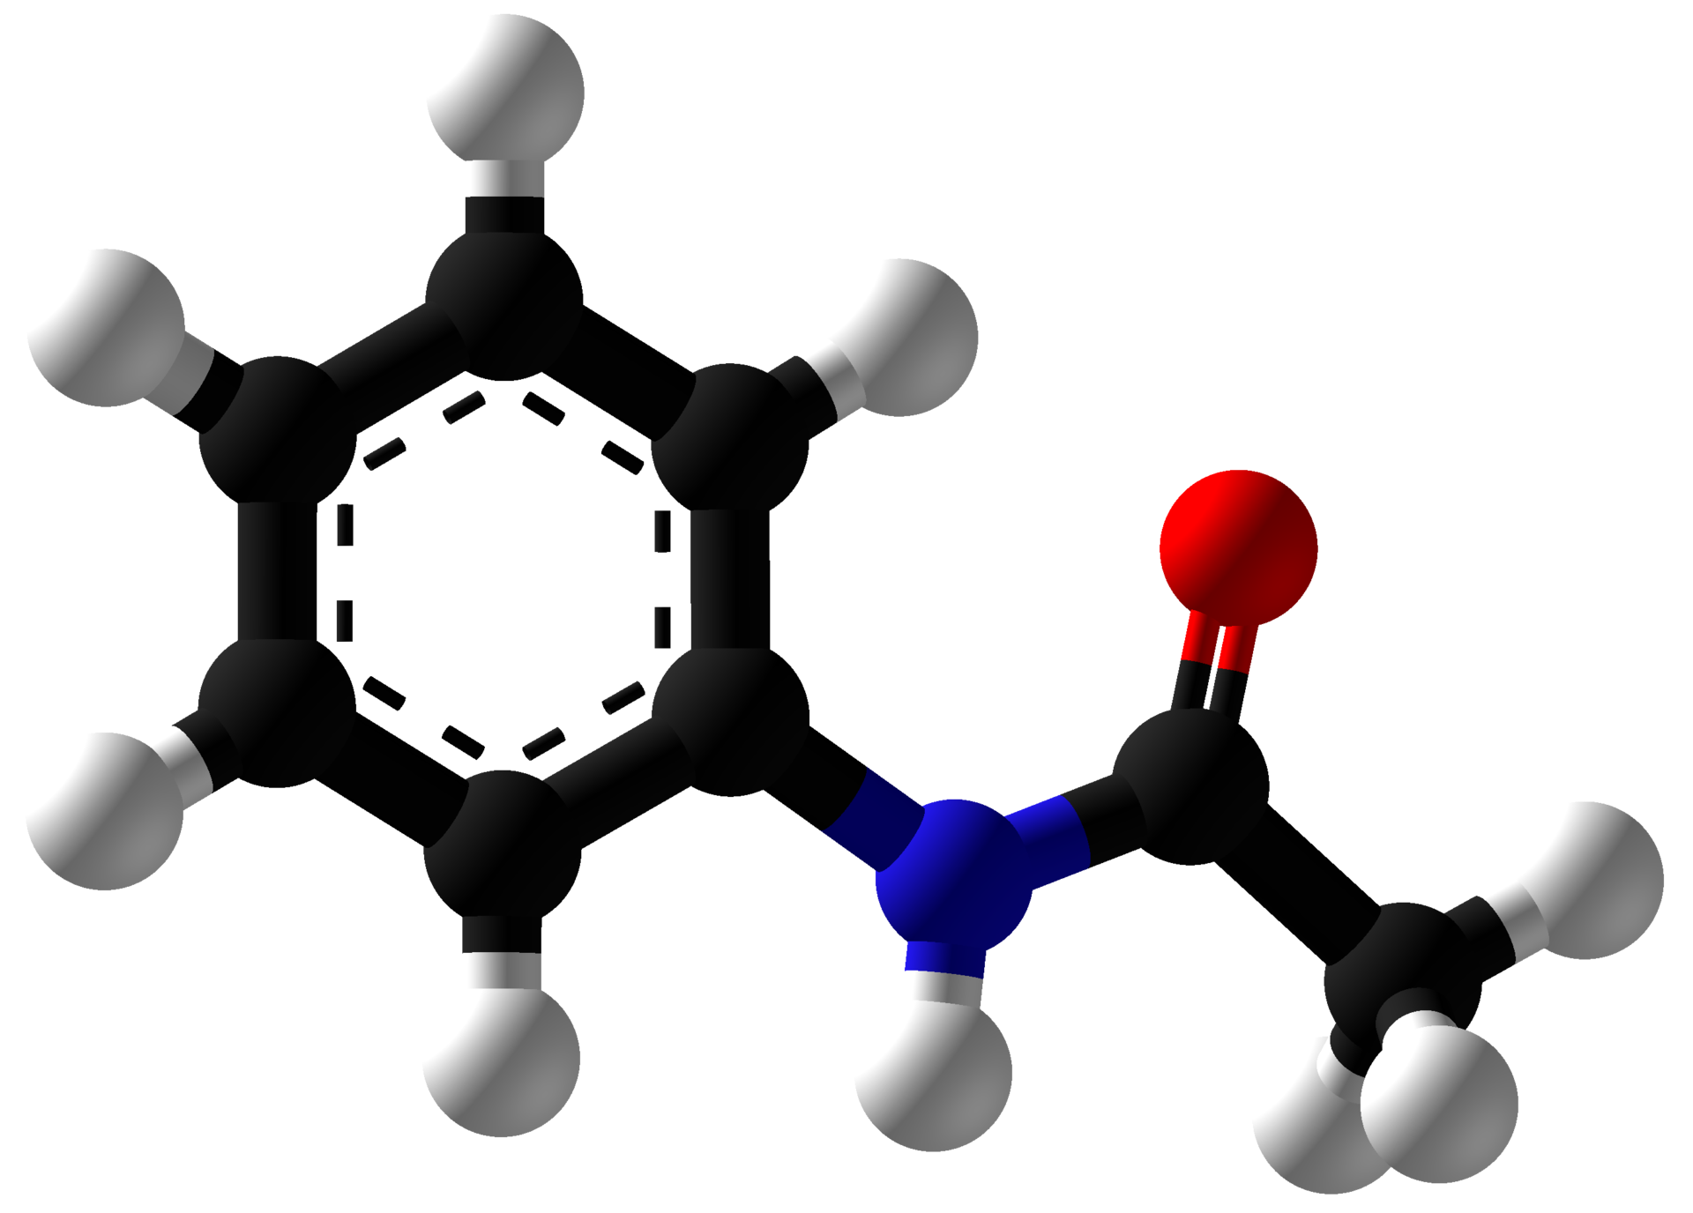

Learning objectives:
- Understanding the process of recrystallization
- Performing a recrystallization

Equipment: Chemicals:
2 - Erlenmeyer flasks (250 ml), beakers acetanilide
filter paper, small decolorizing carbon
stir bar distilled water
watch glass
Hirsch or Büchner funnel
hot plate & hot water bath
vacuum flask & trap

Table I: Properties of acetanilide
formula | C8H9NO
MW (g/mol) | 135.17
density (g/ml) | 1.219
melting point (°c) | 114.3
boiling point (°c) | 304
solubility in water (g/100 ml at 25°c) | <0.56
effective solvents | ethanol, diethyl ether, acetone, benzene

Procedure:
This video provides a preview of recrystallization, the equipment and techniques used: ‘Recrystallization’, MIT digital lab techniques manual:
https://www.youtube.com/watch?v=7LBGQHjgHEw

A. Dissolving the solid
1. Weigh out 5 grams of acetanilide and record its mass exactly.

2. Place the acetanilide into a 250-mL Erlenmeyer flask.

3. Boil approximately 200 ml of distilled water in a beaker.

4. Slowly add the very hot water to the flask. Use the minimal volume necessary to dissolve the solid.

5. Stir constantly until the acetanilide is dissolved in the minimum amount of boiling solvent. If needed, place the flask in a hot water bath to keep the solution hot and prevent recrystallization. Do not place directly onto a very hot stir plate because this might cause oiling out.

B. Recrystallization
1. Allow the solution to slowly cool to room temperature. Crystals will begin to form as the solution cools. If the solvent is volatile, cover it with parafilm or a watch glass. It is often recommended to allow the solution to stand at room temperature overnight, but we will just cool to room temperature and proceed.

2. Place the flask into an ice-bath and cool it to the temperature of the ice-bath.
3. Meanwhile, set up a vacuum flask and trap using the water aspirator at your station. The teams at one station will share a common vacuum flask. I’ll set up an example for you to copy.

4. Filter the cold solution using vacuum filtration and a Hirsch funnel. Be sure to weigh the filter paper and label it with your initials using a pencil.

5. Rinse the collected crystals with cold distilled water; use water chilled in the ice-bath.

6. Continue to pull air over the crystals using the filtration device.

7. Remove the crystals and filter and allow them to dry overnight in a covered watch glass.

8. Weigh the filter and crystals and calculate percent yield.

Adapted from Wheet (2014) ‘Organic chemistry laboratory procedures’ 5/e Molecular structures from Wikipedia

