**CHE2060 Stereoisomer Modeling Lab Key**

You’ll need a Molymod modeling set to do this lab. Feel free to work in groups of four or so.

This lab has five sections:

1. Stereogenic centers
2. Chirality and enantiomers
3. Diastereomers and meso compounds
4. The R-S convension
5. Fisher diagrams

# *Stereogenic Centers (aka chiral carbons)*

1. Make a model of 3-methylhexane and find its stereogenic center. What are the four substituents attached to the chiral carbon?

Hydrogen, methyl, ethyl & propyl groups

1. Make an sp3 carbon model with 4 different substituents: Does the model have a plane of symmetry? No
2. Replace one group so that your carbon now has 2 unique and 2 identical substituents. Is there now a plane of symmetry in the molecule?

Yes. The plane of symmetry runs *through* the two unique substitutents, creating two mirror images that each have one of the two identical substitutents.

1. Draw these compounds using line-bond drawings with dash wedges. Mark any chiral carbons.

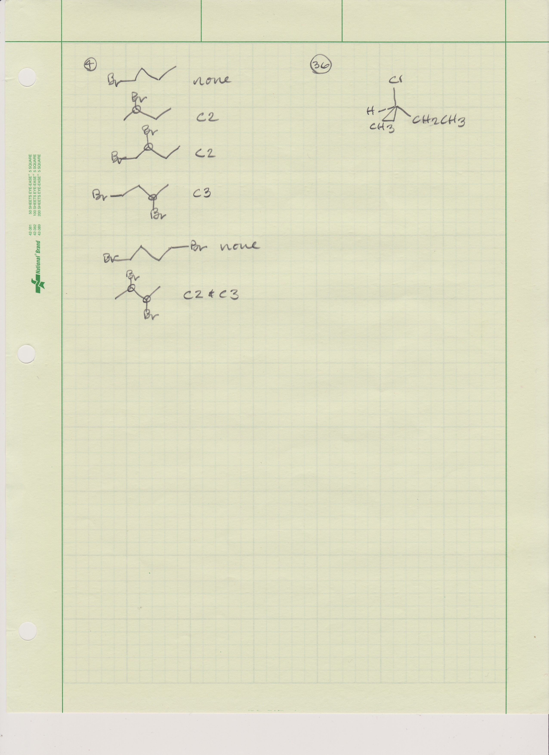1-bromobutane

2-bromobutane

1,2-dibromobutane

1,3-dibromobutane

1,4-dibromobutane

2,3-dibromobutane

***Chirality and Enantiomers***

Reconstruct the model of an sp3 carbon with 4 different substituents: black, yellow, green and red. You have just made a chiral model: no internal planes or centers of symmetry.

Now make a second model that is a mirror image of the first. Place both on the bench with black substituent upwards. These chiral mirror-images are called **enantiomers**. They differ only in properties that have direction or ‘handedness’, but share the same chemical and physical properties. For example, enantiomers rotate planes of polarized light in opposite directions; this is called optical activity, and enantiomers are optical isomers.

So, with the models on the bench with their black substituent pointing up, begin working your way through these exercises.

1. Looking down on the first model, proceed clockwise from the green atom and record the colors of the 3 atoms that lie on the bench. Green -> yellow -> red
2. Looking at the second model determine whether you need to go clockwise or counterclockwise to “read” the colored atoms on the bench in the same order you did in 5. Is the direction the same or opposite? Opposite, counterclockwise
3. Try to superimpose the two models (the original and its mirror image). Can you do it? If not, how do the two models differ? No, 2 substituents won’t superimpose.

Now, replace one substituent to create redundancy so that two substituents are identical; do this for both models. The central carbon is no longer a chiral because it has 2 identical substituents. These molecules are **achiral**; their mirror-images are identical. Achiral molecules are, by definition, optically inactive. Any molecule with an internal plane, or center, of symmetry is achiral.

1. Are the two models still mirror images? yes
2. Does either models have a plane of symmetry? If so, where?   
   Yes. The plane of symmetry bisects the central carbon atom & the two unique atoms.
3. Are the two models superimposable? yes
4. Do the models represent identical or different molecules? They are identical
5. To read the same sequence of atoms on the benchtop do you have to rotate the molecules clockwise or counterclockwise? Either way works
6. Are the molecules chiral? no

# *Diastereomers and Meso Compounds*

For any molecule with 2 or more stereogenic centers, it is possible to have stereoisomers that are not mirror-images. Stereoisomers that are not mirror images are called **diastereomers**. Diastereomers differ in all properties, chiral and achiral.

Construct a model with four different substituents on the central carbon. Construct another molecule identical to the first (they should be superimposable). Remove one identical substituent from each molecule and connect the two molecules with a bond.

1. How many stereogenic centers (or chiral carbons) does this molecule have? two
2. What four different groups are attached to each stereogenic carbon?  
   green, yellow, red, and the other carbon with its three subsitutents
3. Does the model have a plane of symmetry or a center of symmetry in any of its conformations? No

1. Make a mirror image of this model. Is the mirror image identical to, or different from, the first model? Different from
2. What terms describe the two models? enantiomers
3. Is each model chiral or achiral?   
   Chiral – each model has two chiral centers & the two models can’t be superimposed.
4. Now interchange two of the substituents of a single carbon in one of the models. Are the models identical or different now? different
5. Are the two models now mirror images, enantiomers? no
6. Are the two models stereoisomers of one another? yes
7. What term describes the two models? Chiral diastereomers
8. Carefully examine the conformations of the model in which you interchanged the two substituents. Does this model have a conformation with a plane of symmetry? If so, draw that conformation and locate that plane.

Four planes: 1) between the 2 carbons; and 2), 3), 4) along each of the three identical subsitutents.

1. Does the model have a conformation with a center of symmetry? If so draw the conformation and locate the center. Center of symmetry is between the carbons.
2. Would the mirror-image of this model be superimposable (identical to) this model? Verify your prediction by constructing the mirror-image model.

The mirror image models are superimposible after rotating around one bond.

1. Is this model chiral or achiral?   
   Achiral because it’s now a meso compound with an internal plane of symmetry.
2. Would this model be optically active? No, the two chiral carbons “cancel” each other’s rotation of light in equal and opposite directions.

The last model studied here represents a **meso form**. This model possesses 2 stereogenic centers, but these centers (or carbons) are of equal and opposite chirality. Meso forms exist when molecules have two identically substituted stereogenic centers. Meso molecules have easily detected internal planes of symmetry and are **achiral** and optically inactive.

**Tartaric acid** is a meso molecule: HO2C – CH – CH – CO2H

| |

OH OH

Tartaric acid exists in three forms: two are optically active enantiomers, and the third is an optically inactive meso form that is a diastereomer of the optically active forms.

1. Draw Newman projections formulas (looking at the bond between C-2 and C-3) for the three tartaric acids. Label pairs of enantiomers and diasteromers as well as the meso form.



When a molecule has differently substituted stereogenic centers it may exist in four optically active forms (two pairs of enantiomers). To illustrate this with models just replace one non-carbon substituent with a carbon. There are now four ways of constructing the models: two pairs of enatiomers. Verify this by constructing one pair of enantiomers yourself, while your neighbor prepares the other.

1. What name is given to a pair of molecules consisting of one molecule represented by the model that you constructed and one molecule represented by your neighbor’s model? diastereomers

***The R-S Convention***

Several conventions have been devised to designate the arrangement of groups (called the **configuration**) around a stereogenic center. Either the letter R (*rectus*, or right) or S (*sinister*, or left) is used to designate the configuration at a stereogenic center. The four atoms, or groups, attached to the stereogenic carbon are arranged in a priority order according to atomic number: the higher the atomic number the higher the priority. If two atoms have the same atomic number, we look to the next atom out from the stereogenic center, or even further, until we observe a difference in atomic number. We then view the molecule from the side opposite the group with lowest priority. If the remaining 3 groups are ordered clockwise from highest to lowest priority, the configuration is *R*; if counterclockwise, the configuration is *S*.

Construct a model of 2-chlorobutane.

1. Which carbon in the chain is a stereogenic center? C2
2. What are the four groups attached to this stereogenic carbon?  
   Hydrogen, chlorine, methyl group, ethyl group
3. Which group has highest priority? chlorine
4. Which group has lowest priority? hydrogen
5. What is the priority order of the other two groups? ethyl > methyl
6. Set the model on a benchtop so that it can be viewed from the side opposite the hydrogen, which is the lowest priority group. Draw your view of the other three groups attached to the stereogenic center in the model. Place the chorine atom at the top of your drawing.



1. When viewed as described above, do the remaining groups in priority order sequence form a clockwise or counterclockwise array? clockwise
2. What configuration does the model have, *R* or *S* ? R
3. Interchange any 2 groups attached to the stereogenic carbon. What configuration does the model have now? S

## 

# *Fischer Projection Formulas*

It is sometimes convenient to have a two-dimensional representation for three-dimensional molecules, particularly when studying stereoisomerism. One common convention devised by the German organic chemist Emil Fischer and named after him, is described in this section.

Construct a model of a stereogenic carbon atom that corresponds to the three-dimensional drawing shown here.

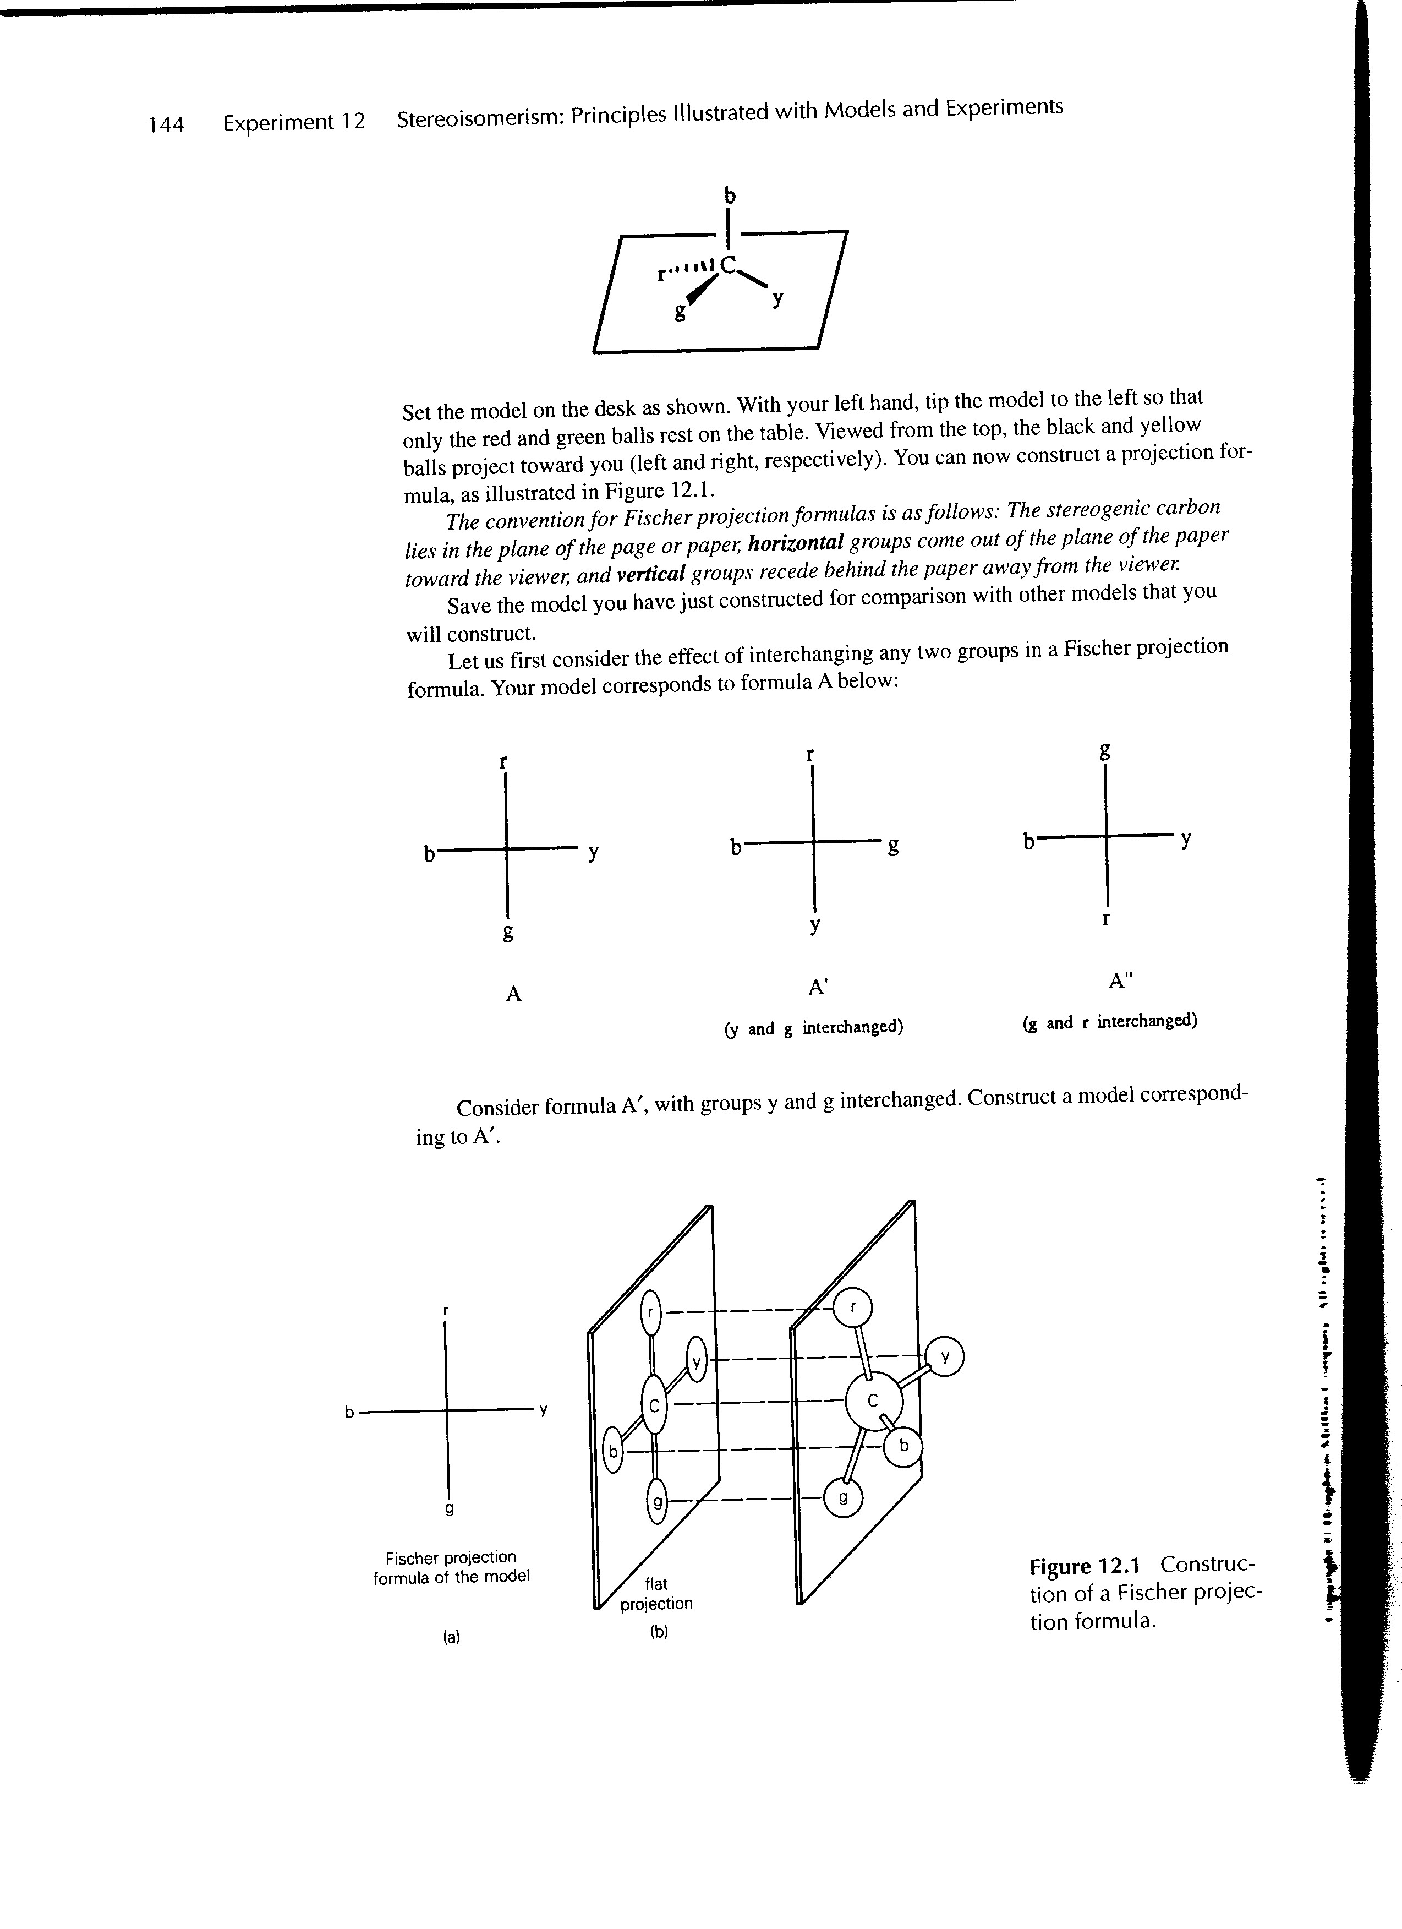

Set the model on the bench as shown here. With your left hand, tip the model to the left so that only the red and green balls rest on the bench. Viewed from the top, the black and yellow balls project toward you (left and right, respectively). You can now construct a Fisher projection formula or drawing.

The convention for a Fischer projection formula is as follows. The stereogenic carbon lies in the plane of the page of the paper, **horizontal** groups come out of the plane of the page toward the viewer, while **vertical** groups recede into the plane of the page away from the viewer.

What is the effect of interchanging any two groups in a Fischer projection formula? Your model corresponds to formula A below:



Consider formula A’ with groups y & g interchanged. Construct a model corresponding to A’.  
To make this easier, give these substituents arbitrary priorities: b > g > r > y. This allows you to assign each Fisher structure R or S chirality. A is R; A’ is S; A” is also S.

1. Is A’ identical to A, or is it the enatiomer of A? Enantiomer: switching two groups on a chiral carbon always creates the enantiomer.
2. Now construct a model corresponding to A” (above). Is A” identical to A, or the enantiomer of A? Enantiomer: A’ and A” are identical (R), just rotated.
3. What generalization can you make about the interchange of any two groups in a Fisher projection?   
   Interchange of any two groups (one pair of substituents) produces an enantiomer of the original Fisher diagram.

1. If you were to make an even number of group interchanges in a Fischer projection formula, would you obtain the original molecule or enantiomer?   
   Enantiomer: see answer to previous question.
2. Do the following Fischer projections represent the same molecule or enantiomers?  
   The same molecule: both are S.

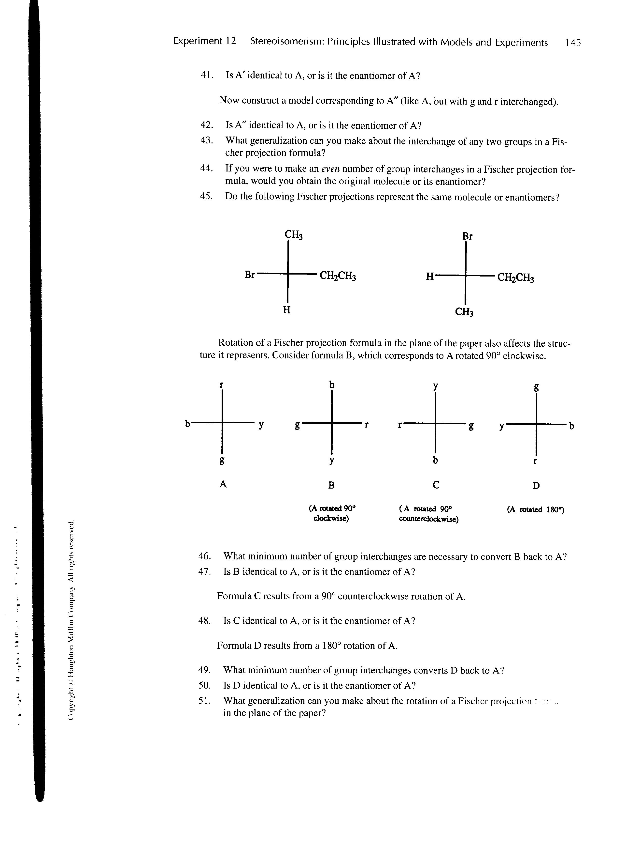

Rotation of a Fischer projection formula in the plane of the paper also affects the structure it represents. Consider formula B, which corresponds to A rotated 90° clockwise.



Think about this by assigning priorities arbitrarily: b > g > r > y. Now determine the R or S of each figure. A = R; B = S; C = S; D = R

1. What is the minimum number of group interchanges needed to convert B back to A?

2: These models have four substituents, or two pairs of substituents. If one pair of substituents on A are switched then it will become B. Prove this by switching A’s b for the y and vv. If you then rotate that switched model, you’ll find that it’s become S.

1. Is B identical to A, or an enantiomer of A?   
   Enantiomer: I arbitrarily assigned priorities and found that A is R and B is S.