SSC2030 End-of-semester survey: Transforming our energy system

This, and our meeting during finals week, is your final assignment for the course. Please complete and submit the survey by Monday midnight so that I can compile the results for our meeting. Either:
- Complete it in Word and email it to me; or
- Print it, fill it in by hand, scan it and email it to me.
And, as always, contact me if you have questions or concerns.

Terminology & perception

1. Which term do you feel best represents our goals? (choose one)
- Sustainable energy
- Renewable energy
- Clean energy
- Clean & secure energy
- Low-carbon energy

2. Which term would appeal to the greatest number of Americans or could win over the most Americans? (choose one)
- Sustainable energy
- Renewable energy
- Clean energy
- Clean & secure energy
- Low-carbon energy

What do you know about energy in the US & Vermont

[Please answer these questions without searching the internet!]

3. Is overall energy production increasing in the US? (choose one)
- yes
- no

4. Is fossil fuel energy production increasing the US? (choose one)
- yes
- no

5. Is renewable energy production increasing in the US? (choose one)
- yes
- no

6. Is overall energy consumption increasing in the US?
- yes
- no

7. Rank type of energy from most rapidly (*****) to most slowly (*) increasing:
- Coal
- Oil
- NG
- Nuclear
- All renewables

Between 1993 and 2011, global energy intensity (Btu per each dollar of GDP) fell 18.7%.
- Where do you think the US ranks globally in terms of global energy intensity?

- Did US energy intensity increase or decrease from 1993 to 2011?
- increased
- decreased

10. Is global climate change is real and happening now?
- yes
- no

11. Are emissions of greenhouse gases increasing or decreasing in the US?
- increasing
- decreasing

Technology & policy:

12. In your opinion, what should America’s top energy priorities be? (Rank top 3: *, **, ***.)
- Protecting the environment from the effects of energy development and use.
- Increasing implementation and reliance on renewable energy.
- Creating jobs within the energy sector.
- Keeping energy prices low for consumers.
- Increasing energy security & reducing dependence on foreign energy sources.

13. Which do you agree with more strongly: (choose one)
- Regulations will be needed to move us towards a more sustainable energy system.
- The free market will be ensure to move us to a more sustainable energy system.

14. Do you think our choice of primary energy resources and energy technologies are related to the amount of air and water pollution in America? (choose one)
- yes
- no
- somewhat

15. Do you believe that it is possible to cut back on environmental regulations and still protect air and water quality? (choose one)
- yes
- no
- somewhat

16. Which do you believe is a better approach to motivating change? (choose one)
- Regulation & penalty (the stick)
- Incentives (grants, tax credits, rebates; the carrot)
- Some mixture of both

17. Do you support government investments / tax credits / incentives in energy efficiency?
- yes
- no

18. Do you support government investments / tax credits / incentives in renewable energy?
- yes
- no

19. Do you support mandatory limits on greenhouse gas emissions (carbon caps)? (choose one)
- yes
- no

20. Do you support a carbon tax? (choose one)
- yes
- no

A new DOE proposal calls for power market operators to guarantee payment and price to power plants that keep 90 days of fuel on site.
21. Do you support this proposal? (choose one)
- yes
- no

22. When voting, do you consider candidates positions on energy and energy-related issues and policies? (choose one)
- always
- sometimes
- never

Your use of renewable energy

23. Do you (or anyone in your family) have any renewable energy at home? (choose one)
- yes
- no

24. If so, which represent your reasons for choosing to use renewable energy. (Rank * to ****.)
- To save money on utility bills
- To help the environment
- To benefit your family’s health
- To get a tax credit or rebate

25. If not, would you like to use renewable energy at home? (choose one & explain)
- yes
- no And please explain why not.

Transforming our energy systems

26. How quickly do you think we should change our energy system? (choose one)
- immediately
- as quickly as alternatives to fossil fuels can be deployed
- only as quickly as existing energy sources are depleted

27. Do you believe that we can power America without fossil fuels: (choose one)
- within 25 years
- within 50 years
- within 75 years
- within 100 years
- no

28. Do you think we could power America using only renewable energy 100 years from now?
- yes
- no

29. Do you support Vermont’s goal of 90% renewable energy by 2050? (choose one)
- yes
- no
- Yes, if I could make some changes to the plan or specify some things.

30. Which are the greatest obstacles to moving towards a more sustainable energy system.
(Rank choices from low* to high*****.)
- High cost / lack of low-interest loans
- Politics / lobbying
- Lack of information / education
- Inertia (change is hard & takes effort)
- Lack of technologically viable options

31. What single step do you think the federal government could take to increase the sustainability of America’s energy system?

32. What single step do you think Vermont’s government could take to increase the sustainability of America’s energy system?

Modeling and accomplishing an energy transition

Stabilization wedge approach [I’ve posted your compiled wedge plans on this web page.]
33. Did you find that the stabilization wedge model made it easier to begin thinking about energy system transition, and did it make transition seem more possible? (choose one)
- yes
- no

34. What approaches or strategies would you add as wedge choices?

35. If you were in charge of implementing a stabilization wedge strategy to transform our energy system, would you allow local / state choice or would you implement a single federal strategy? (choose one)
- local / state
- single federal

36. What role would data and results play if you were in charge of implementing a stabilization wedge strategy?

Regional energy planning: Two-Rivers Ottauquechee Regional Commission (TRORC)
Vermont has eleven regional planning commissions. Each is responsible for developing a regional energy plan with the state’s goal of 90% renewable energy by 2050. Regional plans set energy targets for each region’s member towns, and provide energy data and energy resource mapping for each town.
TRORC’s regional energy plan is the first to be approved and includes Randolph. Please have a look at these posted summaries and map before answering the next set of questions. Note that these are posted on the same web page as this survey.
- TRORC’s energy data & goals;
- My graphical representation of these energy goals; &
- Regional energy resource map, highlighting optimal locations for wind and solar.

37. Do you feel that the regional energy plan and targets are more specific and granular than Vermont’s goal of 90% renewable energy by 2050 and the ‘roadmap’ laid out by Vermont’s 2016 Comprehensive Energy Plan? (choose one)
- yes
- no

38. Do you think that the regional energy plan is sufficient to achieve its goals? (choose one)
- yes
- no

39. Do you see similarities between TRORC’s regional energy plan and the stabilization wedge strategy? Be sure to check my graphical representation of TRORC’s goals. (choose one)
- yes
- no

40. What are your two greatest criticisms of TRORC’s regional energy plan?

41. What two suggestions or changes would you make to TRORC’s energy plan?

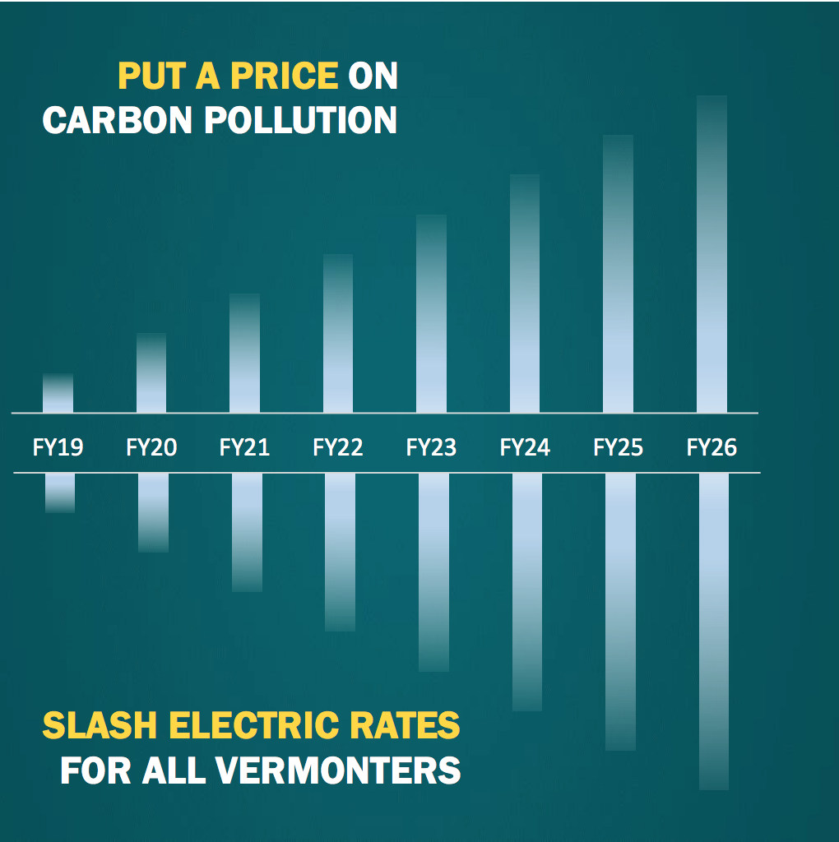
ESSEX plan: a carbon tax plan with a twist
In November 2017, a group of Vermonters including policy experts, advocates, business leaders, economists and lawmakers proposed the ESSEX plan to help Vermont transition to a more sustainable energy system. Briefly, ESSEX (an Economy Strengthening Strategic Energy Exchange) imposes a (carbon) tax on most fossil fuels and applies 100% of that revenue to lowering electric rates, so that the costs of fossil fuels slowly rises while the cost of electricity slowly falls at the same rate.

Of course, there is more to the plan (farm diesel is exempt, there is an additional incentive for rural Vermonters with more driving) but the idea is to combine carrot and stick to reduce fossil fuel use and replace it with electricity while increasing production of renewable electricity.

I’ve posted links to the ESSEX plan and to an article about it on the web page where this survey is posted. To learn more, watch this five-minute VIDEO presentation (2nd video down):
http://eanvt.org/the-essex-plan-an-economy-strengthening-strategic-energy-exchange/

42. Do you support or oppose the broad outlines of the ESSEX plan?
- yes
- no
- somewhat

43. How do you think this would affect Vermont’s electric generators and utilities?

44. What is your biggest question, concern or objection to the ESSEX plan?

